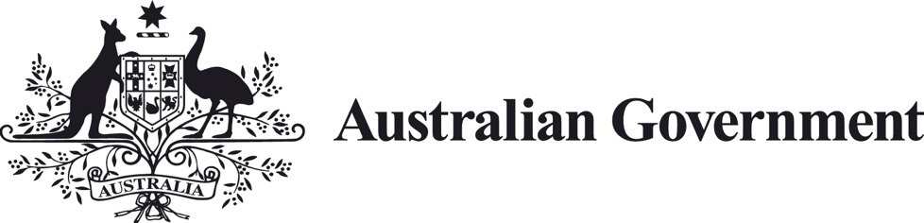

Business Research and Innovation Initiative
Fact Sheet – Challenge 4
Improving uptake of the opportunities available through the Automatic Mutual Recognition of Occupation Registration scheme

Challenge summary
The Department of the Prime Minister and Cabinet is seeking innovative solutions to make it easier for individuals and businesses to understand the opportunities available through the Automatic Mutual Recognition of Occupational Registration (AMR) scheme.
This challenge is seeking applications to improve the uptake of opportunities available through the AMR scheme which could include address information sharing challenges for occupational registrations and licences subject to AMR.
Solutions could focus on certain components of this challenge or sectors.
To apply now, visit business.gov.au/BRII.

Potential themes
This challenge could be addressed by solutions including, but not limited to, artificial intelligence, machine learning, advanced data analytics, unstructured data processing, image recognition, optical character recognition (OCR), and interoperable systems.

Overview of challenge
AMR came into effect on 1 July 2021 in New South Wales, Victoria, the Australian Capital Territory and the Northern Territory and will progressively commence in other states.AMR applies to a limited number of occupations initially and will include more occupations as Australia transitions to the scheme.

AMR makes it easier for workers who need to be licenced or registered for their job to work elsewhere in Australia.
AMR removes the need for a worker to pay and apply for a new licence or registration when working in another state or territory, saving them time and money.
AMR also enables state and territory regulators to continue compliance activity in an efficient and effective manner. This results in a greater need for real-time exchange of regulatory information between jurisdictions.
There are over 600 different state and territory occupational registrations and licences authorising similar activities across Australia.
This is then compounded by many different sources of information outlining the requirements to obtain an occupational registration or licence, and the rules for carrying out activities authorised under each occupational registration and licence.
This makes it difficult for individuals thinking about a career in these occupations or registered workers seeking to apply their trade in another state.
While information is available to understand the registration and licensing requirements in each state and territory and the associated rules to carry out the activities – it is not easy to find and takes time.

The requirements in each state and territory are different despite the activities being carried out being substantially the same.
These differences have built up over time to address local conditions and to respond to different incidences that have occurred.

While many individuals and businesses are able to find the information required and comply with the requirements, many find this a barrier to taking up work interstate. The opportunities available through AMR should also be an incentive to enter these professions.

Such barriers can affect employment opportunities, business sustainability and growth, compound skills shortages and impact the resilience of the Australian economy.

Difficulty in being able to easily and quickly access the different requirements can also impact compliance against the matters these rules are designed to protect, such as the health and safety of workers, consumers, the environment and animal welfare.

Where appropriate, governments and industry are working towards harmonising requirements. In the meantime, it is important to ensure that workers can easily work interstate and when carrying out activities are able to easily access the necessary information.

AMR has a range of safeguards to protect workers, consumers, the environment, animal welfare and the broader community.
These include the ability for a state and territory minister to require a worker to notify and satisfy certain requirements prior to carrying out the activity and, where there are significant risks, excluding certain occupational registrations from AMR.
While these safeguards are important, they provide an extra level of complexity for a worker to understand where the opportunities in AMR are available and therefore impact the take up of it.
A solution to this challenge could address the following:
- How can we ensure relevant information is efficiently maintained?
- How might we efficiently bring together the different opportunities and rules?
- What is the best way to communicate the different types of related information on an ongoing basis?
Solution requirements
- Dynamically adapt to evolving state and territory requirements for occupational licencing.
- Take into account opportunities and requirements available through the Mutual Recognition Act 1992.
- Gather and organise information on occupational licencing requirements held in disparate formats and potentially held in multiple systems within and across multiple jurisdictions.
- Be a source of truth to inform individuals, businesses, consumers and governments.

Benefits of the solution
To make information quick and easy to access and in doing so:
- save time and money for jobseekers, workers, businesses, consumers and governments
- create a more mobile workforce, enabling individuals and businesses to take up opportunities available through AMR

- make it easier for individuals and workers to comply with the requirements to obtain authorisation to carrying on an activity and the rules associated with the activity
- reduce the risks of particular occupational registrations being in AMR
- support recovery following natural disasters (including restoring critical infrastructure)
- support labour mobility, reduced local, regional and national skills shortages and improve employment outcomes
- improve protections for workers, business, consumers, the environment, animal welfare and the broader community
- contribute to Australia's economic recovery and resilience.
The market potential for the solution could be applicable to all areas of society where disparate and dynamic requirements between states and territories need to be communicated and complied with.
This challenge gives successful private sector applicants the opportunity to test the commercial viability of their solution with project partners.

How to apply
For more information on how to apply, visit business.gov.au/BRII.

