  - Business Research and Innovation Initiative
  - Fact sheet

Increasing energy efficiency in commercial fishing operations
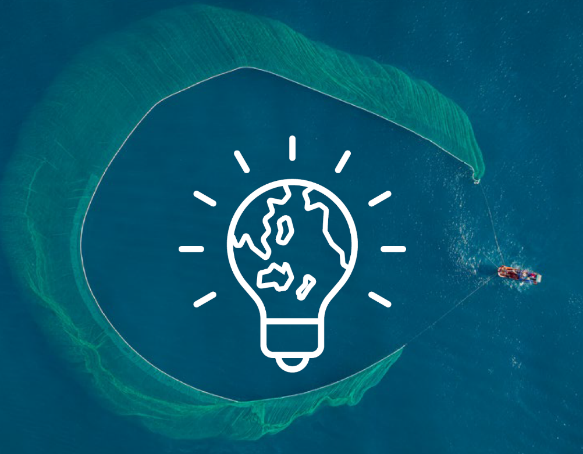
The Fisheries Research and Development Corporation (FRDC) is seeking innovative solutions to improve the energy efficiency of the fisheries and aquaculture sector.

Opportunities
- Access grant funding of up to $1.1million
- Work with government
- Keep ownership of all IP developed for the project
- Accelerate commercial opportunities
- Potential for procurement
- Receive industry expertise and guidance
- Contribute to Australia’s Net Zero targets

The challenge
Can you increase efficiency of Australia’s fisheries and aquaculture sector and reduce the carbon it emits?
The fisheries and aquaculture sector is hard to decarbonise. This is because of the reliance on fossil fuels, limited space on vessels, safety and regulatory needs, and long trips to remote, offshore areas.
Diesel or petrol are the main source of greenhouse gas emissions from commercial fishing vessels. Fossil fuels are a major operational cost and are essential for navigation, fishing, and generating power for refrigeration and catch processing.
Low-carbon alternative fuels and propulsion systems are emerging, but they are not yet widely available for commercial use.
There are other factors that can affect energy efficiency. For example, when the capture of non-target species (bycatch) is high, it increases the time needed to sort and return the bycatch to the ocean. This extra time uses more fuel. Excess bycatch also increases drag during net retrieval which escalates fuel use even more. These factors lead to increased emissions and affect catch quality because of extended time at sea.
The aim of this challenge is to increase the efficiency and reduce carbon intensity of commercial fishing operations by 30% or more.

Potential themes
Solutions could consider:
- fuel-efficiency technologies
- bycatch reduction strategies
- sustainable fishing practices
- environmental impact mitigation
- innovation in commercial fishing equipment and technology
- technology to find fish faster
- improved trawler/vessel efficiency.

Solution requirements
FRDC is open to a range of solutions to address this challenge.
The Business Research and Innovation Initiative (BRII) is seeking new-to-world solutions. The solutions might aim to reduce fuel usage, decrease time spent in fishing activities or apply new technologies to optimise operations.
Solutions:
- should be versatile and enhance energy efficiency across diverse commercial fishing methods, regardless of vessel characteristics or fuel type
- should be adoptable across the commercial fishing industry, both in Australia and around the world
- can be hardware/engineering solutions or software-based
- could show potential use in other agriculture or unrelated sectors to increase commercialisation opportunities.
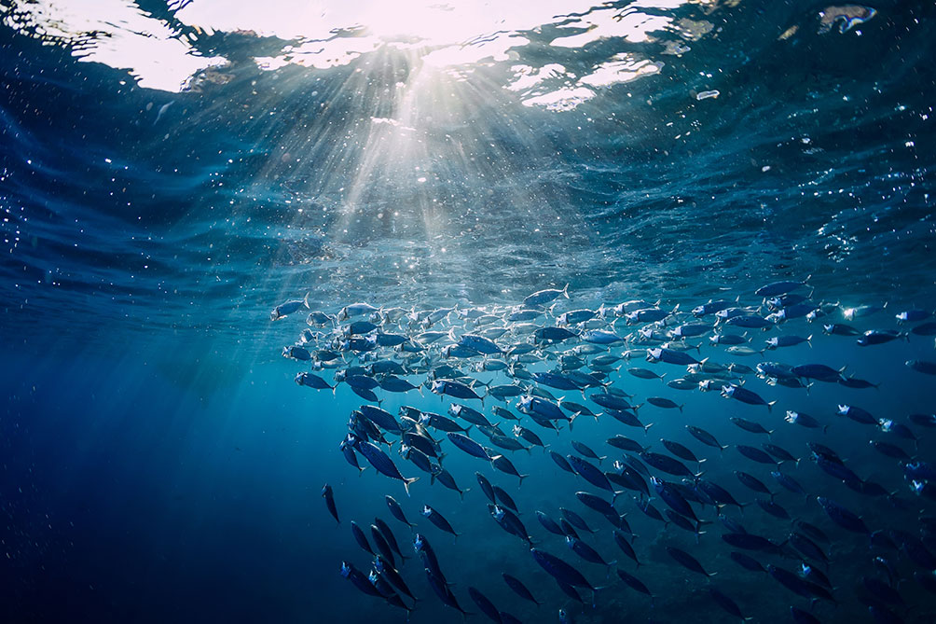

Solution benefits
Proposed solutions should have the potential to be applied commercially across the fisheries and aquaculture sector, but also other sectors. Applicants will keep their intellectual property (IP), so commercial application possibilities for new technologies are considerable.
Solutions that improve the energy efficiency of fishing operations will benefit the environment through reducing greenhouse gas emissions. Those solutions that improve time efficiency will support the industry to increase productivity, lower cost and supply a higher quality product.
Innovations can lead to commercial benefits for fishing companies and wider commercial benefits for the applicant, such as leveraging IP into other technology or industries.
There is a growing market for sustainably-sourced seafood. Reducing carbon emissions can position a fishing company and industry to take advantage of this market, meeting consumer demands for sustainable products.

How to apply
Have you got a great idea to solve this challenge?
For more information or details on how to apply, visit business.gov.au/BRII-RLE or call 13 28 46.

