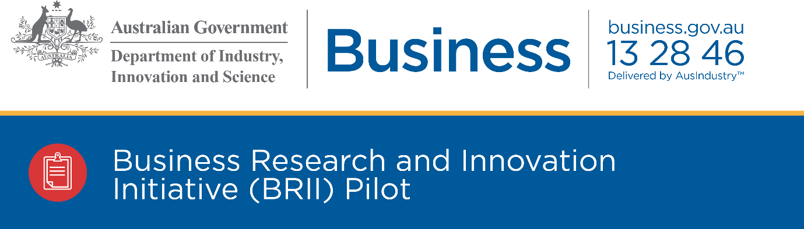

The program drives innovation within both small and medium enterprises (SMEs) and government by offering competitive grants to encourage SMEs to develop innovative solutions to public policy and service delivery challenges nominated by Government.

Why is BRII important?
BRII will help the Australian Government to tap into leading edge thinking and find innovative solutions to important challenges in public policy and develop new ways to deliver government services.

SMEs can apply for funding to create innovative products and services. Businesses will retain their intellectual property and the right to commercialise the ideas in Australia or overseas.

This critical early stage financial support to SMEs will help them test their new ideas, and provide a path to market through developing a track record.

BRII will also act as a catalyst for SMEs with Government as a customer, thereby driving employment and economic growth.

How does BRII work?
The pilot program covers five challenges for which SMEs can develop solutions. These challenges were proposed by Australian Government agencies, recommended by Innovation and Science Australia and approved by the Minister. More detail on each of the challenges is available on business.gov.au/BRII.

SMEs can apply for a competitive grant to undertake a feasibility study on their proposed solution to a challenge. Following the completion of a feasibility study, grantees can apply for a further competitive grant for the development of a proof of concept.

Feasibility study projects must demonstrate the scientific, technical and commercial feasibility of the proposed solution to the challenge. Grants for feasibility studies are up to $100,000 and must be completed within three months.

Proof of concept projects involve undertaking activities to produce a working prototype or demonstration of the proposed solution. Grants for proof of concept projects are up to $1 million and must be completed within 18 months.

At the conclusion of the proof of concept, the Australian Government agency that proposed the challenge has the option to negotiate the purchase of the solution, but is under no obligation to do so. Any purchase of the solution will be subject to negotiation between the agency and the solution provider.

What are the five challenges?
The five challenges are:
- Fast and secure digital identity verification for people experiencing domestic violence (Department of Human Services)
- Intelligent data to transform tourism service delivery (Austrade)
- Uplifting government capability to help deliver world-leading digital services (Digital Transformation Agency)
- Managing the risks of hitchhiking pests and contaminants on shipping containers (Department of Agriculture and Water Resources)
- Automating complex determinations for Australian Government information (National Archives of Australia).

Who can apply?
At a minimum, you must:
- have an Australian Business Number (ABN)
and be one of the following entities:
- a company, incorporated in Australia
- an incorporated trustee on behalf of a trust
- an individual or partnership, provided you agree to form a company incorporated in Australia to enter into a grant agreement.
and
- have a turnover of less than $20 million for each of the last three years. This includes the turnover of any related bodies corporate. If an Australian university or public sector research organisation controls your company, your turnover must be less than $20 million for each of the last three years. Newly established companies are welcome to apply.

You are not eligible to apply if you are:
- an income tax exempt corporation.
- an individual or partnership (however, an individual or partnership may apply if they agree to form an eligible corporation before signing a grant agreement)
- a trust (however, a corporation that is a corporate trustee may apply on behalf of a trust).
- a Commonwealth, state or local government agency or body (including government business enterprises).

Joint applications are acceptable, provided you have a lead applicant who is the main driver of the project and is eligible to apply.

How do I apply?
Prior to applying, you should read the BRII grant opportunity guidelines, online application form and grant agreement.

You can only submit an application during a funding round. The opening and closing dates for each round are published on business.gov.au/BRII.

- To apply, you must complete the relevant online BRII application form
- provide all the information that is needed for us to assess your application
- address all eligibility and merit criteria, ensuring each requirement has been considered
- ensure all mandatory attachments are included.

More information on the application process, forms and attachments to include are available on business.gov.au/BRII.

Need more information?
Visit business.gov.au/BRII or call 13 28 46.

