Regional Jobs and Investment Packages
Regional Tasmania
Local Investment Plan
June 2017

Table of Contents
1 Foreword 3
2 Introduction 5
3 Regional overview and analysis 6
3.1 Regional overview 6
3.2 Analysis 9
4 Investment sectors and strategic priorities (alphabetical order) 11
4.1 Investment Sector: Antarctic & Southern Ocean 11
4.2 Investment Sector: Community Sector 12
4.3 Investment Sector: Cultural and Creative Industries 13
4.4 Investment Sector: Defence 14
4.5 Investment Sector: Education 15
4.6 Investment Sector: Food and Agri-business 16
4.7 Investment Sector: Information & Communication Technology 18
4.8 Investment Sector: Manufacturing 19
4.9 Investment Sector: Visitor Economy 20

Foreword
The Local Investment Plan identifies investment sectors and strategic priorities that create sustainable industries and jobs into the future. The plan provides an economic and strategic overview of the region based on an assessment of the region’s competitive advantages and potential areas of growth.
Funding under the programme will reflect the investment sectors and strategic priorities set out in the plan. Investment sectors reflect broad industry areas that have the greatest potential to drive economic growth and create jobs in the region.
Strategic priorities are nominated for each investment sector. These priorities target specific activities within the sector that can unlock new markets and create opportunities in the region.
Applications for Regional Jobs and Investment Packages (RJIP) funding in the region should align with one or more of the strategic priorities outlined in the plan. The first RJIP merit criterion asks applicants to demonstrate the linkages between their project and the region’s plan.
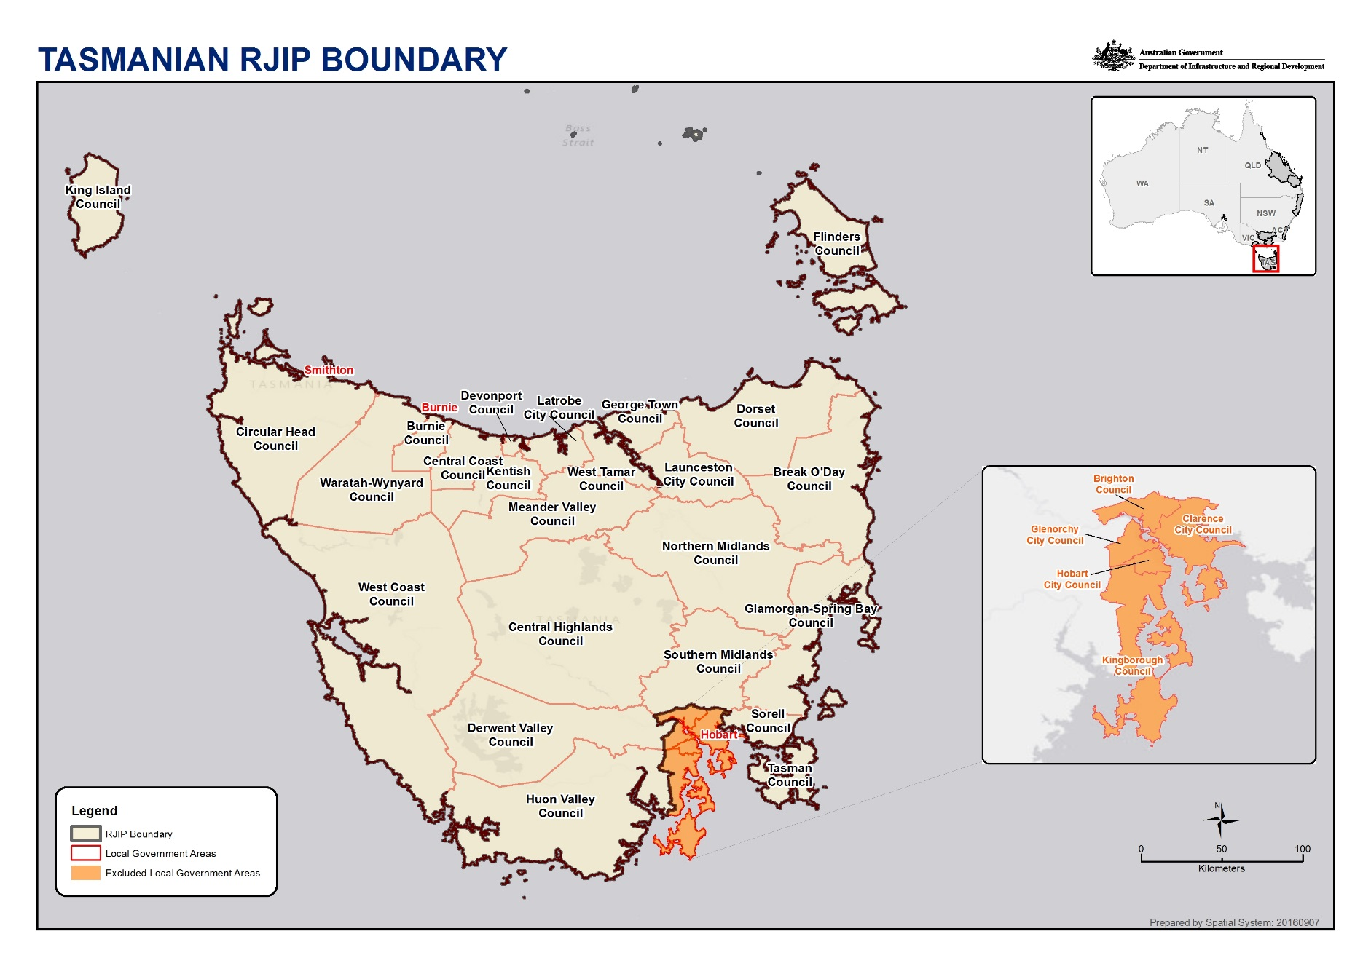

Introduction
The Regional Tasmania Local Planning Committee was appointed by Senator Fiona Nash in April 2017 to produce this Local Investment Plan to support the delivery of the $25 million Regional Tasmania Jobs and Investment Package.
The members of the Local Planning Committee were:

Tom Black (Chair)
Melinda Anderson
Natalie Geard
Robert Higgins
Stephanie Jaensch
Emma Lee
Susan Parr
Peter Skillern
Ian Waller
The Local Planning Committee met on Tuesday 16th May 2017, Monday 22nd May 2017, Tuesday 30th May 2017 and Wednesday 14th June 2017.
The Committee considered information from:

Advanced Manufacturing Growth Centre
Arts Tasmania
Australian Antarctic Division
Australian Bureau of Statistics (ABS)
Australian Computer Society
Australian Institute of Health and Welfare
Brand Tasmania Council
Centre for Food Innovation
Cradle Coast Authority
Dairy Tasmania
Department of Defence
Department of Employment
Department of Infrastructure & Regional Development
Department of Primary Industries, Parks, Water & Environment (DPIPWE)
Department of State Growth
Department of Treasury & Finance
Destination Southern Tasmania
East Coast Regional Tourism
.id the population experts
Launceston City Deal
Northern Tasmanian Development Corporation
Regional Development Australia (RDA) Tasmania Renew Newcastle
SGS Economics & Planning
South East Regional Development Authority
(SERDA)
Tas Council of Social Services (TasCOSS) TasICT
Tasmanian Chamber of Commerce and Industry (TCCI)
Tasmanian Climate Change Office
Tasmanian Farmers & Graziers Association
(TFGA)
Tasmanian Fruit and Vegetable Industry Taskforce Tasmanian Institute of Agriculture (TIA) Tasmanian Polar Network
Tasmanian Red Meat Industry Council
Tourism Industry Council Tasmania (TICT) Tourism Northern Tasmania
Tourism Tasmania
University of Tasmania (UTAS)
Victoria State Government
Volunteering Tasmania
Wine Tasmania
The Local Planning Committee acknowledges the invaluable assistance of:
James McCormack, Employment Facilitator, Department of Employment; Lara Hendriks, Senior Director, Department of State Growth;
Michelle Riley, Senior Project Manager, Department of State Growth; Kevin Turner, Community & Strategic Development, RDA Tasmania; Leaha Dent, Regional Manager, AusIndustry.

Regional overview and analysis
Tasmania is Australia's only island state. It has a cool temperate climate and decentralised population. Tasmania has less than one per cent of Australia’s total land area, but captures almost 12 per cent of the nation’s total annual water run-off.
The Regional Tasmania Regional Jobs and Investment Package region (Regional Tasmania) includes all Tasmanian Local Government Areas (LGAs) except for Brighton City Council, Clarence City Council, Glenorchy City Council, Hobart City Council and Kingborough Council.

Regional overview

Socio-economic profile
In 2012, the Regional Tasmania RJIP region had a population of 312,600 with a projected annual average growth rate of 0.3 per cent, slower than the Tasmanian rate 0.4 per cent and the Australian rate 1.6 per cent.
Aboriginals and Torres Strait Islanders accounted for 13,334 of the Regional Tasmania RJIP region population in the 2011 Census. At 4.25 per cent of the region’s population, this is higher than the national average of 2.5 per cent. The median age of the total Tasmanian population is 40, but for Indigenous people in Tasmania it is 22 years old.
Tasmania is characterised by an ageing population, a decreasing number of working age people, under representation of women of child-bearing age, and relatively low income, training and employment levels. Tasmania has some of the lowest levels of literacy and post compulsory education attainment in Australia.
People living in Regional Tasmania are on average older, have less formal education, are less likely to be in paid employment and earn less, than people living in or close to Hobart.
To illustrate how these factors impact the Tasmanian economy, the Gross State Product is lower in Tasmania (per capita) than the mainland average by a significant margin of $18,600 or 27 per cent.

Industry profile
In the year to June 2016 Tasmania’s largest export commodity category by value was processed metals and metal products (refer Figure 1), reflecting the substantial economic activity generated by Tasmania’s traditional heavy industries at Bell Bay and other locations.
Fig. 1 Latest export commodities categories
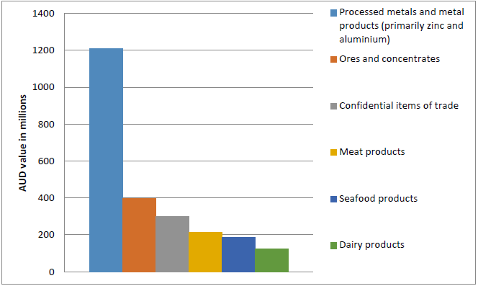
Tasmania’s major service export is the Visitor Economy (incorporating tourism, visiting friends and relatives and visitation for business, education, sport, recreation and events). Its direct contribution to Tasmania’s Gross State Product was $1.7 billion in 2014/15.
Tourism, manufacturing, agriculture, forestry and fishing are considered to be Regional Tasmania’s traditional industries supporting employment and wealth generation, although susceptible to cyclical patterns brought on by global market factors.
Sectors with the largest projected job creation outside of Greater Hobart by 2020 are:
- Health Care & Social Assistance: 2,200 jobs
- Accommodation and Food Services (Tourism): 1,500 jobs
- Construction: 800 jobs
- Retail Trade: 400 jobs
- Agriculture, Forestry and Fishing: 400 jobs
The largest current employers in Regional Tasmania are Health Care & Social Assistance, Retail Trade and Manufacturing (refer Figure 2).
Fig 2. Industries by gross value added & employment
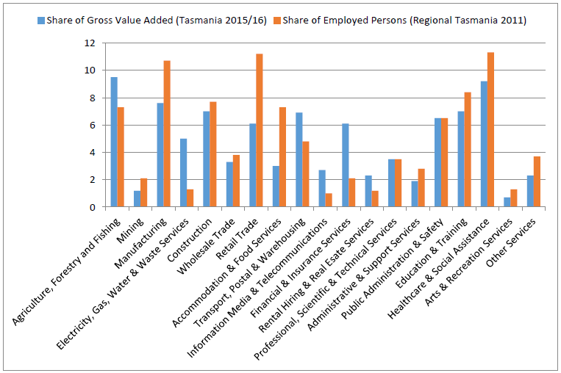
Source: ABS, Census of Population and Housing 2006 and 2011. Compiled and presented by .id , the population experts. (Usual residence data). Source: Australian National Accounts: State Accounts, ABS Cat No 5220.0: Table 7

Access to markets
Tasmania has an export oriented economy. Air and sea access is an integral part of Tasmania’s island life; therefore essential to trade, tourism and the broader economy. More than 99 per cent of freight volumes move in and out by sea making ports central to accessing markets. For the year ending March 2016, 88 per cent of all visitors to Tasmania travelled by scheduled air services and 12 per cent travelled by sea.

Tasmania’s brand and comparative advantages
Tasmania’s brand reflects the State’s unique mix of economic, cultural, community and environmental attributes. It is a core differentiator for Tasmania’s value-added products and services and is increasing in importance. The concepts of quality and authenticity are key values underpinning the Tasmanian Brand across all sectors. Many successful Tasmanian businesses of various sizes have understood this and have made it their policy for decades.
Comparative advantages are endowments and attributes that allow Regional Tasmania economy to do something better than somewhere else.
Tasmania’s environment (climate, high rainfall and biodiversity) is a comparative advantage that supports tourism, food and agri-business, renewable energy, science and research. Business successes based on this comparative advantage vary from the hydro scheme and energy intensive industries to Tasmanian whisky, sparkling wine and multi-day walks.
Tasmania’s society is another comparative advantage. Tasmania has high levels of social and professional connectivity that encourages collaboration and innovation. Business successes based on this comparative advantage include established industry clusters for: mining equipment, metal processing, Antarctic research, ship building, poppies, salmon and wine.
Tasmania’s isolation provides a biosecurity buffer which has proven important for international trade. Tasmania’s location has also made it an important gateway to Antarctica and the Southern Ocean.

Analysis
Analysis of Regional Tasmania’s economy by the Local Planning Committee identified the following principles and themes:

Principles central to Regional Tasmania
These principles will underlie jobs and growth for Regional Tasmania:
- Education; education is the most profitable investment a community can make
- Cross sectoral benefits; infrastructure projects in Regional Tasmania should act as the catalyst for growth of local industries (e.g. affordable energy, digital connectivity, efficient transport and logistics)
- Collaboration; investment sector stakeholders must work collectively to achieve economies of scale and supply chain efficiencies
- Wealth generation; investment strategies must be customised to profit through trade with off-island markets
- Prepare for structural change; changes from climate and the impacts of global trade are processes that can be managed
- Competitive neutrality; the creation of new jobs, rather than jobs that displace another worker, is a win for Regional Tasmania

Regional Tasmania Regional Jobs and Investment Package themes
This Package presents an opportunity to create sustainable employment and unlock investment in key sectors across Regional Tasmania.
Characteristics identified for success:
- Game Changers; transformative projects based on smart planning, leveraging investment by industry and government with the support of the local community
- Tasmania’s Brand; promote premium offerings that are distinctly Tasmanian and build on our comparative advantages
- Value Adding; gain the benefits of higher value operations domestically
- Productivity; achieve a competitive edge through efficiency measures and implementing new skills and technologies
- Sustainability; develop new profit centres to diversify and build on core business
- Export Goods and Services; maximise Free Trade Agreements, the extension to the Tasmanian Freight Equalisation Scheme, direct international shipping, our bio-security status, investment in local infrastructure and growing brand recognition
- Innovation; introduce new systems and processes that transfer smart practices into new settings and environments
- Energy; use local natural resources to provide electricity and heat to Regional Tasmanian industries

Investment sectors and strategic priorities (alphabetical order)
Analysing Regional Tasmania’s attributes the Local Planning Committee determined that the following industry sectors have the greatest potential to create sustainable employment, unlock further investment and reach new markets:
- Antarctic & Southern Ocean
- Community Sector
- Cultural & Creative Industries
- Defence
- Education
- Food & Agri-business
- Information and Communication Technology
- Manufacturing
- Visitor Economy

Investment Sector: Antarctic & Southern Ocean

Evidence
Tasmania is the centre for Australia’s research effort in Antarctica, the sub-Antarctic islands and Southern Ocean. Spending by this sector in 2015/16 comprised of $180.6 million, or 0.69 per cent of Gross State Product. The Antarctic and Southern Ocean (ASO) sector is a major employer; in 2015/16 it employed 755 full-time equivalents, up from 671 in 2011/12.
The ASO sector is forecast to expand over the next five years as a result of investment spending by the Australian Government, with consequent flow-on to Tasmanian activity. The Tasmanian Polar Network Member Directory shows manufacturers from north west Tasmania are already engaged in supplying specialised design, engineering, prefabricated buildings and structures.
Several developments indicate an increase in ASO activity over the next five years:
- Commissioning larger and more complex ships based in Hobart providing greater scope for more maintenance and provedoring work
- More port visits by international ASO programs
- Runway extension at Hobart International Airport, with the possible construction of a year-round runway in East Antarctica
- Investment in the refurbishment of Macquarie Island and upgrades to overland traverse capability providing opportunities for participation by Regional Tasmanian firms.
Applicants applying under this sector will need to demonstrate that projects will directly benefit the nominated Regional Tasmania RJIP region.

Strategic priorities
Improving business capability to deliver services and products to support the Antarctic and Southern Ocean sector
Commercialisation of creative new services and products for the Antarctic and Southern Ocean sector
Evidence
The Tasmanian Polar Network (TPN) is a group of businesses and scientific organisations based in Tasmania that all have a common focus on serving commercial and scientific activity in the Antarctic, sub-Antarctic and Southern Ocean. TPN’s Member Directory includes businesses from across Regional Tasmania that support the ASO sector.
The Australian Antarctic Strategy and 20 Year Action Plan highlights the long history of Australia in the Antarctic, the range of opportunities for Australia in supporting ASO endeavours and the significant investments by Australia to support our ongoing presence in the Antarctic.

Investment Sector: Community Sector

Evidence
“Tasmanians are the unhealthiest, oldest, worst educated, most under-employed and most dependent on government benefits. Consider, what could be achieved if we saw these ‘deficits’ as challenges and opportunities” Susan Parr, Tasmania Report 2016
Social enterprises, Aboriginal community organisations and local government are key enablers of community and economic development in Regional Tasmania by addressing social issues, closing the gap in disadvantage between Aboriginal Tasmanians and the wider community, and improving productivity, economic participation and population levels.
The Health Care and Social Services Sector is Regional Tasmania’s largest employer. An additional 2,200 new jobs are forecast for this sector by 2020, with much of this growth anticipated to be in aged care due to Regional Tasmania’s rapidly ageing population or in disability services due to the National Disability Insurance Scheme.
The Community Sector is also heavily supported by volunteers, with approximately four out of five Tasmanians volunteering in 2014.
Paid and voluntary participation in the Community Sector is an important part of Regional Tasmania. Community innovation can meet local needs with local services and facilities and also support Regional Tasmanians to become industry leaders in the delivery of community services.
Regional Tasmania’s ‘deficits’ will not improve without investment into the Community Sector for innovative projects that create new processes or introduce successful processes from other sectors.
Creating liveable communities is a pillar of the Tasmanian Government’s Population Growth Strategy in recognition that vibrant and supportive communities attract and retain people. Factors that determine liveability include local infrastructure and access to services.

Strategic priorities
Job creation by local services and facilities to create liveable and vibrant communities and/or reduce, avoid and mitigate determinants that create Regional Tasmania’s poor socio-economic trends
Align to regional infrastructure or workforce plans and can demonstrate they are part of a collective approach to overcoming regional issues
Liveability projects that nurture and/or stimulate local communities
Evidence
Examples of the Community Sector meeting local needs in Regional Tasmania include the not-for-profit Emmerton Park aged care facility in Smithton and public and private projects like the Windsor Park Community Precinct in West Tamar.
Devonport’s Living City and the tactical prioritisation of infrastructure projects by South East Regional Development Authority (SERDA) are examples of local government collaborating with the private and community sectors to improve liveability.

Investment Sector: Cultural and Creative Industries

Evidence
Recent major film and television productions have boosted Tasmania’s capability and reputation for the cultural and creative industries. MONA and the increase in cultural and creative events have created more professional opportunities in this sector and raised awareness of career pathways in cultural and creative industries.
Creativity and design are at the forefront of a rapidly changing world and as a result are more valued by individuals, society and employers than previously. Creative workers play an important role in driving economic, social and cultural development.
More than 9,000 Tasmanians are directly employed in the cultural and creative industries or in cultural and creative occupations, with countless more employed indirectly through the related tourism, hospitality and retail sectors.
Creative industries account for 3.6 per cent of employment in Tasmanian. While this share is relatively low compared to Australia as a whole (4.4 per cent), Tasmania boasts the highest share of specialists (33 per cent compared to 28 per cent nationwide), or people with creative professions working within creative industries.
Industry segments include; advertising, architecture, visual arts, crafts, design (including fashion), film, video and photography, music and performing arts, festivals, museums and galleries, writing and publishing, digital and entertainment media, TV and radio.
Opportunities for economic participation by Aboriginal Tasmanians would be supported by programs and activities that recognise and support traditional and contemporary Aboriginal arts and culture.

Strategic priorities
Industry development that supports businesses to build and meet national and international demand for Tasmanian cultural and creative goods and services
Place based projects such as film locations
Projects that embed creativity and design into other investment sectors to grow demand for their goods and services
Evidence
Filming The Kettering Incident in Tasmania resulted in a $6 million spend in the state, employing 110 cast and crew. Rosehaven has been picked up for a second series including broadcast to the USA. The Light Between Oceans, The Hunter and other internationally successful productions made strong use of Regional Tasmanian locations.
The Renew Newcastle project placed cultural and creative industries into the Newcastle CBD; for every $1 invested in the project it generated $14 in economic benefit for the city.
Cultural and creative industries have strong linkages with other sectors in the economy and investments generate important flow-on effects in the economy. The production induced and consumer induced effects of direct investments in creative industries are relatively high compared to other industries.

Investment Sector: Defence

Evidence
The Australian Government’s commitment to invest $195 billion into defence capability from 2016 to 2026 is Australia’s largest ever defence spend and presents a significant opportunity for Regional Tasmania.
Key areas of opportunity include maritime systems manufacturing, repair and maintenance; land systems repair and maintenance; and maritime skilling.
There are twenty six Tasmanian businesses holding defence or national security related contracts supporting some 1,950 jobs and generating $340 million turnover a year. For most of these enterprises the defence sector is just one customer and represents less than 20 per cent of turnover, demonstrating considerable opportunity in this sector.
As well as the opportunity presented domestically, several Tasmanian businesses supply defence equipment, innovation, intellectual property and support to defence forces globally. For example, maritime simulators for the Singapore Navy.
Tasmania is home to the Australian Maritime College (AMC), a world class training and research institute with close ties to the Navy.

Strategic priorities
Increase involvement and integration into the supply chain for the Defence sector
Improve business capability and productivity where there is a direct link to providing an essential strategic advantage by being located in Australia
Evidence
The Australian Department of Defence’s Defence White Paper 2016 outlines the government’s $195 billion investment in Australia’s defence capability over ten years. The opportunities for Tasmanian businesses to support the defence supply chain range in scale and type and can potentially provide long term opportunities for local businesses to diversify and expand their off-island markets.
Of particular interest is the Naval Ship Building Plan which could draw on Tasmania’s strong capabilities in maritime manufacturing and expertise in training.
The Tasmanian Government Defence Strategy recognises defence as a significant growth opportunity for the State and the opportunity for businesses to access this growing market, both nationally and internationally and increase their capability to be defence ready.

Investment Sector: Education

Evidence
“The single most important thing that needs to be done in order to improve Tasmania’s material living standards relative to those of other Australians ..... is to increase the levels of educational participation and attainment.” Saul Eslake, The Tasmania Report 2016
Regional Tasmania has some of the lowest levels of literacy, educational attainment and labour productivity in the country.
The consequences of inadequate workforce literacy and numeracy include inability to comprehend standard operating procedures, poor completion of workplace documents, time and materials wastage through repeated work, financial miscalculations, workplace injuries and recruitment and training difficulties.
Industry workforce plans indicate that industry growth requires an expanded workforce with appropriate skills. Formal (e.g. apprenticeships, traineeships) and community supported education can help new labour sources into these growth opportunities.
A Tasmanian Aboriginal Registered Training Organisation has broadened educational attainment in the fields of health and land management. Tasmania has the highest percentage of Indigenous people studying at higher education levels of all the Australian states and the Northern Territory.
An investment opportunity for the Education sector is to develop projects that find more effective ways to engage the Regional Tasmania community in learning.
Additional opportunities for the Education sector comes from location-based projects to enhance the student experience by addressing barriers to integrating learning with work and civic activities. In Victoria they have taken this approach to International Education which now creates one job for every four international students.

Strategic priorities
Improve aspirations for and engagement in post-compulsory education
Support enterprises to grow essential business skills
Enhance the student experience (accommodation, transport, civic and cultural participation, finding work and being entrepreneurial)
Address barriers to education
Evidence
Higher levels of educational participation and attainment won’t solve all Tasmania’s economic and social challenges – but they will make them less difficult to solve.
A good education is the grounding for a productive life. As well as teaching literacy, numeracy and interpersonal keys, education gives us the chance to learn how to learn and learn resilience when faced with difficulties.
The University of Tasmania’s project to deliver an education-driven revitalisation of Northern Tasmania will include an estimated 1,700 new international students living and studying in Launceston and Burnie. For Launceston, engineering and business have particularly high proportions of international students and by locating these in the CBD will become more attractive for international students. In Burnie, inadequate facilities have limited opportunities for international students but the new West Park site aims to address this.

Investment Sector: Food and Agri-business
(Incorporating agriculture, fisheries and downstream processing)

Evidence
“The Island of Tasmania is the new go to place for wonderful produce” Rick Stein, BBC’s A Cook Abroad, 2015.
In 2011, 14,890 people were employed in food and agri-business.
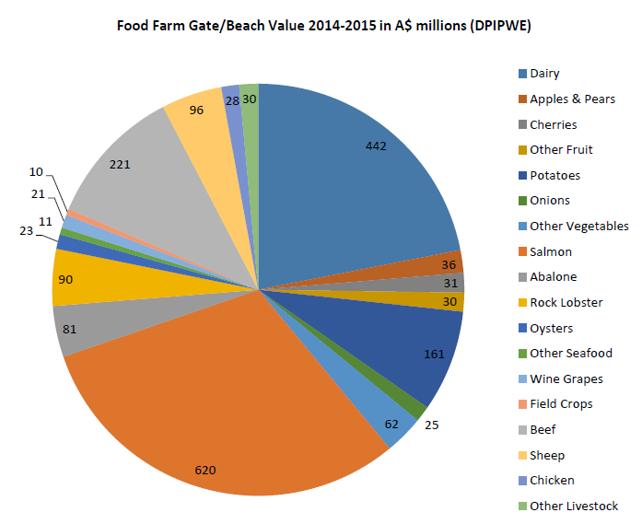
Tasmania has a strong agricultural tradition and the sector is highly diversified, underpinned by excellent growing conditions, affordable land, biosecurity control, abundant water resources and strong research and development capability.
Issues shared by all food and agriculture businesses are logistics, transport, market development, business development, labour force skills and regulatory compliance.
Three out of four Australian Dollars in food and agri-business are made post farm gate.
Aboriginal Tasmanians’ land and fisheries management help Aboriginal people to connect to country, while building economic opportunities, for example Murrayfield Station on North Bruny Island or in the Tasmanian Wilderness World Heritage Area.

Strategic priorities
Improve productivity through the adoption of new technologies and improved practices
Develop higher value operations in Tasmania for the agrifood value chain
Address workforce development through training, up-skilling and building awareness of career pathways
Build and penetrate off-island markets
Evidence
The competitiveness of Tasmania's food products is increasingly dependent on how efficiently and effectively we provide Australian and international consumers with superior value through our value chains. An agrifood value chain is a system of linked production, processing and marketing activities undertaken by businesses committed to efficiently delivering food products that respond to consumer needs.
The Tasmanian Government’s AgriVision 2050 Plan sets a strong target for growing the value of the agriculture sector in Tasmania tenfold to $10 billion per year by 2050.
Tasmania’s Agri-Food Plan identifies promotes projects and programs to help the food and agri-business sector to grow, make and protect (i.e. biosecurity).
Tasmanian Primary Industries Workforce Development Scan 2015-16 identified a diversity of career pathways into agriculture including pre-farm gate activities and post-farm gate opportunities, which include business and finance, logistics, marketing and research and development.

Investment Sector: Information & Communication Technology

Evidence
The number of full time ICT workers in Tasmania is approximately 4,380 and at least a further 1000 employed in non-ICT but related industries.
The sector is ideally placed to take advantage of opportunities arising nationally and internationally from next generation broadband and engagement in the digital economy.
Investment opportunities include:
- Industry applications of new technologies, for example remote sensing by rural industries.
- Design and manufacture of ICT products and components
- ICT infrastructure and services aligned to Regional Tasmania’s comparative advantages of climate, energy security and isolation, for example data storage centres.
The Tasmanian Government’s pilot of a new communications network called LoRaWAN (Long Range Wide Area Network) will begin in 2017 in the Greater Launceston area. The network is designed to transmit sensor data cost effectively and reliably. Early interest in using the network has come from the agricultural sector and from local government. Start-up and entrepreneurial activity is being supported through Enterprize and the Macquarie House Entrepreneurship and Innovation Hub.
Challenges for Tasmania include delays in access to the NBN and limitations of optical fibre links across Bass Strait.

Strategic priorities
Innovative projects that help grow Regional Tasmania’s industries
Enable digital connectivity for Regional Tasmania
Use of digital technologies to enhance the quality and performance of regional services
Build workforce capability to deliver innovative products and services, business management, marketing and entrepreneurship
Evidence
Tasmanian ICT Industry Strategic Plan identifies actions consistent with the above strategies as important to build the ICT industry in Tasmania.
Tasmanian Information and Communications Technology Workforce Plan 2015-2018 identifies the development of the ICT workforce as a strategic priority for Tasmania.

Investment Sector: Manufacturing

Evidence
‘Manufacturing has an important role to play as Australia looks to create a diverse, innovative and globally oriented economy. The nature of global manufacturing is changing in ways that provide positive opportunities for Australia, if we are bold enough to seize them.’ Advanced Manufacturing Growth Centre
Manufacturing plays an important role in Tasmania both through direct employment and supporting a strong supply chain. Manufacturing in Regional Tasmania is transitioning as processes become more advanced and technology is applied. There are over 1,600 manufacturing businesses in Tasmania and those in Regional Tasmania employ approximately 10,700 people. Established industry clusters exist for mining equipment, technology and services sector, the metal processing sector and the maritime sector.
Manufacturing also provides opportunities for support industries including design, engineering, technology, research and development as well as supporting innovation and operations in other sectors such as agriculture and aquaculture.
Recruitment of skilled workers is an issue for Regional Tasmania and success often relies on individuals developing multiple skills as they fill gaps in areas of expertise other than their own.

Strategic priorities
Improve productivity through the adoption of new technologies and improved practices
Create new and expanded off-island markets
Enable a workforce with skills that anticipate future workforce requirements including multi-trade workers and the integration of design and technology
Evidence
In May 2015, the Tasmanian Government hosted an Advanced Manufacturing Summit with over 160 industry and stakeholder participants. The above priorities align with the outcomes of the summit. The priorities also align with the Tasmanian Advanced Manufacturing Action Plan and the Commonwealth’s Advanced Manufacturing Growth Centre’s Sector Competitiveness Plan 2017.

Investment Sector: Visitor Economy

Evidence
Current data indicates the Visitor Economy sector is on a growth trajectory. Delivery of the T21 Visitor Economy Strategy is on track to bring 1.5 million visitors to Tasmania in 2021. In 2013, annual visitor numbers passed the 1 million mark for the first time. During the year ending December 2016 1.24 million visited Tasmania.
Compared with 2013, Tasmania in 2021 will have 50 per cent more visitors looking for accommodation, visiting attractions, browsing shops and eating out. With this growth comes opportunities but also challenges and it is essential that regional Tasmania can accommodate extra visitors and meet and exceed brand expectations.
The Visitor Economy direct contribution to Tasmania’s Gross State Product was $1.7 billion in 2014/15.
The T21 Visitor Economy Strategy is underpinned by Destination Management Plans, the Visitor Engagement Strategy and local Destination Action Plans and all contribute to growing tourism in Regional Tasmania.
Opportunities for economic participation by Aboriginal Tasmanians include, but are not limited to, tourism experiences that are Aboriginal owned, businesses where Aboriginal people and/or community benefit by gaining employment and income, and Aboriginal tourism experiences that provide consenting contact with Aboriginal people, cultural heritage or land.

Strategic priorities
Alignment with T21, the Visitor Engagement Strategy and/or Destination Action Plans
Develop signature experiences in Regional Tasmania to drive interest in Tasmania, stimulate visitor demand and encourage travel within the state
Build capability and capacity through tourism related infrastructure
Develop a high quality workforce for now and the future
Grow air and sea access to Regional Tasmania
Digital infrastructure that allows visitors to engage with places and connect to their online networks
Evidence
The Visitor Engagement Strategy provides an in-depth understanding of motivators to visit and return to Tasmania. It encourages projects that engage with new and existing markets, protect and communicate the Tasmanian brand, and develop industry collaboration.
The Tasmanian Tourism and Hospitality Industry Workforce Development Plan has identified labour and skills challenges.
The Destination Action Plan* (DAP) process will identify priority actions for key destinations.
*Finalised DAPS: Bruny Island, Central Coast, Circular Head, Flinders Island, George Town, Greater Hobart, King Island, Tamar River, Tasman, West Coast, Wynyard. In draft DAPS: Bicheno, Burnie, Central Highlands, Coal River, Derwent Valley, Devonport, Freycinet, Great Western Tiers/Meander Valley, Heritage Highway, Latrobe, Launceston, St Helens, Swansea, Triabunna

http://www.infrastructure.tas.gov.au/__data/assets/pdf_file/0004/48226/State_Infrastructure_Strategy_2010_Part2.pdf
National Aged Care Data Clearing House, Population Projections 2012 to 2027
ABS, Census 2011
RDA Tasmania, Regional Plan, 2016
ABS, Year 12 Achievement and Continuing Education (2071.0), April 2013
TCCI, Tasmania Report, 2016
TCCI, Tasmania Report, 2016
Department of State Growth, Value of Tasmania’s international exports by product, 2011-12 to 2015-16
Tourism Tasmania, Fast Facts, March 2017
Department of Treasury & Finance, Structural Change in the Tasmanian Economy Information Paper, April 2013
Australian Government, Labour Market Information Portal, 2016 Employment Projections
https://www.brandtasmania.com/about-tasmanias-brand/
Sir Douglas Copeland, first professor of economics at the University of Tasmania
Antarctic Climate & Ecosystems CRC, Climate Futures for Tasmania General Climate Impacts, October 2010
Wells, The contribution of the Antarctic and Southern Ocean Sector to the Tasmanian Economy 2015-16, 2017
TCCI & TasCOSS, Tasmania Report 2016, December 2016
ABS, Census 2011
Volunteering Tasmania, State of Volunteering Report 2014
Department of State Growth, Population Growth Strategy, September 2015
https://www.qut.edu.au/creative-industries/about/what-are-the-creative-industries
Tasmanian Government, Cultural and Creative Industries Strategy, December 2015
SGS Economics & Planning, Valuing Creative Industries in Tasmania
Department of State Growth, Cultural and Craetive Industrues Sector Summary 2014
Tasmanian Government, Cultural and Creative Industries Strategy, December 2015
Flanagan & Mitchell, An Economic Evaluation of the Renew Newcastle Project, December 2016
www.sgsep.com.au/publications/valuing-creative-industries-tasmania
Department of Defence, Defence White Paper, 2016
Department of Defence, Naval Ship Building Plan, 2017
Department of State Growth, Our Fair Share of Defence, March 2016
Ai Group, National Workforce Literacy Project, 2010
www.skills.tas.gov.au/employersindustry/workforceplans
Tasmanian Aboriginal Centre, TAC Strategic Plan 2014-2017, March 2014
Indigenous Land Corporation, Tasmania 201-2017 Regional Indigenous Land Strategy
International Education Sector Strategy, Victoria State Government, March 2016
Eslake, The Tasmania Report 2016
RDA Tasmania, What Tasmania Needs From Education, October 2014
University of Tasmania, Education Driven Revitalisation of Northern Tasmania, March 2016
AgriGrowth Tasmania, Tasmania’s Sustainable Agri-Food Plan 2016-2018
Professor Stanley, “Consumer Trends and Insights event” Friday 12th May 2017
Indigenous Land Corporation, Tasmania 2013-2017 Regional Indigenous Land Strategy
Department of Premier and Cabinet, Resetting the Relationship with the Tasmanian Aboriginal Community, January 2017
Tasmanian Institute of Agriculture, Strategic Plan, June 2016
AgriGrowth Tasmania, Tasmania’s Sustainable Agri-Food Plan 2016-2018
Tasmanian Farmers & Graziers, Tasmanian Primary Industries Workforce Development Scan 2015-16
Australian Computer Society and Centre for Innovative Industries Economic Research, 2013
Office of the Coordinator-General, Data Centre Action Strategy
Launceston City Deal, April 2017
TASICT, Tasmanian ICT Industry Strategic Plan, December 2012
TASICT, Tasmanian Information and Communications Technology Workforce Plan 2015 – 2018, April 2015
Page 8, Advanced Manufacturing Growth Centre’s Sector Competitiveness Plan 2017
Department of State Growth, Manufacturing in Tasmania, June 2016
ABS, Census 2011
Tourism Tasmania, Tourism Fast Facts, March 2017
Tourism Tasmania, Fast Facts, March 2017
Department of Premier and Cabinet, Aboriginal Tourism Development Plan for Tasmania, May 2007
Department of State Growth, Tasmanian Visitor Engagement Strategy, October 2016
Tasmanian Tourism and Hospitality Industry Workforce Development Plan, November 2016

