Right Click Capital – making investment ‘sweeter’
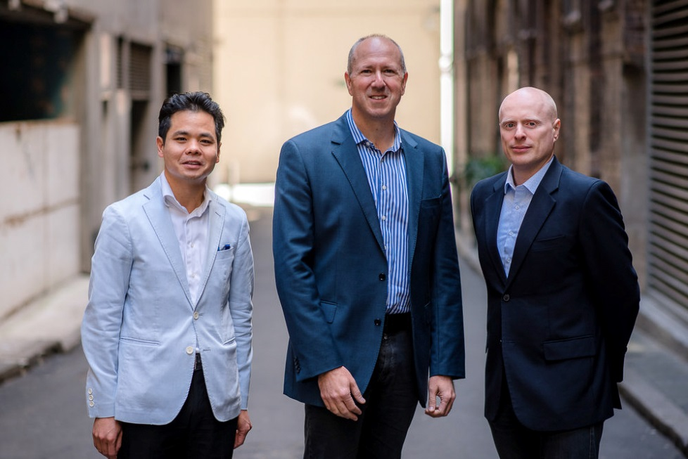
Right Click Capital partners (left to right): Benjamin Chong, Garry Visontay and Ari Klinger
Investment fund manager Benjamin Chong says Australia’s venture capital arrangements are encouraging more people to consider investing in high-potential, early stage Australian companies.
Mr Chong, one of three partners at venture capital firm Right Click Capital, says a 10 per cent tax offset introduced in 2016, for people investing through early stage venture capital limited partnerships (ESVCLPs) is ‘sweetening’ investment opportunities and attracting new investors.
“Investors can also receive capital gains tax free status for complying investments made through ESVCLPs, making it a very attractive asset class for investors,” he says. “The tax measures allow new investors to put their toe in the water on a very favourable basis.”
In 2016, the venture capital arrangements were also changed to allow venture capital funds to provide more support to innovative companies for longer.
The changes raised the investment ESVCLP funds can make, from $100 to $200 million, and mean funds no longer need to divest companies once their value exceeds $250 million.
“Becoming a larger fund, making larger investments, allows us to better support more emerging companies,” Mr Chong says. “And not having to divest companies that reach a value of $250 million means we are not forced to sell our stake in a business prematurely … it’s a very helpful measure.”

Encouraging investment in early stage companies
Right Click Capital backs Australian internet tech start-ups that have the potential to go global. Its investors include high net wealth individuals, family offices and superannuation funds.
“Our fund not only provides money, we also add value, spending time with founders to help them with their company strategy and operation, helping them work out how to expand or best export to international markets,” Mr Chong says.
Right Click Capital’s backing has nurtured the success of several high-profile Australian companies, including hipages, which connects consumers and tradespeople in an online marketplace.
“We've been the key investor in that business over the last couple of years and have seen it grow to be Australia’s largest home services marketplace,” Mr Chong says.
"We’re also very excited to be an early investor in 8i, a 3D imaging and virtual reality start-up, that allows customers to create 3D images and 3D holograms, and which recently scored a $25 million investment from Time Warner.”
Mr Chong says it is rewarding to be part of the growth of these dynamic Australian companies.
“They not only create direct jobs and revenue, they also have a spill-over effect and create jobs and growth in other parts of our economy,” he says.
Australian Government venture capital programs work with private venture capital fund managers to provide capital and professional expertise to innovative Australian companies.
Visit the Right Click Capital website.

