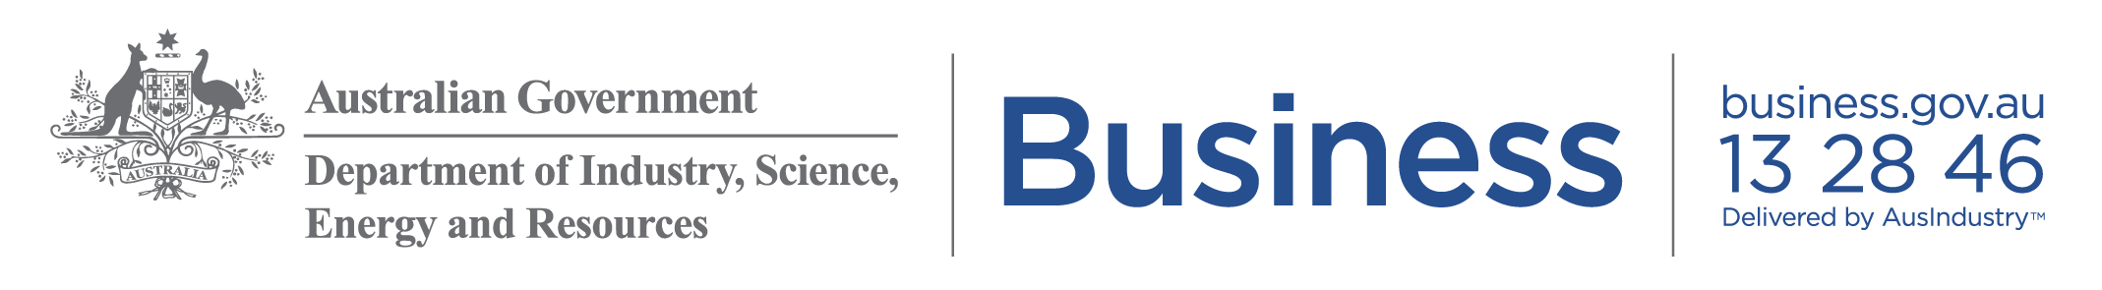

Marketing kit for small business advisers

Suggested social media posts
You can use these suggested social media posts to share the mental health, financial and business advisory support available to small businesses.

Hashtags: #SmallBizAU #COVID19 #inthistogether #smallbusiness

Topic: Workplace health and safety
A national three step plan will guide states and territories on relaxing coronavirus restrictions. Check your state or territory information for local advice. Safe Work Australia has industry specific guidance to help you operate your business safely: https://www.safeworkaustralia.gov.au/covid-19-information-workplaces

Topic: Mental wellbeing
Looking after your wellbeing is not only good for you, it’s good for your business. If you are feeling worried or you’re not sure where you can get help, visit business.gov.au for information to support you and your business: https://www.business.gov.au/risk-management/emergency-management/coronavirus-information-and-support-for-business/coronavirus-and-mental-health

Topic: Government Stimulus Package
There is financial support to help your small business. For a breakdown on the Government assistance and how to apply, visit business.gov.au: https://www.business.gov.au/risk-management/emergency-management/coronavirus-information-and-support-for-business/government-assistance-for-business

Topic: Looking after staff
If you need help to look after your staff through coronavirus, you can find information on the JobKeeper payment and other financial support at business.gov.au: https://www.business.gov.au/risk-management/emergency-management/coronavirus-information-and-support-for-business/support-available-for-employers

Topic: Business continuity planning
business.gov.au has advice for positive steps you can take to keep your business going. There’s help to review your finances, market your business and create a business continuity plan: https://www.business.gov.au/risk-management/emergency-management/coronavirus-information-and-support-for-business/continuing-your-business

Topic: Business advice
If your business has been affected by coronavirus, you can speak to a business adviser for free, or at a low cost, to make a plan. They can help you take your business online, boost cash flow, manage your staff and much more. Find an adviser near you on business.gov.au https://www.business.gov.au/Expertise-and-Advice/Australian-Small-Business-Advisory-Services-ASBAS-Digital-Solutions

Images
Download the following images to support your posts: https://business.gov.au/risk-management/emergency-management/coronavirus-information-and-support-for-business/supporting-small-businesses-during-coronavirus

Mental health  Business advice | Financial support

