Automotive Engineering
Graduate Program
Knowledge Priorities

Introduction
A set of Australian Automotive Technology maps has been produced, identifying nine knowledge area priorities. Alignment with priority areas serve as a selection criterion for funding applications in the Automotive Engineering Graduate Program.

Table of Contents
Nine high-level prioritised knowledge areas…………………..Page 3
Connected, Automated, shared vehicle……….………………Page 4
Electrified Vehicle……………………………….……………….Page 5
Electronics and Electrics…………………………….……….....Page 6
Fuel cell and hydrogen………………………….………..……..Page 7
Electric energy storage………………………………...………..Page 8
Policy and company decision making……….…………….......Page 9
Functional materials………………………..………..…………..Page 10
Automotive safety…………………………………..…..………..Page 11
Thermal propulsion…………………………………...…..……..Page 12

Figure 1 – The program’s nine high-level prioritised knowledge areas

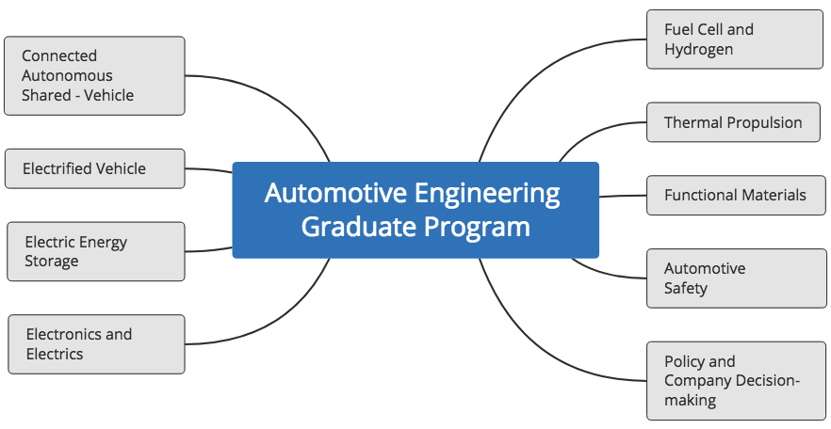

Figure 2 – Knowledge area “Connected, Automated, Shared Vehicle” and next level prioritised knowledge area

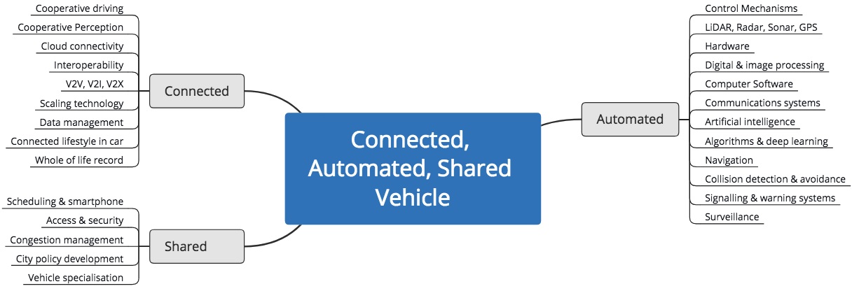

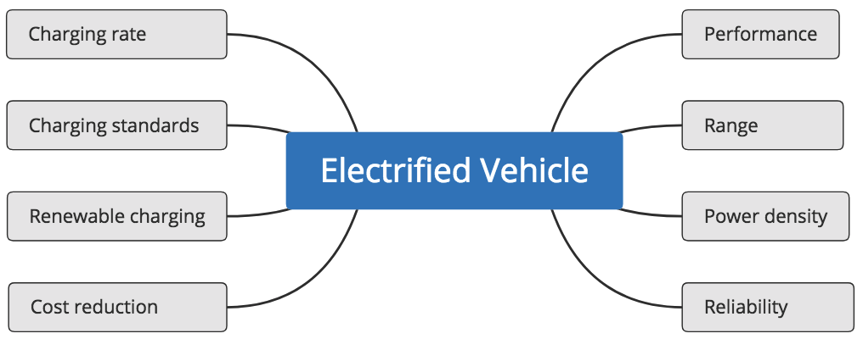
Figure 3 – Knowledge area “Electrified Vehicle” and next level prioritised knowledge areas

Figure 4 – Knowledge area “Electronics and Electrics” and next level prioritised knowledge areas

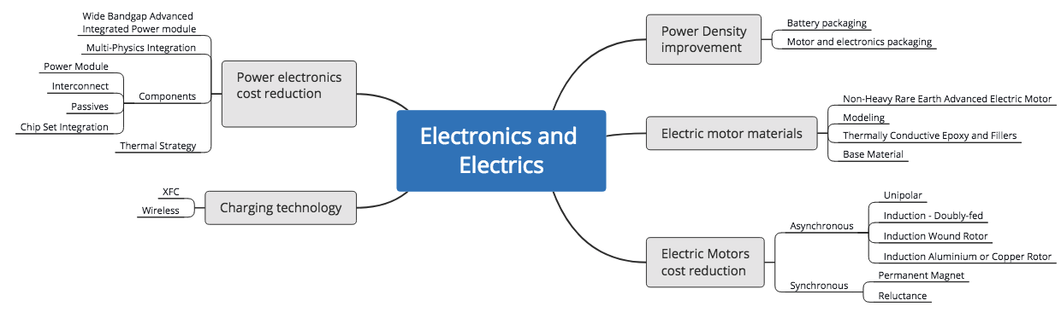

Figure 5 – Knowledge area “Fuel Cell and Hydrogen” and next level prioritised knowledge areas

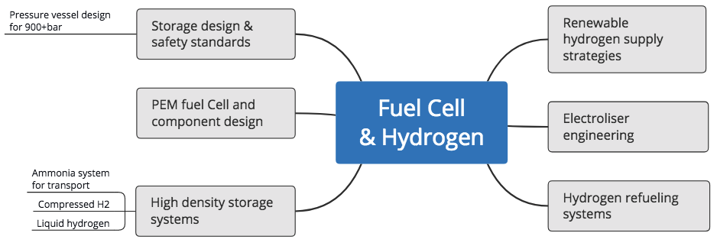

Figure 6 – Knowledge area “Electric Energy Storage” and next level prioritised knowledge areas

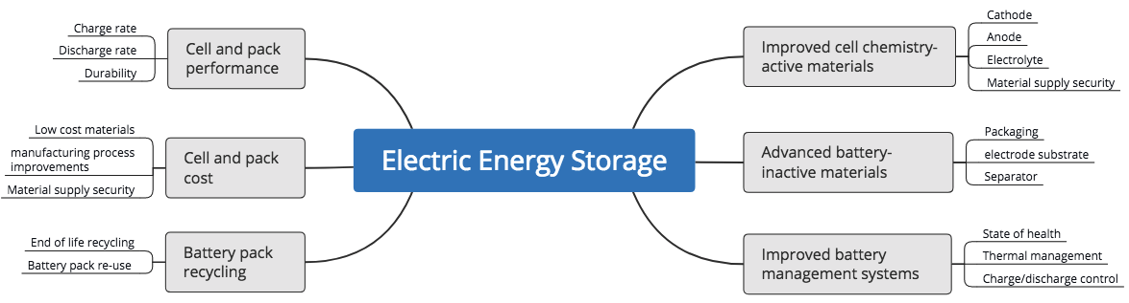

Figure 7 – Knowledge area “Policy and Company Decision Making” and next level prioritised knowledge areas.

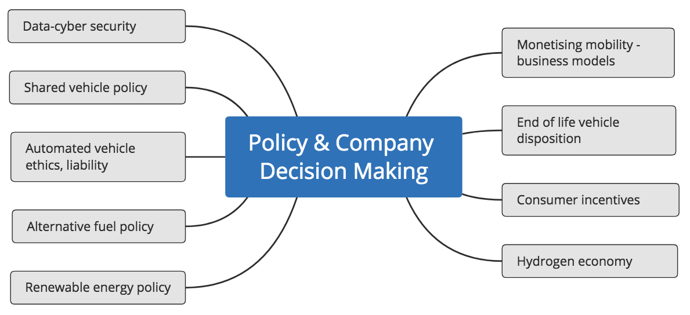

Figure 8 - Knowledge area - “Functional Materials” and next level prioritised knowledge areas.
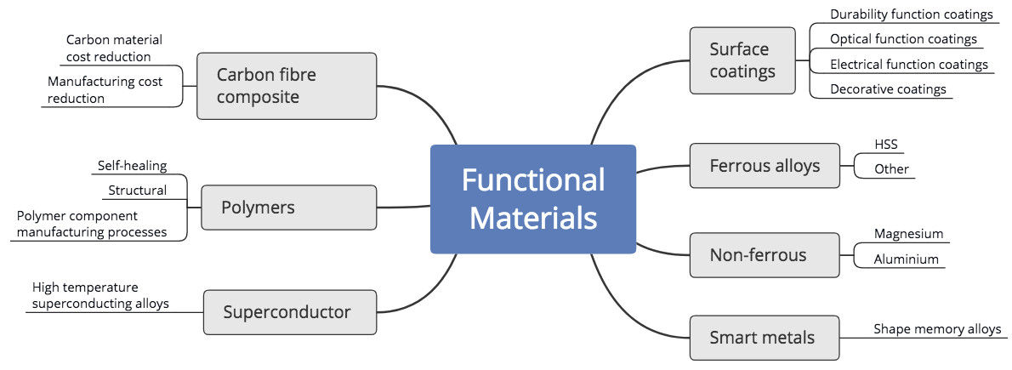

Figure 9 - Knowledge area - “Automotive Safety” and next level prioritised knowledge areas

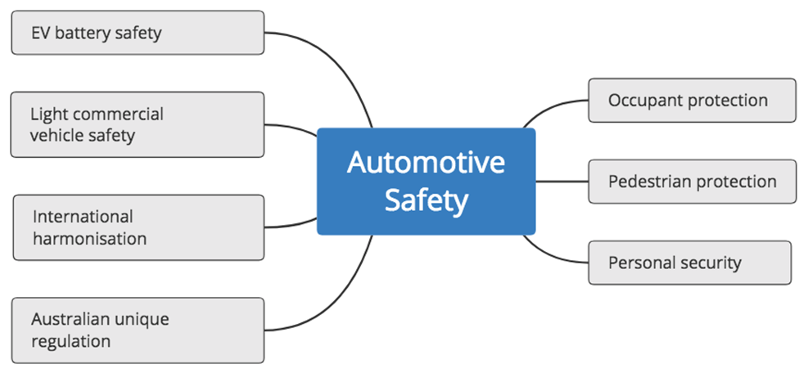

Figure 10 – Knowledge area “Thermal propulsion” and next level prioritised knowledge areas
