Building Better Regions Fund Round Five
Version 1 – December 2020
This document will be updated from time to time as new questions arise. If you have other questions please contact us at business.gov.au or call the contact centre on 13 28 46.
These FAQs apply to both the Infrastructure Projects stream and Community Investments stream unless otherwise specified.
Contents
Building Better Regions Fund Round Five 1
When will I be notified about the outcome of my application? 3
Will there be future rounds? 3
What are the major differences between Rounds Four and Five? 3
Why are the regional boundaries set where they are? 3
My project is in an excluded area but the project benefits will flow directly to an eligible area, how can I demonstrate this in my application? 3
Will the Department contact me with questions relating to my application? 4
Can I provide additional information or make a change to my application after the closing date? 4
Will all eligible applications be funded? 4
Is an amount set aside for each stream and region? 4
Is there an equal amount of money available for each year of the BBRF? 4
Can I apply for exemptions to the grant opportunity guidelines? 5
Will the decision maker approve a different grant amount to what I requested? 5
How is an organisation’s not-for-profit status decided? 5
What is the definition of a school under BBRF? 6
Can Local Government Financial Assistance Grants be used as cash contributions under the BBRF? 6
How can I provide evidence of cash contributions committed to by candidates in the lead up to a State Government general election? 6
Can the provision of land be considered as part of my mandatory cash contribution? 7
Can I apply for funding for one stage of a bigger project? 7
What type of information should I include when answering questions on project management, risk management and maintaining project benefits? 7
How do I withdraw my application 7
Infrastructure Projects Stream 8
Should I apply for the tourism-related infrastructure project funding? 8
Does my organisation have to own the infrastructure we would like to upgrade or extend using a BBRF grant? 8
Is an infrastructure project eligible if part or all of the project is on land not owned by the applicant? 8
Can I seek funding under the Infrastructure Projects stream to purchase land or existing infrastructure? 8
Can I seek funding under the Infrastructure Projects stream for investment in a vehicle or vessel such as a boat? 9
Can a local governing body or not-for-profit organisation apply for funding when the principal motivator of the project is a private company? 9
How do the Australian Government Building and Construction WHS Accreditation Scheme requirements impact my project? 9
Community Investments Stream 9
Will the Community Investments Stream fund my event for more than one year? 9
Can my staff provide the regional leadership? 9

When will I be notified about the outcome of my application?
- Announcement of decisions is expected in mid 2021.
- Applicants will be notified if their application is ineligible once all applications received have been assessed against the eligibility criteria.

Will there be future rounds?
- Decisions on future rounds are a matter for the Australian Government.

What are the major differences between Rounds Four and Five?
- The emphasis on supporting drought affected regions by supporting projects which deliver direct benefit to drought affected communities.
- Round Five will provide $100 million for tourism-related infrastructure projects under the Infrastructure Projects Stream, and a further $100 million for other projects under the Infrastructure Projects Stream and the Community Investments Stream combined.
- Under Section 2.1.2 of the Infrastructure Projects Stream, a new section called ‘Tourism Related Infrastructure project funding – key points’ has been included. This section lists the key points for an application to be considered for the tourism-related infrastructure projects pool. A factsheet is available at business.gov.au
- If you are applying for tourism-related infrastructure project funding, you may wish to discuss your proposed project with independent regional, state/territory tourism organisations to assist in identifying key elements of your project that can support broader tourism stimulus and investment initiatives – evidence of which may be provided as a supporting document in your application.
- If you are applying for tourism-related infrastructure funding under the IP stream, you must clearly demonstrate the economic impact of the COVID-19 pandemic on the tourism industry in the region in which your project will be located, or the region which will directly benefit. (section 2.1.2 and 7.1 of the grant opportunity guidelines).
- Pre-construction activities, including architect services, design, surveying, planning, environmental or other regulatory approvals, that exceed 20 per cent of the total eligible project expenditure will be considered ineligible.
- For multi-stage projects, the first stage of the project must be investment ready within 12 weeks of executing the grant agreement. Refer to section 2.1.1 of the Infrastructure Projects Stream grant opportunity guidelines.
- Assessment criterion 1 has included the use of sustainable work practices/goods as an example of an economic benefit.
- Substantiation of any employment numbers must be demonstrated with evidence.
- Assessment criterion 3 includes a requirement for you to consider mitigation of health risks associated with the current COVID-19 pandemic in your risk management plans.
- If a project is still in the planning or concept stage, it is not likely to be competitive.
- Projects must be completed by 31 December 2023.
- If you are considering applying for funding to develop current leadership and resilience skills within the Community Investment Stream, you may like to consider the Building Strong, Resilient Regional Leaders initiative announced in the 2020-21 Federal Budget.

Why are the regional boundaries set where they are?
- The boundaries were decided by Government and represent the regional focus of this program. You should check the BBRF mapping tool to confirm the eligibility of your proposed project location.

My project is in an excluded area but the project benefits will flow directly to an eligible area, how can I demonstrate this in my application?
- For your project located in an excluded area to be eligible, you must clearly demonstrate that significant and demonstrable benefits and employment outcomes flow directly into an eligible area. You can do this by providing information in your responses to assessment criterion 1 (economic benefits) and assessment criterion 2 (social benefits).
- All applicants:
  - economic and social benefits – you must clearly define and quantify the benefits which will flow directly into an eligible area. To do this you must include measurable outcomes, robust methodology, a well-articulated need/demand for the project, a defined target group in the eligible area, and clearly show how the benefits are linked to the project
  - evidence – you must include strong and comprehensive evidence to support the benefits you have claimed will flow to the eligible area from the project. Evidence must be current (within 18 months). One example could be letters of support from councils and organisations in eligible areas confirming the benefits that will flow to their region
  - benefits beyond the project – you must demonstrate that benefits will be sustained in the eligible area beyond the project period and that further economic and social growth will result from the project.
- For Infrastructure Projects:
  - job outcomes – you must show significant job outcomes flowing to the eligible area. Refer to the Employment Outcomes Factsheet.
- For Community Investments projects:
  - job outcomes – you must show job outcomes flowing to the eligible area. Refer to the Employment Outcomes Factsheet.
  - benefits beyond the project – for local events and activities projects, you must provide evidence to demonstrate how the project will be funded and delivered into the future without Australian Government funding.

Will the Department contact me with questions relating to my application?
- If the assessment process identifies unintentional errors in your application, we may contact you to correct or clarify the errors, but you cannot make any material alteration or addition.

Can I provide additional information or make a change to my application after the closing date?
- No further information can be accepted or changes made to your application after the closing date.
- Prior to the closing date:
  - You can withdraw your application and resubmit a new one. You will need to complete a new form in this case. Please call 13 28 46 to confirm withdrawal of your application.

Will all eligible applications be funded?
- No. The program is a competitive grants program and we expect the funding round to be oversubscribed. While it is necessary for your application to be eligible, your application will also need to be competitive to give your project the best chance of being funded. This means having strong claims, supported by evidence, against all four of the assessment criteria.

Is an amount set aside for each stream and region?
- Round Five will provide $100 million for tourism-related infrastructure projects under the Infrastructure Projects Stream, and a further $100 million for other projects under the Infrastructure Projects Stream and the Community Investments Stream combined.
- Excluding the tourism-related infrastructure projects under the Infrastructure Projects Stream, there is no amount set aside for either stream or region. The amounts that go to each stream or region will depend on the level of applications received, the assessment of those applications and the decisions on which applications to fund made by the Ministerial Panel, who considers a range of factors as published in the Grant opportunity Guidelines.

Is there an equal amount of money available for each year of the BBRF?
- Decisions on future funding amounts will be made by the Australian Government.

Can I apply for exemptions to the grant opportunity guidelines?
- No. The department is bound to administer the program in accordance with the grant opportunity guidelines. The grant opportunity guidelines outline the criteria against which all applications will be assessed.

Will the decision maker approve a different grant amount to what I requested?
- The grant amount offered to successful applicants is a decision for the Ministerial Panel. The guidelines allow for the Ministerial Panel to take into account a number of factors in their decision making including:
  - the spread of funding and projects across regions
  - whether similar projects exist to ensure that projects build on and support other projects and services, while not duplicating them
  - previous funding under other programs, which may result in offering an amount different to the grant amount requested.

How is an organisation’s not-for-profit status decided?
- A not-for-profit organisation for the purposes of BBRF is defined as an organisation that does not operate for the purpose of profit, personal gain or other benefit of particular people, when it is in operation or when it is wound up.
- Typically an organisation’s constitutional or governing documents contain clauses demonstrating the not-for-profit character of the organisation which prevent it from distributing profits or assets for the benefit of particular people. Not-for-profit organisations must provide evidence of their not-for-profit status. Mandatory attachments are listed in the grant opportunity guidelines at Section 7.1.
- The diagram below shows how an organisation’s not-for-profit status is determined for the purposes of BBRF.

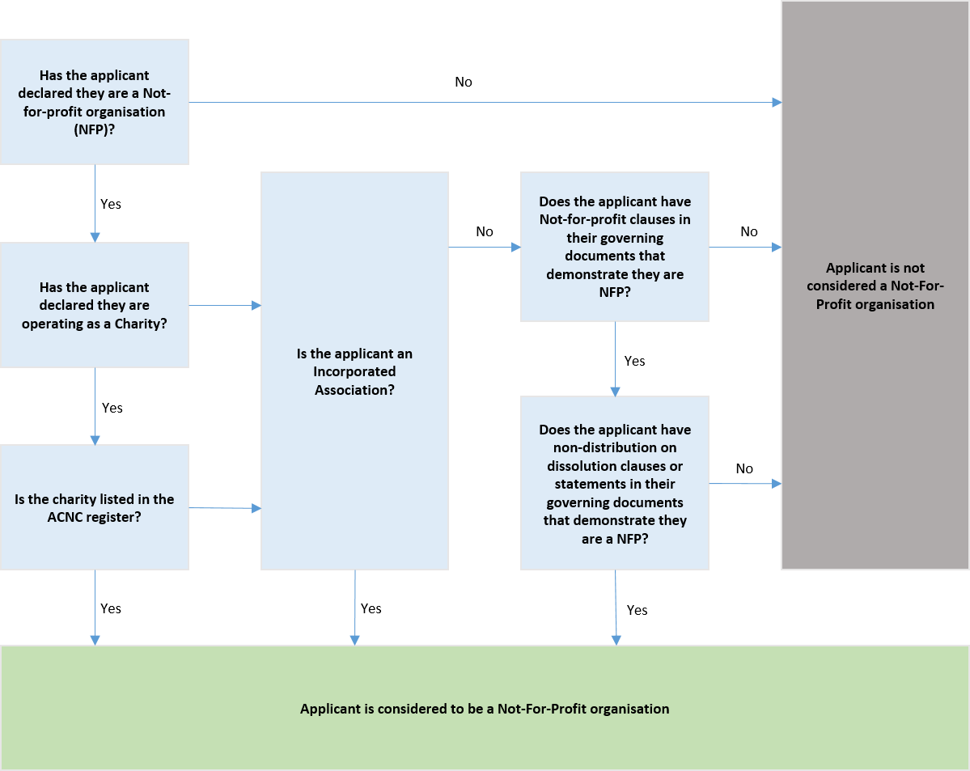

What is the definition of a school under BBRF?
- If your organisation sits under the jurisdiction of a State Government education department to deliver educational outcomes then you are considered to be a school under the Building Better Regions Fund. Schools are ineligible for funding under the BBRF.

Can Local Government Financial Assistance Grants be used as cash contributions under the BBRF?
- Financial Assistance Grants are untied, allowing local government bodies to spend the grants according to local priorities. Financial Assistance Grant funding is considered a contribution from the applicant, and not the Commonwealth.

How can I provide evidence of cash contributions committed to by candidates in the lead up to a State Government general election?
Proponents should prepare applications working with funding partners as per normal. In line with section 7.1 of the grant opportunity guidelines, all cash contributions, including those that are committed during an election campaign, must be evidenced.
All applicants must attach letters evidencing the cash contribution from each contributing organisation or individual. This evidence must be submitted with the application prior to the closing date.
The letter must be:
  - on the organisation’s letterhead,
  - signed and dated by an authorised person, and
  - set out the value and timing of contributions and any conditions attached.
Therefore, if a candidate in a State Government general election makes a commitment to a project, the Applicant must provide with their application a letter on the party letterhead, signed and dated by an authorised person, setting out the value and timing of contributions and any conditions attached.
As part of the assessment of applications the Department may seek confirmation of cash commitments from the incoming State Government. No action is required from applicants in this regard.
Only election commitments made and confirmed by the party(ies) that forms Government will be accepted as evidence of co-funding for the purposes of BBRF.

Can the provision of land be considered as part of my mandatory cash contribution?
- No. A contribution of land will be considered an in-kind support to the project. In kind support is not co-funding. All contributions must be cash and towards eligible expenditure.

Can I apply for funding for one stage of a bigger project?
The application form requires that you provide a brief overview description of the project for which funding is being sought and a description of the project outcome and outputs. If the project is part of a larger program of works you will need to describe this in the application form. The proposed BBRF project will be assessed as a standalone project and be able to deliver the benefits described without completion of the larger program of work.
How do I make clear that the project I am applying for is one stage of a larger project? You must address how you will manage project stage dependencies in Assessment Criterion 3.

What type of information should I include when answering questions on project management, risk management and maintaining project benefits?
- You must make the best possible case to demonstrate that you have done all planning required to provide confidence that the project will be delivered on time, on budget and to an appropriate standard to deliver the benefits described in your application.
- Project Management – you must address the implementation of the project from commencement to completion. You should define how, when and by whom project activities will be completed to demonstrate that the project will be delivered on time, on budget and to the required standards. You should include the following information:
  - confirmation of required approvals, are they in place or being sought?
  - how will goods and services be procured
  - how will you ensure the project is delivered on time and on budget and to the required standards, e.g. who will manage the project and what governance arrangements are in place.
- Project Risk – you must provide details on the key risks to your project and the mitigation or management strategies in place across the life of the project. You must provide at least three risks.
- Maintaining Project Benefits (Infrastructure Projects stream only) – you must demonstrate that the outputs of the project will be retained in original condition for the relevant period as outlined in section 12.8 of the Infrastructure Projects grant opportunity guidelines. You should outline the operational needs of the project into the future, a strategy to manage the project and to maintain the ongoing viability of the completed project.
- The level of detail required to make a convincing case is relative to the project size, complexity and grant amount requested.

How do I withdraw my application
- Please call 13 28 46 for assistance. You will receive an email confirming the withdrawal of your application.

Infrastructure Projects Stream

Should I apply for the tourism-related infrastructure project funding?
- Round Five of the program incorporates $100 million towards tourism-related infrastructure projects.
- When applying through the online application form, you will be asked to indicate your intention to seek funding for your project from the tourism-related infrastructure projects funding pool.
- You will be asked to demonstrate the COVID-19 pandemic’s impact on your region’s tourism industry (or the region that will benefit from your proposed project) and how your project will provide direct benefit to the tourism industry and assist in mitigating the impact from the COVID-19 pandemic.
- You will be required to provide evidence to support your claims. You must also meet the eligibility requirements of the grant opportunity guidelines.
- You do not have to be a tourism organisation to apply for the tourism-related infrastructure funding.
- Austrade may be consulted as part of the assessment process for tourism-related infrastructure project funding.
- If you do not clearly articulate how your project will provide benefits to the tourism industry in the region to assist in mitigating the impact of the COVID-19 pandemic, and support those claims with tangible evidence, your application will not be considered for the $100 million tourism-related infrastructure project funding. It will instead be considered with the general infrastructure project applications.
- If you are applying for tourism-related infrastructure project funding, you may wish to discuss your proposed project with independent regional, state/territory tourism organisations to assist in identifying key elements of your project which can support broader tourism stimulus and investment initiatives. This evidence may be provided as supporting documentation in your application.A Tourism-Related Infrastructure project funding Factsheet is available on www.business.gov.au

Does my organisation have to own the infrastructure we would like to upgrade or extend using a BBRF grant?
- You do not need to own the infrastructure associated with your BBRF project. However, you must be able to demonstrate with evidence that you have appropriate authority from the owner and access to the infrastructure, capital equipment, technology or intellectual property required to undertake the project.
- You will have to demonstrate you have planned for, or have in place all regulatory and development approvals required to undertake the project.
- You will also need to demonstrate you will be able to operate and maintain the project infrastructure into the future to ensure you can deliver the benefits throughout the operational period outlined in 12.8 of the Infrastructure Projects Stream Grant opportunity guidelines.

Is an infrastructure project eligible if part or all of the project is on land not owned by the applicant?
- You do not need to own the land associated with your BBRF project. However, you must be able to demonstrate with evidence that you have appropriate authority from the owner and access to the infrastructure (including land), capital equipment, technology or intellectual property required to undertake the project.
- You need to demonstrate you have planned for or have in place all regulatory and development approvals required to undertake the project.
- You will also need to demonstrate you will be able to operate and maintain the project infrastructure into the future to ensure you can deliver the benefits throughout the operational period outlined in section 12.8 of the Infrastructure Projects Stream grant opportunity guidelines.

Can I seek funding under the Infrastructure Projects stream to purchase land or existing infrastructure?
- No, you can only spend the grant and cash contributions on eligible activities directly related to the project. The purchase of land or existing infrastructure is an ineligible activity under the BBRF.

Can I seek funding under the Infrastructure Projects stream for investment in a vehicle or vessel such as a boat?
- No, infrastructure must be a fixed physical structure or facility (e.g. buildings, roads, power supplies) needed for the operation of a community.

Can a local governing body or not-for-profit organisation apply for funding when the principal motivator of the project is a private company?
- It is not the intention of the program that an eligible organisation applies on behalf of an ineligible organisation. The organisation applying for the funding is responsible for the delivery of the project and its outcomes. Please note, if it appears that an applicant is not the principal motivator of the project, the application may not be competitive. Project expenditure must be incurred by the applicant during the project period to be eligible and grant funds are paid as a proportion of eligible expenditure.

What does ‘investment ready’ mean?
- Under section 2.1.1 of the Infrastructure Projects Stream grant opportunity guidelines a new section called ‘Investment Ready Projects’ has been included in both Rounds Four and Five which emphasises projects should be ready to commence within 12 weeks of executing the grant agreement, and lists the requirements to be ‘Investment Ready’. Investment ready projects have completed pre-construction activities and are ready to commence construction activities.
- Pre-construction activities, including architect services, design, surveying, planning, environmental or other regulatory approvals, which exceed 20 per cent of the total eligible project expenditure will be considered ineligible expenditure.

How do the Australian Government Building and Construction WHS Accreditation Scheme requirements impact my project?
- If you are successful and your grant amount is over $6 million you may need to have your head contractor accredited under the Australian Government Building and Construction WHS Accreditation Scheme. Your obligations under the scheme will be discussed as part of the negotiation of your grant agreement. Information on the scheme is available at www.fsc.gov.au.

Community Investments Stream

Will the Community Investments Stream fund my event for more than one year?
- No, local events will only be eligible for funding under the program once. Funding under the Community Investments Stream is intended as seed-funding to support an inaugural event or funding for a one-off expansion of an existing activity. You will need to clearly outline in your application your strategy to fund future and expanded events without Australian Government funding.
- Events must take place after you execute the grant agreement with the Commonwealth.

Can my staff provide the regional leadership?
- Leadership training must be conducted by an external entity to the organisation as funding for staff wages is considered an ineligible activity.
- You must provide a quote and course information dated within two months of lodging your application.
- If you are considering applying for funding to develop current leadership and resilience skills to support your local communities through future economic challenges, you may like to consider the Building Strong, Resilient Regional Leaders initiative announced in the 2020-21 Federal Budget.

