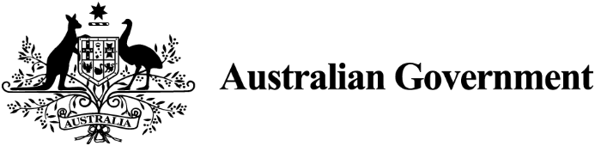
  - Business Research and Innovation Initiative
  - Fact sheet

Powering safe drinking water for Australian First Nations remote communities
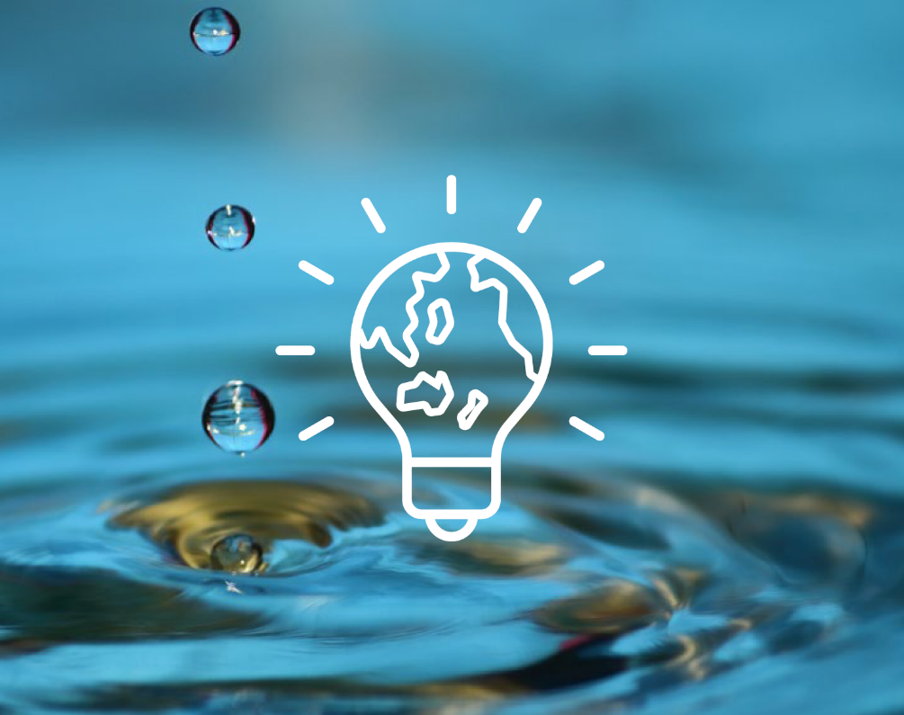
The Department of Climate Change, Energy, the Environment and Water (DCCEEW) is seeking solutions to create efficient, cost‑effective water treatment systems powered by renewable energy.

Opportunities
- Access grant funding of up to $1.1million
- Work with government
- Keep ownership of all IP developed for the project
- Accelerate commercial
opportunities
- Potential for procurement
- Receive industry expertise and guidance
- Contribute to Australia’s Net Zero targets

The challenge
Can you improve access to drinking water for Australia’s remote communities?
First Nations Peoples living in remote regions of Australia face challenges in accessing clean drinking water.
These culturally-rich and diverse communities often lack the technologies needed to treat water in the varied settings they call home. The varying amount of water available, especially in arid areas, compounds the complexity of the situation. Salts, heavy metals and other contaminants in the water make specialised treatment processes necessary to meet safe drinking standards.
Energy supply is also a significant barrier to water treatment. Reliable electricity grids can face limits or be non-existent.
Conventional systems, relying on treatment stages such as filtration and disinfection, are energy intensive, noisy and expensive. They often use diesel generators which are noisy and expensive. They also contribute to environmental damage and greenhouse gas emissions.
Systems must be able to operate continuously (even at night) in harsh conditions with little need for skilled maintenance. This is particularly necessary in areas where accessibility is limited for parts of the year because of poor road conditions.

Potential themes
Solutions could consider:
- renewable energy integration
- solar-powered solutions
- water treatment
- contaminants
- weather resistant materials
- water treatment methodologies
- waste management
- atmospheric water solutions
- low-maintenance technologies
- scalable technologies.

Solution requirements
DCCEEW is open to a range of solutions to address this challenge.
The challenge is to develop innovative, integrated solutions that combine renewable energy and water treatment systems.
To ensure the long-term supply of safe drinking water, it is critical to develop systems that are:
- effective in meeting Australian water quality standards
- low cost to set up and maintain
- have minimal maintenance needs
- hardy to withstand harsh weather conditions
- able to operate continuously (even at night)
Where possible solutions should be scalable and show potential use in other scenarios.
You must consider the different water quality challenges that remote communities face. For example, the impact of heavy metals, excessive salt or biological contaminants. Solutions need to meet Australian safe drinking water guidelines.
This challenge involves collaboration with several partners, including the National Indigenous Australians Agency and state agencies. A critical part of this challenge is to work closely with First Nations communities to develop solutions that are tailored to their needs. DCCEEW can support applicants to identify and engage appropriate First Nations partners.

Solution benefits
Successful solutions will ensure remote communities have reliable access to safe drinking water, enhancing their health and well-being.
Solutions have the potential to be applied commercially across Australia’s remote communities, as well as other applications and internationally. Applicants will keep their intellectual property (IP), so commercial application possibilities for new technologies are considerable.
Solutions will support environmental sustainability by reducing carbon emissions and integrating renewable energy and water treatment technologies.
Innovations can lead to commercial benefits for water providers and have wider commercial benefits for applicants.

How to apply
Have you got a great idea to solve this challenge?
For more information or details on how to apply, visit business.gov.au/BRII-RLE or call 13 28 46.

