**Customer**: Atamo

Atamo is a Perth based electronic product solutions business that relished an opportunity to help safeguard Australia from diseases brought in by mosquitoes and bugs.

**Employees:** 13 employees, three graduates

**Exporting:** The New Zealand Ministry for Primary Industries has requested to trial Atamo’s device with Air New Zealand and the New Zealand Military.

**Sector**: Manufacturing

**Location**: Bayswater, WA

**Electorate:** Perth

**Products / Industries of the electorate**:

Industries include medical, education, retail, recreation, light industrial, commercial, tourism, transport, professional services, public services and hospitality.

**Program**: Business Research and Innovation Initiative (BRII)

BRII provides small to medium sized enterprises with grant funding to develop innovative solutions for government policy and service delivery challenges.

**Funding**: Atamo received two grants under round one of BRII – for the Department of Agriculture and Water Resources project titled ‘on-the-spot technology for measuring pyrethroid surface residues’.

For more information on Atamo visit [www.atamo.com.au/](https://www.atamo.com.au/).

For more information on the BRII visit [business.gov.au](https://www.business.gov.au/assistance/business-research-and-innovation-initiative) or call 13 28 46.

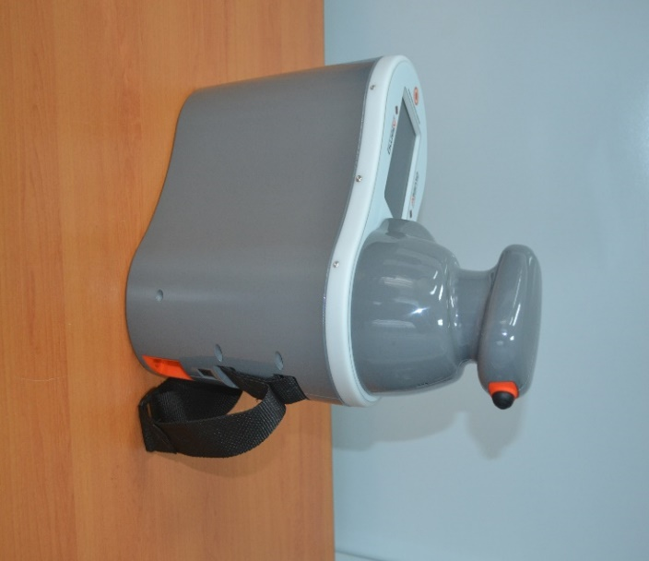

Atamo was started in 2003 by senior engineers who were keen to help others take their novel ideas and turn them into technically and commercially successful products. Those ambitions seem well on track with Atamo’s portable, automated spectrometer system to measure pyrethroid residues on internal surfaces of aircraft.

Planes have long been a way for mosquitoes and bugs to hitch-hike into Australia. The brilliance behind Atamo’s device is that it automates the process of regular testing and helps to ensure airlines are compliant with Australia’s bio‑security requirements.

The BRII project had university and other companies collaborate with Atamo to develop this solution, test and refine the device and its technical elements, and to produce prototypes.

The success of Atamo’s BRII round one project has led to the business being involved in discussions to rid the world of malaria – including possible future work with the Innovative Vector Control Consortium (IVCC), to develop technologies to combat malaria and other deadly mosquito-borne diseases. Australia’s Department of Foreign Affairs and Trade is playing a lead role in this future work.

**“It is not just funding for research. The fact BRII allows businesses to retain the intellectual property, and the fact we are obliged to seek broader markets for the device beyond its original application, means real economic benefits for the country and business.” Stewart Snell, CEO, Atamo**