Customer: WaterflowTM, by Marsden Jacob Associates (MJA)
Waterflow provides water market information through mobile phone and web-based applications. It came about as a national need to improve transparency and reliability of water market information.
Employees: MJA’s water team is nationally recognised as a leading advisor on water market, policy and infrastructure.
Sector: Water
Locations: Melbourne, Sydney, Perth, Brisbane.
Electorates: Melbourne, Sydney, Perth, Brisbane.

Program: Business, Research and Innovation Initiative (BRII)
The Business Research and Innovation Initiative (BRII) provides small to medium sized enterprises (SMEs) with funding to develop innovative solutions for government policy and service delivery challenges.
The Department of Agriculture, Water and Resources proposed this BRII challenge.

Support: In mid-2017, Marsden Jacob Associates was awarded a BRII Feasibility Study grant of $99,897 to prove how its Waterflow product would improve transparency and reliability of water market information.
That study was successful and from October 2017 the Waterflow project kicked into gear through the support of a $1 million BRII Proof of Concept grant.
For more information on Marsden Jacob Associates’ initiative visit Waterflow.

For more information on BRII visit business.gov.au or call 13 28 46
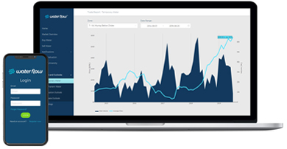

Waterflow is not a trading platform. Rather, it provides, at no cost; a market commentary and informs to save water market participants many hours researching water prices, availability and rule considerations.
Marsden Jacob partnered with software development company, Alliance Software, to develop Waterflow and make it work on both mobile and web-based platforms.
Waterflow’s mobile app presents quick and easy-to-understand water markets information.
The web application also provides the same content as the mobile application, however, premium users can also access more detailed data and analysis.
It helps water market participants to better understand markets and make better-informed trades.
Many users have likened Waterflow’s search and price comparison tools to being the ‘Trivago search’ for water markets.
But the Marsden Jacob team feels that this is only the beginning of the benefits that Waterflow can provide, through the many data sources that are being drawn together on the platform.
“BRII has enabled us to develop and test a water market information platform that will be accessible via mobile and web applications, and confirm that there is a distinct market need for this service.”
Rod Carr, Marsden Jacob Associates Director

