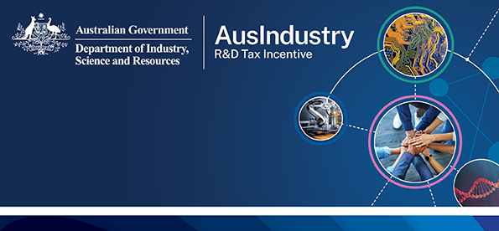
R&D Tax Incentive at a glance
The Research and Development Tax Incentive (R&DTI) encourages business to invest in R&D that benefits companies and the broader Australian economy.

Incentivising investment in R&D
The R&DTI is an incentive program that supports your company to invest more in eligible R&D activities.
If your R&D activities meet the program criteria, you may be eligible for a tax offset that covers some of the costs of your R&D.
The R&DTI can also support collaboration with registered Research Service Providers (RSPs).

Who should apply for the R&DTI?
You should take a closer look at the R&DTI if your company:
- is incorporated under Australian or a foreign law
- conducts or plans to conduct one or more eligible core R&D activities
- has eligible R&D expenditure greater than $20,000 (if your expenditure is less than $20,000 you can still claim the tax offset by using a registered RSP to conduct your R&D).

R&DTI tax offset benefits
Different benefits apply according to company turnover.
Companies with an aggregated turnover of less than $20 million may receive a refundable R&D offset rate equal to their corporate tax rate plus an 18.5% premium.
Companies with an aggregated turnover of $20 million or more may receive a non-refundable R&D tax offset rate equal to their corporate tax rate plus an incremental premium.
Premium increments are based on the intensity of your R&D expenditure as a proportion of total expenditure for the year. There are two premium increments:
- R&D intensity up to 2% receives a tax offset equal to the company tax rate plus 8.5% premium
- R&D intensity above 2% receives a tax offset equal to the company tax rate plus 16.5% premium.

If eligible expenditure exceeds $150 million for an income year, the tax offset for the amount above $150 million is calculated using your company tax rate.

What are ‘eligible R&D activities’?
- types of eligible activities are set out in Section 355.25 of the Income Tax Assessment Act 1997, the law that applies to the program.
- your activities must meet all of the requirements for core and supporting R&D activities to be eligible for the program
- more information on eligibility is available in our Guide to Interpretation.

Eligibility – how it works
The R&DTI is a self-assessment program. Before you register to apply, you must decide whether your R&D activities are eligible according to the legislation. You are responsible for ensuring your R&D activities meet legal requirements.
- Refer to the law when assessing whether your activities are eligible.
- Keep records to support your claim.
- We may review your application before or after registration and provide you with tailored guidance or conduct a formal examination of your claim. Find out how we monitor applications by visiting www.business.gov.au/rdti.

Advance and Overseas Findings
You can get certainty about the eligibility of your activities by applying for an Advance Finding. You must apply for an Advance Overseas Finding to claim any R&D activities you conduct overseas. Find out more by visiting www.business.gov.au/rdti.

How to apply
Applying for the R&DTI is an annual process.
- Self-assess your eligibility while planning your R&D. Check your company is eligible. Check that your R&D activities are eligible.
- Consider applying for an Overseas Finding or Advance Finding.
- Conduct your R&D and continue to self-assess. Keep records of your R&D activities and associated expenditure.
- Register your R&D activities. Apply to register your activities using the R&DTI application portal.
- Claim your tax offset. To claim your tax offset you must enter your registration number into the R&D schedule of your company’s annual income tax return.

Information and support
The R&DTI is jointly administered by the Department of Industry, Science and Resources and the Australian Taxation Office.
For helpful guidance on interpreting the legislation and keeping records visit business.gov.au/rdti or phone 132846.
For R&D entity and expenditure information visit ato.gov.au/rdti.

