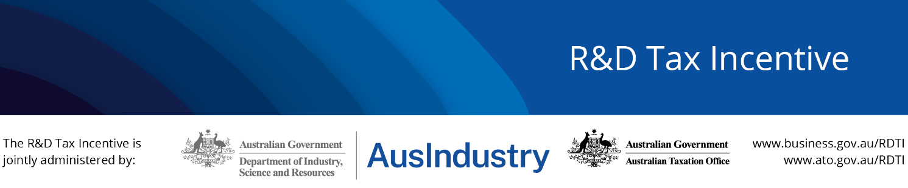

R&D Tax Incentive

Roundtable Meeting

MEETING RECORD
Meeting Date | 20 March 2023
Time | 10:00am-12:00pm AEDT
Co-Chairs | Tara Oliver | General Manager, R&D Tax Incentive Branch,  Department of Industry, Science and Resources (DISR)
 | Brett Challans | Senior Director, Innovation Taxes, Australian Taxation Office (ATO)
Guest Presenter | Sandra Roussel | General Manager, Venture Capital & Entrepreneurship, DISR
Attendees | Kristina Kipper | KPMG (Host)
 | Gary Shapiro | Rimon Advisory
 | Hoor Akhtar | Cooperative Research Australia
 | Róisín Arkwright | Deloitte
 | Laurence Osen | Ernst & Young
 | Rebecca Roberts | Cochlear
 | Mariana von Lucken | The Tax Institute
 | Nicola Morris | Universities Australia
 | Nicola Purser | BDO
 | Steve Carroll | Evolv3
 | Stephanie Caredes | Corporate Tax Association
 | Sophia Varelas | PwC
Apologies | Kelly Canavan | Assistant Commissioner, Private Wealth, ATO

Agenda
Item | Speaker | Chair
- Welcome  - Acknowledgement of country  - Introductions around the table | Tara Oliver | DISR
- ATO Update  - ATO program updates | Brett Challans | ATO
- DISR Insights  - DISR program updates | Tara Oliver  Joanne Taylor | DISR
- Where R&DTI fits into the R&D ecosystem  - DGTO, NRF and Innovate to Grow  - Discussion on cross promotion opportunities | Lyndall Milward-Bason | DISR
- Venture Capital and Entrepreneurship | Sandra Roussel | DISR
- Advance Finding Pilot Program | Tara Oliver | DISR
- Members Insights  - Members to share R&D outlook from their vantage point and their key priorities | Tara Oliver | DISR
- R&DTI Roundtable  - Value to be achieved by Roundtable  - Future forum delivery | Brett Challans | ATO
- Other business and close  - Other business  - Agenda items for next meeting | Tara Oliver | DISR
Meeting Close

Introduction of co-chairs and welcome
- Tara Oliver (DISR) welcomed attendees and Brett Challans (ATO) as co-chair for the meeting.
- Apologies were conveyed for Kelly Canavan (ATO).
- Tara Oliver thanked KPMG for hosting the Roundtable and invited other members to host in future.
- It was noted this was the first in-person Roundtable to occur since the COVID-19 pandemic travel restrictions had been lifted.

ATO Update
- Changes to legislation effective since 1 July 2022 have gone smoothly. General and specific advice requests on uniform clawback provision and feedstock adjustment have increased. Information on feedstock calculation is on the website and new guidance has been released which should help with responding to the advice requests. The ATO is happy to assist in reviewing feedstock calculations but will require the actual calculations to be sent through so we can follow the methodology and provide feedback.
- An additional legislative change will occur after 1 July 2024. The ATO will publish R&D claimant information for the 2022 year and this will be an ongoing annual publishing process. This will include R&D entity name, ABN and R&D notional deduction claimed less feedstock.
- The ATO website has been updated with new guidance content and improvements to website functionality. Further updates are ongoing with additional content to be released.
- Issues are arising with claims for payment to associates. Payments are not considered made when:
  - payment is converted to a loan
  - ‘round robin’ payments are made where payment is returned so the next payment can be made in a cyclical nature
  - loans are being used as contingent payments where payment is expected after an anticipated future event (for example, listing on a stock exchange)
  - shares are being issued as payment, which is disallowed by TR 2008/5.
- Another issue observed is the use of one apportionment rate for all overhead expenditure claims (for example, a percentage of the profit/loss statement). This is an estimate, correct calculation can only be used for overheads on R&D and the most appropriate apportionment rate.
- Record keeping remains a key issue for the program.
- The ATO offers support to companies and consultants in the program and is open to queries.

DISR Insights
Members were invited to ask questions on the program update included in the agenda papers (Attachment 1). Further insights offered during the meeting were:

Industry and research collaboration
- The 2022 Roundtable working group on Research Service Providers (RSP) continues to inform our communication and education strategy.
- A meeting of the Research and Development Incentives Committee (RDIC) was held on 6 March to investigate leveraging the program to promote research and business collaboration. Key points discussed included:
  - Innovation-active businesses that collaborate report increased employment, productivity and sales.
  - Collaboration between Small-to-Medium Enterprises (SMEs) and universities or research institutes promotes knowledge exchange and increased workforce skills. These businesses have a higher turnover and are more likely to introduce new-to-market innovations and new and improved products and processes.
  - The R&DTI has a role in realising the benefits of innovation in Australia by encouraging industry-research collaboration and commercialisation.
- Department of Education representatives presented to RDIC on their work on improving commercialisation. This included Australia’s Economic Accelerator, a new research funding program providing competitive grants designed to bridge the ‘valley of death’, and the National Industry PhD and Fellowship Scheme. Legislation for the accelerator passed parliament on 7 March 2023.

Data trends
- SMEs make up an increasing share of first-time registrants, growing steadily from 61% in the 2012-13 income period to 91% in the 2019-20 income period.
- Manufacturing firms represent a declining share of new registrants with firms in the professional, scientific, and technical services industries increasing from 27% in the 2012-13 income period to 45% in the 2019-20 income period.
- Younger companies (less than 2 years in existence) accounted for 32% of new registrant applications in the 2012-13 income period and this has grown to 72% in the 2019-20 income period.

Determinations
- Over 121 applications have relied on the Industry Research and Development (Clinical Trials) Determination since it commenced on 1 April 2022, covering over 763 individual activities.
- A determination framework is being established to support the development of future Determinations.
- Future determinations will:
  - align with Government priorities
  - demonstrate high value to the economy
  - strengthen the intent of the program
  - resolve uncertainty and provide clarity
  - deliver savings for applicants and for the administration of the program
  - be supported by data

Compliance and guidance approach
- In a post COVID environment, DISR has returned to a compliance as usual footing. DISR looks forward to being able to visit more companies to learn about their R&D activities firsthand.
- DISR continues to adopt a guidance focussed approach to ensuring integrity in the program.
- DISR and the ATO continue to host ‘Introduction to the R&DTI’ information sessions which provide companies with a high-level overview of the program.
- In-person information sessions are also being trialled for the first time since the Covid pandemic.
- The R&DTI Insider newsletter continues to be one of the main ways for sharing information with program applicants and is sent to over 7000 subscribers.

ANAO and Board of Taxation review recommendations
- The Government released the Board of Taxation (BoT)’s Review of the R&D Tax Incentive Dual Agency Administration Model report on 29 March 2022.
- The report recommended the two agencies publish a joint charter setting out:
  - the expectations and roles of all parties that participate in the R&DTI program
  - timeframes for engaging with all aspects of the program
- The report also recommended timeframes for DISR findings be published.
- The ANAO audit published on 25 November 2021 made similar recommendations about publishing service standards for DISR statutory assessments.
- The full-service standards of both agencies will be published as part of the joint program charter, which will be released for consultation by early in the 2023-24 financial year.
- Other recommendations currently under review include:
  - Better performance measurement of the R&DTI program against its legislated objectives, especially the extent to which the program delivers on its additionality and spillover goals.
  - Ways to improve information sharing between DISR and the ATO.

Registration deadline
- The registration deadline for the income year that ended on 30 June 2022 has been amended from 30 April 2023 to 2 May 2023 as the next business day in all states.
- This is a peak period for registration applications. Up to 30% of the 12,000 plus applications received each year are submitted during the last week of April.
- The maximum extension of time that can be given for applications is 92 days after the statutory deadline.
- Where companies meet the criteria, they should rely on the Clinical Trials Determination. Messaging and education is ongoing regarding the application of the determination.
- It is essential to include a company contact in the primary contact application field, rather than insert tax agent email address in there in this field.

Research Service Provider (RSP) registration
- From 30 June 2023, all RSP application forms will be moved to the customer portal. This includes New RSP Applications, RSP Variation Applications and RSP Annual Renewal Applications.
- RSP registrations for the 2023-24 financial year will be submitted through an online Smart Form, which will be available from Monday 1 May 2023 to 31 May 2023.
- More information about the Smart Form will be provided in the annual renewal communications which will be sent to RSPs in the coming weeks.

Where the R&DTI fits into the R&D ecosystem
- The R&DTI fits within the Government’s broader industry and innovation support system. DISR is working to help businesses understand what initiatives are available and how they might access them. These initiatives include:
  - Digital Games Tax Offset (DGTO): provides tax offsets for certain expenses relating to the development of digital games. Once the legislation for this program - currently before the Senate - is passed and receives Royal Assent, the DGTO will commence retrospectively from 1 July 2022. The legislation precludes access to the DGTO where the same expenditure is entitled to the R&DTI.
  - The National Reconstruction Fund (NRF): will create a corporation that can invest in areas of national priority (for example, via equity or loan agreements where there are good prospects of a return on investment) to support, diversify and transform Australia’s industry and economy.
  - CSIRO’s Innovate to Grow program: provides SMEs with free guidance about engaging in, or considering, research and development.
  - Australia’s Economic Accelerator: will provide industry-led study and postgraduate research grants to bring tech into priority sectors to the point of commercial investor readiness.

- DISR has successfully embarked upon cross-promotion of the R&DTI and the CSIRO’s Innovate to Grow initiative and is now looking to build on this with other Government initiatives, such as Australia’s Economic Accelerator.
- Members discussed further opportunities for cross-promotion. Members stated it was important to map where the R&DTI journey overlaps with other programs; and a need for companies to understand where they are on the innovation journey.
- Members expressed interest in future changes to the Entrepreneurs’ Programme considering the user journey mapping.

Venture Capital and Entrepreneurship
- Sandra Roussel, General Manager of Venture Capital and Entrepreneurship for DISR shared a presentation with members (Attachment 2). This included an overview of current programs, including:
  - Venture Capital and Entrepreneurship: supports innovative businesses directly and indirectly through start-up, scale up and growth.
  - The Entrepreneurs’ Programme: helps SMEs to accelerate elements of commercialisation, including commercialisation advice and match grant funding for start-ups. DISR and members recognised the importance of this program and work is ongoing to determine what it will look like going forward.
  - Boosting Female Founders: focused on majority female lead and owned start-ups and early scale ups, providing mentoring and match grant funding.
  - Business Research and Innovation Initiative: a smaller program looking to solve government, policy and service challenges by using a more innovative and competitive approach to get small Australian businesses to bid for providing solutions
- Indirect support is offered via two tax concessions programs, namely the Venture Capital Limited partnerships and Early-stage Venture capital.
- Venture Capital deals and funding trended up globally prior to 2021 and are now trending back down due to the broader economic environment. While deals and funding are down from highs seen in 2021, they are both tracking higher than any time before 2021.
- 72% of Venture Capital funds in Australia in 2022 went to early-stage investment which is high when compared globally. This signals an element of resilience in building a strong pipeline for future growth and scaling for start-ups in Australia.
- In VCLP and ESVCLP, seen notably increases in the number of registered and conditionally registered partnerships. In total, they have committed approximately $30 billion in funds, of which half is still to be allocated to Australian start-ups and businesses.
- The purpose in these programs is to attract domestic and foreign investment for Australian startups and Innovative businesses.

Advance Finding Pilot Program
- Advance Findings (AFs) provide companies with certainty around the eligibility of their R&D projects for up to three income years and may help them raise funds, secure finance, recruit and retain talent through longer-term contracts and make important investment decisions.
- DISR has recently streamlined the administration of processing AF applications, significantly reducing the timeframes for assessment.
- DISR has also been working with the Technology Council of Australia to deliver an AF ‘pilot’ to software-related companies that want to access the R&DTI Program. The pilot aims to address software and tech companies’ requests for enhanced certainty and guidance when applying for the R&DTI program.
- Small group consultation sessions were conducted by DISR Case Managers with software sector expertise throughout March 2023. The consultations were designed to provide the 23 participating companies with information on the R&DTI program, an understanding of the purpose of advance findings and details on how to apply via the R&DTI portal.
- These companies now have until 26 April 2023 to submit their AF application.
- Company feedback is being collected throughout the process to measure effectiveness of this form of guidance.
- Members welcomed the advance findings pilot and shared their experiences with some members noting that the AF process has previously been lengthy and resource intensive for companies.
R&DTI Roundtable
- Members were invited to provide feedback on the Roundtable forum and how it can best provide value.
- Members were invited to share feedback and suggestions by emailing rdti.engagement@industry.gov.au

Action Items
- The Productivity Commission’s report on advancing prosperity to be included as a future Roundtable agenda item.
- Invitation to be extended to the National Reconstruction Fund for a guest speaker to attend a future Roundtable.
- DISR to share, with members, slides presented by Sandra Roussel during her presentation (Attachment 2).
- ATO to raise with Tax Practitioners Board that R&D Advisors are unable to advise on early state innovation company (ESIC) investment.
- DISR to review guidance provided to companies on registrations whilst waiting for the outcome of an overseas finding.

Attachments

Attachment 1 – R&D Tax Incentive program update

Attachment 2 – Venture Capital and Entrepreneurship presentation

Attachment 1

R&D Tax Incentive
Program Update – March 2023

- Departmental Changes

- Registrations updates
-- 30 April deadline
- Registration insights

- Program guidance
- Information sessions
- Website updates

- Advance finding pilot

- Research service providers
- Guidance
- Registration updates

- Registrations and claims data

Departmental Changes
The Department of Industry Science and Resources recently underwent a restructure. This included the integration of the R&DTI branch with Venture Capital and Entrepreneurship and the Office of Industry Innovation and Science Australia in the Commercialisation Division led by Nick Purtell. This division sits within Industry and Commercialisation under the purview of Deputy Secretary Julia Pickworth.
For more information, please see the full organisation chart available at industry.gov.au.

Registrations updates

30 April deadline
The R&DTI registration deadline for applicants with a financial year that ended on 30 June 2022 is 2 May 2023. This deadline has been amended from 30 April 2023 as this date falls on a Sunday and the next business day is a public holiday in Queensland and the Northern Territory.
To avoid significant processing delays created by numerous extension of time requests in the peak April period, we are advising applicants to establish portal access well ahead of the 2 May deadline. We also ask that tax agents and R&D consultants remind their clients that the principal authority for an R&D entity must first establish access to the portal before they are able to grant authority for others to access the portal on their behalf.

Registration insights
There are several common mistakes made by applicants that can cause a delay in their registration.

Tax agent is given authorised access to the incorrect ABN
The ABN used must be that of the head entity for taxation purposes, not any of the subsidiaries. This should be checked before the application is started as it’s not possible for the ABN to be changed in the portal after an application has been drafted or submitted.

Incorrect financial year selected
This is particularly an issue with substituted accounting periods as the portal includes both early and late options. The income period and income year cannot be changed after the application is submitted, the application must be withdrawn and resubmitted for the correct financial year.

Tax agent portal access has expired
Customer portal authorisation access is granted for a set period of time, if this expires it’s no longer possible for the tax agent to access the portal on behalf of the company.

Individual authorisation is established via ATO’s Relationship Authorisation Manager (RAM). The authorisation details in RAM will show the end date for each ABN’s authorisation.

Tax agency authorisation is established via the ‘Manage Access’ tile in the customer portal. Go to ‘Switch Business’ to view the end date for each authorisation.

Incorrect project/activity end date
Pre-filling for the next income year will only work for projects/activities that have an end date that continues into the next income year.

Delay in establishing customer portal access
Companies can miss the lodgement deadline if insufficient time is allowed for portal access. Setting up a portal account for the first time can take longer than expected, please encourage clients to commence this process well in advance of the deadline.

Program guidance

Information sessions
DISR and the ATO offer regular online information sessions to explain program requirements and assist companies to self-assess their R&D activities. These sessions are tailored to entities that are new to the program and provide guidance on requirements for both activities and related expenditure, together with information on how and when to apply, and advice on record-keeping.
To assist with accessing the customer portal, DISR offer information sessions which show attendees how to complete the authorisation process, login to the portal for the first time and authorising access for others such as staff, individual tax agents and a tax agency.
All upcoming information sessions are listed on business.gov.au/rdti.

Website updates
You can keep up with major changes to R&DTI website content at business.gov.au/rdti by visiting this page: latest updates to the R&D Tax Incentive content. We recommend that you regularly check this page to ensure any content you reference on your website is up to date.

Advance finding pilot
Industry feedback highlights the importance of providing program participants with upfront certainty before they register and obtain the tax offset. In response to this feedback, DISR has worked diligently over the past year to streamline the advance finding process and deliver faster decisions. As part of this effort, DISR is now conducting a pilot program with software companies to showcase the progress that has been made to date and to test further improvements.

The pilot team held a webinar on 8 February 2023 to educate potentially eligible companies about advance findings, their benefits, and how to participate in the pilot. Interested companies have until 10 March 2023 to register for small group consultation sessions with an R&DTI software expert. These sessions will provide clarity on eligible R&D activities and allow for two-way communication to learn more about advance findings in the software context.

Participants in the pilot program will then have until 26 April 2023 to submit their advance finding applications. The DISR team will conduct a full assessment and release decisions before 30 June 2023.

Companies interested in participating in the pilot should contact rdti.engagement@industry.gov.au for more information.

Research service providers

Guidance
We continue to use feedback gathered at the 2022 Roundtable working group on Research Service Providers (RSPs) to inform our communication and education strategy.
We have found that RSPs and companies who collaborate with RSPs are willing to share their experiences through customer stories. We released a short video sharing various stories from companies who have worked with RSPs, and a university professor involved in collaboration with companies. More customer stories are in production for release later in the year.
We have updated the business.gov.au webpage advising companies through a step-by-step guide on how to collaborate with RSPs.

Registration updates
The deadline is approaching for Research Service Providers to renew their registration for the 2023/24 financial year. An online Smart Form, developed to provide a better and consistent user experience for all RSPs, will be available from Monday 1 May 2023. This form will be distributed to all RSPs currently registered with the program through our annual renewal communication.

What you need to know
- Registrants can review their existing Fields of Research on the online register and reflect updates to their Fields of Research in the RSP application.
- Applications are due by 31 May 2023 and the smart form will be decommissioned at 11:59pm (AEST) on 30 June 2023. The online register will be updated in July 2023.
- With the decommissioning of our Smart Forms, this renewal process will migrate to the R&DTI Customer Portal which will align RSP registrations with registrations for the R&DTI program.
- From 1 July 2023, all RSP application forms will be available in the R&DTI Customer Portal. This will include New RSP Applications, RSP Variation Applications and RSP Annual Renewal Applications.
- New users of the R&DTI Customer Portal can view a walk-through of the customer portal on the customer portal help and support page at business.gov.au/rdti.
The RSP team can be contacted at rsp@industry.gov.au for assistance.

Registration and claims data
The below figures demonstrate R&D Tax Incentive registrations for the 2020/2021 income period. This is the most recent complete dataset due to the application period closing 10 months after the end of the financial year.
Please note that where the count of registrations for a metric is less than 5, or expenditure is below 1 million dollars, the information is not presented.

Table 1: Overall registrations
R&D Tax Incentive Program REGISTRATIONS
Number of Registrations | 12,403
R&D Expenditure (billion) | $13.40

Table 2: Comparison of registrations and expenditure by organisation size
registrations/expenditure | SMEs | Large Companies
Number of Registrations | 10,871 | 1,532
R&D Expenditure (billion) | $6.91 | $6.49

Table 3: Overall claims for the full 2020/21 financial year (ATO)
claims | refundable | non-refundable
Number of Claims | 10,513 | 1,209
Offset paid or applied (billion) | $2.7 | $2.0

Table 4: Comparison by sector – Australia-wide
 | Services | Manufacturing | Agriculture | Mining | E,G,W & WS*
Number of Registrations | 7,671 | 3,524 | 515 | 412 | 281
R&D Expenditure (million) | $7,213 | $3,956 | $671 | $1,216 | $346

Table 5: Comparison by sector – NSW
 | Services | Manufacturing | Agriculture | Mining | E,G,W & WS*
Number of Registrations | 3,036 | 1,074 | 113 | 51 | 92
R&D Expenditure (million) | $3,348 | $1,554 | $218 | $116 | $180

Table 6: Comparison by sector – VIC
 | Services | Manufacturing | Agriculture | Mining | E,G,W & WS*
Number of Registrations | 2,287 | 1,066 | 107 | 30 | 58
R&D Expenditure (million) | $2,307 | $1,259 | $88 | $206 | $98

Table 7: Comparison by sector – QLD
 | Services | Manufacturing | Agriculture | Mining | E,G,W & WS*
Number of Registrations | 1,198 | 736 | 126 | 90 | 46
R&D Expenditure (million) | $734 | $623 | $107 | $158 | $29

Table 8: Comparison by sector – WA
 | Services | Manufacturing | Agriculture | Mining | E,G,W & WS*
Number of Registrations | 629 | 366 | 78 | 213 | 61
R&D Expenditure (million) | $456 | $272 | $69 | $676 | $27

Table 9: Comparison by sector – SA & NT**
 | Services | Manufacturing | Agriculture | Mining | E,G,W & WS*
Number of Registrations | 328 | 226 | 50 | 21 | 18
R&D Expenditure (million) | $239 | $183 | $58 | $56 | $6

Table 10: Comparison by sector – ACT
 | Services | Manufacturing | Agriculture, MINING** and e,g,w & ws*
Number of Registrations | 144 | 20 | 10
R&D Expenditure (million) | $103 | $39 | $6

Table 11: Comparison by sector – TAS
 | Services | Manufacturing | Agriculture | Mining** and e,g,w & ws*
Number of Registrations | 49 | 36 | 36 | 8
R&D Expenditure (million) | $26 | $26 | $130 | $5
* Electricity, Gas, Water & Waste Services
** Combined for confidentiality reasons.

Comparison of registrations by States and Territories
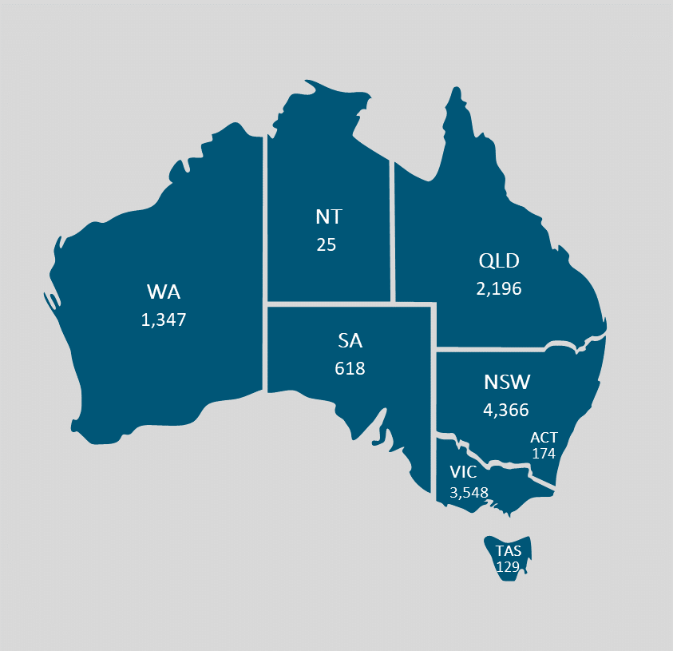

Attachment 2

