Regional Jobs and Investment Packages
Bowen Basin Region

Local Investment Plan
May 2017

Table of Contents
2 Regional overview and analysis 5
3 Investment sectors and strategic priorities 6
3.1 Investment Sector: Aged Care, Allied Health, and Social Assistance 7
3.2 Investment Sector: Education 8
3.3 Investment Sector: Energy and Bio Futures 9
3.4 Investment Sector: Engineering and Heavy Industrial 9
3.5 Investment Sector: Food & Agribusiness 10
3.6 Investment Sector: Tourism 11
4 References 12

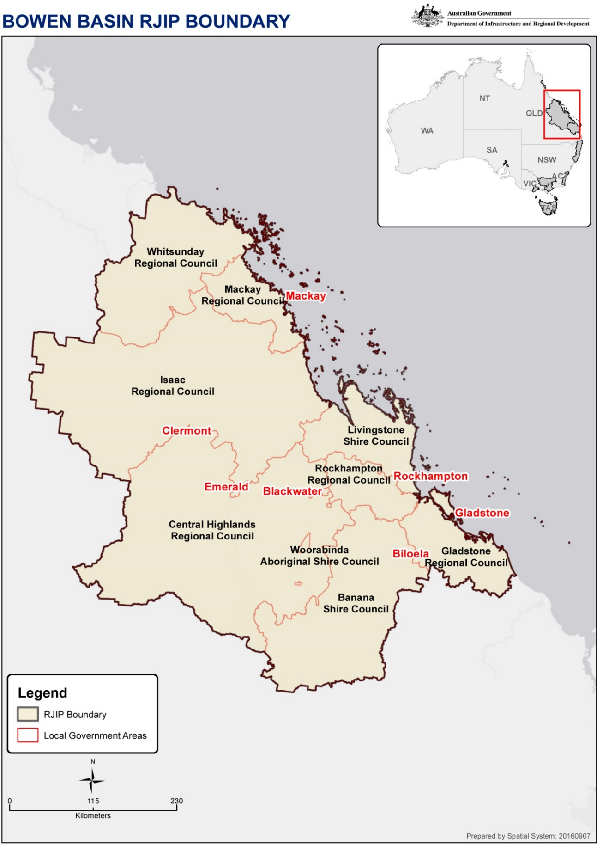
  - Introduction
The Bowen Basin Regional Jobs and Investment Package has been developed to assist in diversifying the region’s economy, create local jobs, and grow skills in the local workforce.
To identify priority areas, the Bowen Basin Local Planning Committee reviewed relevant planning documents, assessed the economics of the Bowen Basin region, and drew upon local knowledge to identify six priority areas that are most likely to catalyse, stimulate, diversify and grow our regional economy.
The Planning Committee has undertaken consultation and engagement with:
- Regional Development Australia Fitzroy and Central West
- Regional Development Australia Mackay-Isaac-Whitsunday
- Central Queensland University
- Department of State Development
- George Christensen MP – Federal Member for Dawson
- Michelle Landry MP – Federal Member for Capricornia
- Ken O’Dowd MP – Federal Member for Flynn
- Resource Industry Network
- Moranbah Traders Association
- Bowen Collinsville Enterprise
- Whitsunday Regional Council
- Isaac Regional Council
- Mackay Regional Council
- Woorabinda Shire Council
- Livingstone Shire Council
- Rockhampton Regional Council
- Central Highlands Regional Council
- Banana Shire Council
- Gladstone Regional Council
- Gladstone Engineering Alliance
The Planning Committee reviewed the following planning documents:
- The Queensland Renewable Energy Plan, Department of Employment, Economic Development and Innovation 2009
- Central Queensland Regional Plan – Department State Development, Infrastructure and Planning 2013
- Mackay, Isaac & Whitsunday Regional Plan – Department of Local Government and Planning February 2012
The Planning Committee drew upon the following reports and data sources:
- Queensland Government Statistician’s Office
- Employment Projections, Australian Government, Department of Employment
- Economic Impact Analysis of Central Queensland University Report, 2008 Rolfe, Cui, Sidiropoulos
- The Value of International Education to Australia, Australian Government, and Deloitte Access Economics, 2015
- Australian Institute of Health and Welfare, Australian Government
- Queensland Farmers Federation
- ARENA – Australian Renewable Energy Agency
- ABC
- Capricorn Enterprise – Economic Profile – 2016
- Central Highlands Development Corporation - Economic Profile – 2016
- Mackay Regional Council Economic Development Strategy
- Banana Shire Council ED website
- Remplan Data – Whitsunday Regional Council
- Remplan Data – Isaac Regional Council
Please refer to the reference section for a more comprehensive list of documents, reports and data sources used to develop this plan.

Regional overview and analysis
The boundary for the Bowen Basin Regional Jobs and Investment Package is inclusive of nine local government areas including: Whitsunday Regional Council, Mackay Regional Council, Isaac Regional Council, Livingstone Shire Council, Central Highlands Regional Council, Rockhampton Regional Council, Banana Shire Council, Woorabinda Shire Council, and Gladstone Regional Council.
According to the Queensland Government Statistician’s Office
, as at 30 June 2015, the estimated population for this region was 417,084. It is expected the population will reach 572,996 by the year 2036.
The region has competitive advantages for the following reasons:
- it is home to Queensland’s largest coal reserves with associated mining related communities and support industries
- it is home to four shipping ports with more than 60% of Queensland’s trade by tonnage
- cruise ships regularly visit the Whitsundays and Gladstone
- numerous agriculture products are produced in the region
- one internationally capable airport, four significant regional airports, a comprehensive university, five coal fired power stations, a 38MWh co-generation plant, three LNG plants, two alumina refineries, an aluminum smelter, regionally significant public and private hospitals, state significant cattle exchange, four meat works, five sugar mills and a bio-ethanol production plant.
Data from the Labour Market Portal identified that in January 2017 the top five industries for employment in the combined Fitzroy and Mackay districts were Health Care and Social Assistance (11.3%), Mining (10.8%), Retail Trade (10.2%), Construction (7.9%), Manufacturing (7.8%).
Industry Employment Projections published through the Labour Market Portal identify employment declines in:
- Agriculture, Forestry, and Fishing, and
- Mining and Manufacturing.
With employment growth predicted in:
- Health Care and Social Assistance,
- Professional Scientific and Technical Services,
- Education and Training and
- Retail Trade.
Given the changing industry landscape, the Bowen Basin Regional Jobs and Investment Package is essential to ensure employment rates increase, the skilled workforce diversifies to meet the changing needs of the region, and that regional economic growth occurs through investment in priority areas.
It is anticipated that by investing in the six key priority areas the region will be equipped to take advantage of the new employment and industry trends.

Investment sectors and strategic priorities
The following strategic priority areas have been set for the Bowen Basin Regional Jobs and Investment Package (in alphabetical order).
- Aged Care, Allied Health, and Social Assistance (In priority order below)
  - Increased in-home or within service tele-health service provision to reduce travel and costs associated with health provision and capitalise on the increased availability of optic fibre
  - Increased Aged Care Accommodation provision
  - Increased Allied Health Service provision
  - Increased National Disability Insurance Scheme Service provision
- Education (In priority order below)
  - Increased access to higher education and training services to boost skills across the region
  - Services to increase the attraction of students to the region including sporting and cultural facilities
  - Increase the capacity of either campus-based or associated applicable student accommodation to attract resident international and domestic students to live and study in the region
- Energy and Bio Futures (In priority order below)
  - Supporting businesses to undertake and implement the outcomes of an Energy Audit
  - Projects that reduce the cost of energy to individual businesses and not-for-profit organisations in the areas of power generation, transmission, or distribution
  - Increased innovation in energy technology that reduces the costs of power generation, transmission, or distribution excluding funding already provided by other Government agencies
- Engineering and Heavy Industrial (In priority order below)
  - Increased capacity of Engineering and Heavy Industrial businesses to meet diversified markets (incl. Defence and Defence Construction) and geographical dispersion
  - Increased innovative technology that leads to productivity gains
  - Increased export of advanced knowledge, skills, expertise and technology
- Food and Agribusiness(In priority order below)
  - Increased ability to value add (processing/packaging/transport etc.) to agricultural product
  - Improved digital connectivity that allows agribusinesses to take advantage of new technologies
  - Increased access to water efficient technology to reduce costs and increase productivity.
  - Increased innovative technology that leads to productivity gains
  - Improved supply chain connectivity that allows for export of agricultural product
- Tourism (In priority order below)
  - Increased local tourism product development for target areas including leisure, business, family and friends and international markets
  - Increased development of other tourism products including sports tourism, adventure tourism, event tourism and business tourism
  - Improved connectivity and regional dispersal for domestic and international visitors

Investment Sector: Aged Care, Allied Health, and Social Assistance

Evidence
In 2013, the Aged Care (Living Longer Living Better) Act 2013 formalised aged care reforms with the aim of giving consumers of aged care services more choice, easier access, and better care.
The average age of the Australian population has been increasing since the 1970s, reversing the trend of the 1950s and 1960s caused by the post-war baby boom. In 1985, 10% of the population were aged 65 and over compared with 15% in 2014. Furthermore, within the older population, the number of 'very old'—aged 85 and over—has been growing at a greater rate than the number aged 65 to 84, so that the proportion of older Australians who are very old has been increasing.
Employment growth across Australia is projected to rise in the Health Care and Social Assistance sectors by 16.4% from 2015 to 2020.
Factors contributing to this strong projected growth include the implementation of the National Disability Insurance Scheme, Australia’s ageing population, and increasing demand for childcare and home based care services.

Strategic priorities (in priority order)
- Increased in-home or within service tele-health service provision to reduce travel and costs associated with health provision and capitalise on the increased availability of optic fibre
- Increased Aged Care Accommodation provision
- Increased Allied Health Service provision
- Increased National Disability Insurance Scheme Service provision
Evidence connecting this sector to the region’s economic profile
With an aging population, there is an increasing need for allied health services, a greater focus on allied health services will support the independence of older Australians.
The new NDIS Scheme will allow people with a disability to select their preferred service providers, currently however there are limitations on services and provider options within the region.
A robust telehealth network will enable patients to receive quality care closer to home via videoconferencing, reducing time and travel costs associated with accessing specialist healthcare from regional areas.
Evidence shows that it is the desire of many older Australians to age in place, a natural outcome of increasing the provision of community care and access to aged care facilities in close proximity to their home town.

Investment Sector: Education

Evidence
In 2014–15, the ABS valued exports from international education at $18.8 billion, making it Australia’s third largest export. In addition is it estimated international education contributes an additional $935 million in export revenue to Australia through friends and family visiting international students, revenue from offshore campuses, education related expenditure, and international students undertaking study tours at Australian public schools.
The Bowen Basin region is home to CQUniversity, which is a world class University catering for domestic, international and distance students. James Cook University also has a presence in the Mackay region through its association with the Mackay Base Hospital.
In 2008, economic modelling demonstrated that if CQUniversity did not exist it would impact the total economic output and expenditure of the region by $334.25M, a total employment impact of 3,017 jobs, and total employment income impact of $163.63M. Recent growth within CQUniversity would suggest these figures to be conservative.
Currently the accommodation available on the Rockhampton Campus isn’t extensive enough to cater for projected growth in International and domestic Student numbers. The accommodation on the Mackay campus is highly restricted and there currently isn’t accommodation identified in either Emerald or Gladstone for this purpose.
Local availability of student oriented budget accommodation is very limited across all locations within the Bowen Basin footprint.

Strategic priorities (in priority order)
- Increased access to higher education and training services to boost skills across the region
- Services to increase the attraction of students to the region including sporting and cultural facilities
- Increase the capacity of either campus based or associated applicable student accommodation to attract resident international and domestic students to live and study in the region
Evidence connecting this sector to the region’s economic profile
Leveraging from the strong foundation set by CQUniversity as a fully comprehensive dual sector education provider the potential for growth in this section is high. The associated trade links being explored by the collective local councils can be further highlighted with expanded education opportunities within the region. The extensive research projects being undertaken by CQUniversity/James Cook University and their growing profile will see an increase in the popularity of courses put forward hence requiring further accommodation.

Investment Sector: Energy and Bio Futures

Evidence why the Energy and Bio Futures sector was chosen
Businesses are currently challenged by increased energy costs in the running of their businesses with prices increasing significantly over the last 5 years. Electricity costs are a combination of the following:
- generation costs: creating electricity at a power station
- transmission costs: to build and maintain the state's network of high voltage powerline infrastructure
- distribution costs: to build and maintain the network of low-voltage poles and wires that deliver electricity to homes and businesses
- retail costs: connecting customers, billing customers and managing their accounts

Strategic priorities (in priority order)
- Supporting businesses to undertake and implement the outcomes of an Energy Audit
- Projects that reduce the cost of energy to individual businesses and not-for-profit organisations in the areas of power generation, transmission, or distribution
- Increased innovation in energy technology that reduces the costs of power generation, transmission, or distribution excluding funding already provided by other Government agencies
Evidence connecting this sector to the region’s economic profile
Examples of the impact of increased electricity costs and concerns in the Bowen Basin region include:
- rural businesses switching back to diesel power for pumping and horticultural use;
- it is the number one concern for intensive agriculture;
Dobinson’s Spring and Suspension based in Rockhampton, that export all over the world have a power bill that has escalated from $110,000 a year in 2007, to almost $350,000 in 2016.

Investment Sector: Engineering and Heavy Industrial

Evidence
Manufacturing business employees have decreased from 17,400 in 2011 Q1 to 16,800 in 2016 Q4 however have increased from 15,000 in 2015 Q4. Given the proximity of the Bowen Basin, METS (Mining Equipment, Technology, and Services) plays a key role in the region’s Engineering and Heavy Industrial sector, however the sector was originally born out of agricultural development in the region and continues to provide services to this sector.
Queensland Resource Council regional statistics reveal that the resources sector which currently drives a large amount of Engineering and Heavy Industrial demand, provides $13.1B of the region’s GRP and supports 87,609 of the region’s full-time employees.
METS Ignited is one of Australia’s six industry growth centres and has released a 10 Year Sector Competitiveness Plan to guide industry development. The QLD Government are also significant partners in the METS Ignited growth centre.
Mackay has been identified by the QLD Government as a key player in the METS sector as evidenced by Minister Lynham media release on 06th January 2016 which highlighted opportunities for Mackay. These opportunities also extend to other mining service areas including Gladstone, Emerald and Rockhampton.

Strategic priorities (in priority order)
- Increased capacity of Engineering and Heavy Industrial businesses to meet diversified markets (incl. Defence and Defence Construction) and geographical dispersion
- Increased innovative technology that leads to productivity gains
- Increased export of advanced knowledge, skills, expertise and technology
Evidence connecting this sector to the region’s economic profile
- The METS sector is powered by highly creative, globally focused manufacturing firms (41% of sector’s value)
- Limited financial strength to fund commercialisation following development is one of top 5 barriers to innovation in METS sector
- In May 2016 CSIRO Futures identified six key trends that CSIRO see impacting the future of mining, including three trends relevant to this program:
  - Plugged in and switched on - Digital technologies, data analytics and automation along with greater mobility and increasing connectivity is creating exciting opportunities for the mining industry
  - The Knowledge Industry - Developing countries are emerging as key suppliers of mined resources globally. However, many lack the trained staff required for efficient and sustainable exploitation of mineral reserves
  - The Innovation Imperative – companies require new solutions and technologies to become more productive, less water and energy intensive, more sustainable and ultimately more profitable.
Whilst this evidence is largely based around METS, the trends are directly transferrable to the Engineering and Heavy Industrial sector.

Investment Sector: Food & Agribusiness

Evidence why the Food and Agribusiness sector was chosen
In 2014-2015 the SA4 regions of Fitzroy and Mackay produced agricultural commodities worth $2.45B (ABS 7503.0 Value of Agricultural Commodities Produced). This represented a 14% increase on the previous year’s figure of $2.15M.
ABS data shows that 8999 businesses within the Mackay and Fitzroy & Central West regions are involved in agriculture, forestry and fishing representing over 25% of the businesses in the regions.
Food and Agribusiness has been acknowledged in the Australian Government’s “Developing Northern Australia White Paper” as one of five key industry pillars that play to Australia’s strengths and have the most potential for growth.
The inclusion of the Food and Agribusiness sector aligns with the 2040 vision to double agribusiness production, as highlighted in Queensland’s Agriculture Strategy.
12,300 persons are employed in agriculture, forestry, and fishing as at 2016 Q4 which is a significant increase (81%) on 2011 Q1 figure of 6,800 people. (Office of Chief Economist – Industry Map). This represents 5.7% of the region’s total employed persons.

Strategic priorities (in priority order)
- Increased ability to value add (processing/packaging/transport etc.) to agricultural product
- Improved digital connectivity that allows agribusinesses to take advantage of new technologies
- Increased access to water efficient technology to reduce costs and increase productivity
- Increased innovative technology that leads to productivity gains
- Improved supply chain connectivity that allows for export of agricultural product
Evidence connecting this sector to the region’s economic profile
The Agricultural Competitiveness White Paper completed by the Australian Government developed five priorities with two areas key to this region including:
- Farming Smarter
- Accessing Premium Markets
Global agriculture must double in next 30 years to sustain population growth with little new arable land available. Innovation will be key and direct consumer producer relationships will blossom.
First Stage Processing value add makes up only 21.5% of total primary industry GVP in Qld. This is similar to FYE14 figure of 21.2% and shows stagnation in value adding.

Investment Sector: Tourism

Evidence why the Tourism sector was chosen
3360 businesses within the CQ, Mackay and Whitsunday tourism regions are involved in tourism
Passenger numbers at traditional tourism airports (Whitsunday & Hamilton Island) increased by 23.92% and 4.23% respectively in FYE16 representing an increase of ~88,000 passengers
Cruise ships visit both the Whitsundays and Gladstone regions.
Overnight visitors to region for year ending September 2016 remained steady for the region, however visitor nights increased by 2.0% to 11,058,000 and trip expenditure increased by 6.8% to $1.671B.
International visitors increased for year ending September 2016 by 9.6% in Whitsundays, 2.4% in Mackay and declined by 11.11% in CQ. Overall combined regional increase 2.2%.
Annual regional expenditure for year ending September 2016 associated with international visitors increased by $37M or 21.5% for Whitsundays and declined by $7M or 13.3% in Central Queensland (Mackay figures unavailable). Overall regional increase was $30M or 13.3%.
Accommodation and food services business employees have increased from 12,300 in 2011 Q1 to 15,500 in 2016 Q4.
Tourism and Hospitality has been acknowledged in the Australian Government’s ‘Developing Northern Australia White Paper’ as one of 5 key industry pillars that play to Australia’s strengths and have the most potential for growth.

Strategic priorities
- Increased local tourism product development for target areas including leisure, business, family and friends and international markets
- Increased development of other tourism products including sports tourism, adventure tourism, event tourism and business tourism
- Improved connectivity and regional dispersal for domestic and international visitors
Evidence connecting this sector to the region’s economic profile
UK, Germany, NZ and US are four most prevalent visitor origins to our region (TRA – Region Profiles 2015), however Chinese visitation to Australia is now ranked second per visitor number (14.7% of overall visitors) and first for visitor nights (17.23% of overall) and trip expenditure (23.3% of overall).
Linking our domestic, national, and international tourism market to local, national and international sporting events held within the region hold significant economic and trade benefits and link to the current Australian Sports Diplomacy Strategy 2015-18 and link to the $14 billion economic contribution sport makes to Australia every year.

References

Queensland Statistics, Queensland Government Statistician’s Office
Labour Market Portal, Department of Employment, Australian Government
Employment Projections, Labour Market Information Portal, Department of Employment
Aged Care (Living Longer Living Better) Act 2013
Growing Older, Australian Institute of Health and Welfare
Health Care and Social Assistance, Australian Jobs 2016, Department of Employment, Australian Government
National Disability Insurance Scheme
The Value of international Education to Australia, 2015, Deloitte Access Economics
Economic impact Analysis of Central Queensland University, 2008, Rolfe, Cui & Sidiropoulos
Mining Equipment Technology Services, 10 year sector competitiveness plan, Department of industry, Innovation and Science, Australian Government
METS Ignited Sector Competitiveness Plan)
CSIRO Australia 2030 Report
Value of Agricultural Commodities Produces, Australia, 2015, Australian Bureau of Statistics
Our North, our Future: White paper on Developing Northern Australia, Australian Government
Queensland’s Agriculture Strategy: A 2040 vision to double agricultural production
Industry Map, Office of the Chief Economist
Agricultural Competitiveness White Paper, Australian Government
10 big trends for Agriculture, Jim Carroll
Queensland AgTrends 2015-16, Department of Agriculture and Fisheries
Queensland AgTrends 2015-16, Department of Agriculture and Fisheries
Tourism Regions Australia – regional profiles)
BITRE – aviation statistics
TRA – Travel by Australians – National Visitor Survey
TRA International Visitor Survey
TRA International Visitor Survey
Industry Map, Office of the Chief Economist, Australian Government
Our North, Our Future: White Paper on Developing Northern Australia
Tourism Regional Profiles, Austrade, Australian Government
Australian Sports Diplomacy Strategy 2015-18, Department of Foreign Affairs and Trade, Australian Government
The economic contribution of sport to Australia, 2009, Frontier Economics

