Regional Jobs and Investment Packages
Goulburn Valley
Local Investment Plan
August 2017

Table of Contents
1 Introduction 4
2 Regional overview and analysis 4
2.1 Investment Sector: Agriculture 4
2.2 Investment Sector: Tourism 6
2.3 Investment Sector: Manufacturing 8
2.4 Investment Sector: Aged health care 8
3 References 9

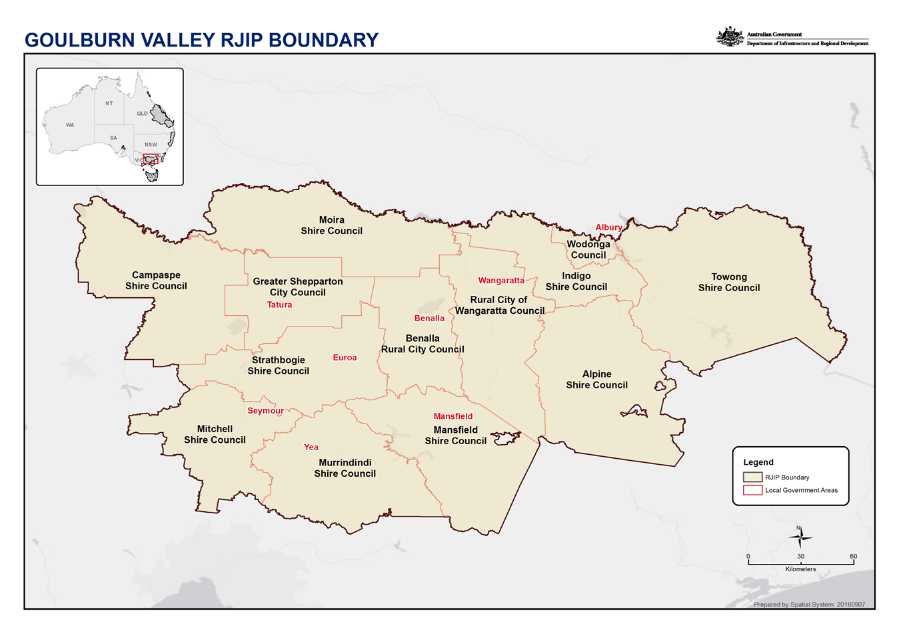

Introduction
The Goulburn Valley Regional Jobs and Investment Package (RJIP) area encompasses thirteen local government areas, from Campaspe in the west, Towong in the east, Moira in the north and Mitchell, Murrindindi and Mansfield in the south. It is a diverse region, both in terms of landscape and demographics and industry strengths.
Irrigated agriculture and food manufacturing are strong in the Goulburn Murray Irrigation District, centred around Shepparton and Echuca, as is agriculture throughout the entire Goulburn Valley RJIP area. Manufacturing industries are concentrated in the major population centres of Shepparton, Wodonga, Echuca, Benalla and Wangaratta. The iconic Murray River, and other waterways and lakes are major drivers of tourism for many towns within the region and offers recreational opportunities and a unique natural amenity. The Alpine areas have a range of natural assets that encourage recreational and adventure tourism opportunities such as skiing, hiking and cycling.
Agriculture, manufacturing, tourism and health services are major employers in the Goulburn Valley RJIP area, and require connectivity to major centres and capital cities to function effectively. There is a deficit of connectivity infrastructure throughout the Goulburn Valley RJIP area. Investment in rail (passenger and freight) and digital infrastructure will enhance the strategic priorities in this plan. It is critical that the Goulburn Valley RJIP area be better connected to major population centres.
Areas in the Murrindindi and Mitchell Shires have experienced proportionally higher population growth due to their proximity to Melbourne.
The diversity of the people of the region is a major strength. A strong and enduring Aboriginal culture exists throughout, and there are many places and stories of significance. The Goulburn Valley RJIP committee acknowledges the Commonwealth Government Indigenous procurement policy and encourages the move towards Reconciliation Action Plans.
The history of migration to the region, from the early 1800s to the post war and more recent migration, has seen the region become a very successful multicultural society.
The region has a strong tradition of economic development; with strategic funding and commitment to major infrastructure the Goulburn Valley RJIP area will continue to grow, create sustainable employment and increase gross domestic product for the nation.
The strategic priorities of this plan require people who have the job readiness to participate in the workforce of the future. This is enabled by an effective education system, from cradle to career. This must be a key focus of all governments.

Regional overview and analysis

Investment Sector: Agriculture
Agricultural production is a major economic driver and employer in the Goulburn Valley RJIP area.
The Goulburn Murray Irrigation District (GMID) is a significant gravity fed irrigation scheme which supports a diverse range of agricultural enterprises with a focus on dairy and horticulture. Outside the GMID there is significant dry land cropping, dairy, livestock and viticulture production.
Traditionally agricultural production has served the global bulk commodity markets however over time there has been a shift to value added, higher margin products for domestic and export markets. This is a great opportunity for future growth and diversification for the agricultural industry, particularly given that Australia is a higher cost producer.
The agriculture sector must continue to diversify and focus on value adding as much as possible to the raw product. To do this we must utilise technology, encourage easier market access (both export and domestic) and facilitate networks that encourage smaller producers to collaborate more. The provenance story and the reputation the Goulburn Valley RJIP area has for food quality and safety is an important message to convey to Australian and International audiences.
In a changing climate, technology will assist with adaptation and help farmers to re-align their practices. It is forecast that water will be less secure and severe weather events more common. Agriculturalists must find ways to run profitable businesses in this changing operating environment.

Evidence
The Goulburn Valley Industry and Employment plan (GVIEP 2013) was created by the Goulburn Valley taskforce in 2013 and recommends a strategic plan for the Goulburn Valley based on three pillars – strengthening the agriculture sector, developing the region’s wealth generators and advancing leadership through an adaptive business environment (GVIEP 2013). Agriculture and the associated manufacturing and services are major employers in the region.
Dairy
Murray region 1450 farms that in 2015/16 produced 24% of the national milk produced (2.3 billion litres) and 28% of Australia’s milk exports. (Murray Dairy 2017).
The global milk powder market has been volatile over many years, affecting milk processors and farm gate milk prices.
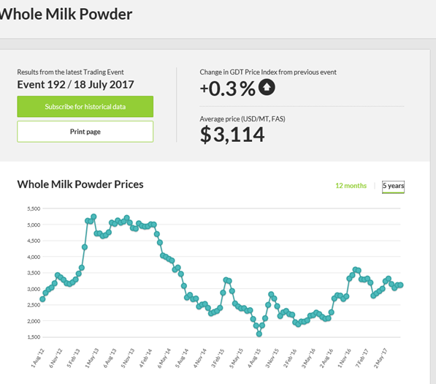
Source: https://www.globaldairytrade.info/en/product-results/whole-milk-powder/
Horticulture
The GMID produces:
- 99.9% of Victoria's tomatoes for processing
- 99% Apricots
- 98% Nectarines
- 97% Pears
- 94% Plums and prunes
- 91% Peaches
- 57% Apples
Source: Victoria’s Foodbowl (2011) http://www.victoriasfoodbowl.com.au/agriculture
Water
There is a declining irrigation water entitlement in the GMID.
Water Allocations in the GMID (Murray Dairy Summit report 2017 - GB CMA graph)
Agriculture according to the 2011 abs figures attributed $2,273,600,000 Gross value to the region.
In 2011 there were 127809 people employed in the region, 9.2% in Agriculture, forestry and fishing.

Strategic priorities
- Initiatives that demonstrate diversification, innovation and/or the creation of value added agricultural products for domestic and/or overseas markets.
- Initiatives that have positive impact across industry sectors to help agricultural producers improve productivity and/or adapt to the challenges of a changing climate.
- Initiatives that address workforce issues for agricultural businesses both current and future, including upskilling of existing workforce, succession planning of agricultural businesses and promotion of career pathways and development of programs to cater for future technological needs.
- Ensuring that transport and/or digital connectivity can enable the above strategic priorities

Investment Sector: Tourism
The Goulburn Valley RJIP area offers a range of tourism experiences for domestic and international visitors. The strength of the areas tourism lies in the amenity of the natural environment, strong cultural and historical experiences. The mountains and rivers are key natural assets, offering an abundance of recreational opportunities and eco-tourism that connect with nature.
The Goulburn Valley RJIP area has a strong Aboriginal history which is demonstrated through stories, culture and places of significance. There are opportunities to learn and experience Aboriginal culture and this can be integrated through the broader tourism industry. This cultural experience can provide a connecting link with the natural assets and give an understanding of the ancient cultural significance of the natural and physical features in the Goulburn Valley RJIP area.
There are more opportunities to develop, promote and support this potential emerging Aboriginal cultural tourism through product development and marketing.
Recent migration of people from diverse backgrounds in Asia, the Middle East, Africa, Europe and South America adds to the richness of the region’s cultural diversity.
The Goulburn Valley RJIP area has a historic folk lore focusing on the high-country legends and the activities of early colonial settlers which is a significant asset to the tourism industry.
The area has a strong record of staging major events, encompassing adventure tourism, sport, arts & culture, markets, festivals, food & wine and music.
The area’s agricultural industry offers a wide variety of food and beverage experiences for visitors, and there is an opportunity to further leverage on the provenance story and farm gate opportunities.

Evidence
Goulburn Valley has approximately:
- 3,687 Tourism Businesses
- 4.34 million domestic day visitors in to the region per year
- 2.69 million Domestic overnight visitors per year
- 52,000 International visitors each year
- Domestic and International visitors stayed a total of 8.2 million nights per year
- Estimated Tourism Spend into the region $1,413,000,000
(Tourism Research Australia - Area Profiles 2015)
Major events in Goulburn Valley RJIP area:
- Southern 80 ski race (Echuca)
- Shepparton Festival
- The Winery Walk About’ Rutherglen
- The Kangaroo Hoppet at Falls Creek
- The Man from Snowy River’ at Corryong
- The Fifties festival’ at Tallangatta
- The Bright Autumn Festival’ at Bright
- Alexandra Truck and Ute Show
- Opening of Trout season at Eildon pondage
- Beechworth Celtic festival
- Yackandandah Folk Festival
- High Country Festival Mansfield
- Targa High Country
(not an exhaustive list)

Strategic priorities
- Leveraging the cultural, historical and natural assets to create tourist products for a range of markets, including international markets. Encouraging extended length of stay and enhancing visitor experience.
- Traditional Owners of the land creating tourism experiences and products that give an insight into the Aboriginal culture of the region. Collaboration to encourage visitation from a wide range of markets, including international markets, to create a package of experiences throughout the region.
- Initiatives that address workforce issues, including training and upskilling to be able to service different market segments.
- Enhancing and linking the provenance and farmgate tourism experience.
- Ensuring that transport and/or digital connectivity can enable the above strategic priorities

Investment Sector: Manufacturing
The manufacturing sector is strong in the region, from the food manufacturing linked to the agricultural sector, the industry manufacturing ancillary goods for food manufacturers and the manufacturing of other goods.
There is an opportunity to build regional capacity – to work together to maximise the opportunities, identify product and services gaps. Technological advances are required to keep manufacturers competitive. Networks can help skills sharing and technological knowledge.
Energy is a significant cost in manufacturing and advances that can reduce this input will enhance competitiveness.
Given incentives and assistance, many metropolitan based manufacturing business, especially those that require agricultural product inputs, would consider relocating to the region.

Evidence
In 2011 there were 127809 people employed in the region, with 12.3% in Manufacturing. Major food manufacturing and associated manufacturing is concentrated around Shepparton with SPC, J Furphy & Son tanks, Unilever, Murray Goulburn, Tatura Milk and Fonterra. Echuca has many food manufacturing businesses – Kagome, Simplot and Kraft-Heinz. Wodonga is home to significant manufacturing business such as Mars Petcare, BAE Systems and Vitasoy. D and R Particleboard company is in Benalla.

Strategic priorities
- Initiatives enabling productivity gains, increased competitiveness and/or value-added products.
- Create networks for information sharing, promotion of manufacturers and collaboration.
- Initiatives that address workforce development issues in changing environment.
- Ensuring that road, rail and/or digital connectivity can enable the above strategic priorities

Investment Sector: Aged health care
Aged care is a growing sector in the Goulburn Valley RJIP area. A number of facilities have and are being developed in the Goulburn Valley RJIP area, and demand continues to outstrip supply. In addition to these facilities, there are alternative models for aged care, that link with care for the disabled.
The major limiting factor for the sector is the availability of skilled staff across all areas.

Evidence
Health Care and Social Assistance sectors are the biggest employers in the Goulburn Valley RJIP area. With an aging population a greater proportion of this will be in aged health care and social assistance. In 2011 there were 127809 people employed in the region with 12.7% Health Care and Social Assistance.
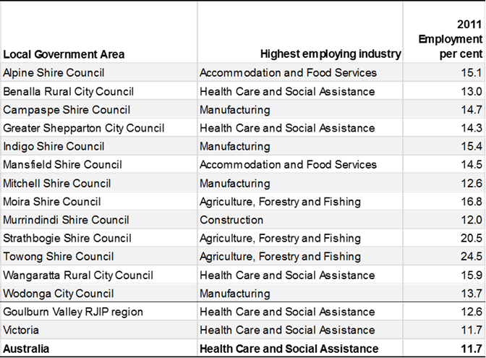
Source (RJIP Regional Snapshot – Goulburn Valley)

Strategic priorities
- Developing better models and approaches for aged care delivery in regional areas that are aligned with the standards of the aged care and disability sector.
- Initiatives that address labour shortage issues, including promotion of career pathways and development of programs to cater for future technological needs.
- Programs to train, and retrain people for the sector that are in line with the National Aged Care Workforce Strategy.

References
- http://www.victoriasfoodbowl.com.au/agriculture
- https://www.globaldairytrade.info/en/product-results/whole-milk-powder/
- Murray Dairy Summit Report 2017
- Goulburn Valley Industry and Employment Plan 2013
- Tourism Research Australia - Area Profiles 2015 (based on four-year average from 2012 to 2015)
- Regional Snapshot Goulburn Valley – RJIP – Department of Infrastructure and Regional Development

