Space Infrastructure Fund – Mission Control Centre

Last updated 30 January 2020

How do I apply for funding?
The grant opportunity application can only be submitted through the online portal. Go to business.gov.au for information on how to apply.

Program timing?
Application opened at 12pm AEDT Tuesday 10 December 2019, and will close at 5pm AEDT Tuesday 18 February 2020.
The successful applicant is expected to be able to commence their project from June 2020.
Projects must be completed by 30 June 2022.

Can I locate the Mission Control Centre at a location of my choice?
The project must be located on the ground floor of the McEwin Building at Lot Fourteen, corner of North Terrace and Frome Road, Adelaide.
Adjacent to the Mission Control Centre will be an auditorium that allows the public to view the centre. The auditorium will form part of the Australian Space Discovery Centre, which comprises the remaining area of the ground floor of the McEwin Building.

What are the specifications of the space in the McEwin Building allocated to the Mission Control Centre?
The design of the ground floor of the McEwin Building is in the concept stage. There is a traditional meeting space available for the Mission Control Centre. The area available is approximately:
- 54 m² located on the ground floor:
  - Length 9050 (mm)
  - Breadth 5860 (mm)
- Height 3700 (mm).
The area is currently at concept stage and so may change slightly.
It is proposed that there will be some storage or locker space and access to the staff kitchen area, which is to be shared with staff of the Australian Space Discovery Centre. Also proposed are two server rack spaces as a minimum for the Mission Control Centre, with access to a higher security zone 4 server space if required in the basement.
The Mission Control Centre will be located with the Australian Space Discovery Centre, which takes up the remaining space on the ground floor. To improve security, access to the Mission Control Centre will be through the main business lobby of the building where it is proposed that there will be a separate airlock to enter into the Mission Control Centre.
Business clients of the Mission Control Centre will enter via the tower lobby and the proposed security airlock. The security airlock will have an access door into the Australian Space Discovery Centre as part of a partnered agreement. The security airlock space is proposed to take up to 6.7m².
Users of the Mission Control Centre do not need to access the Australian Space Discovery Centre in order to operate the Mission Control Centre. The main entry to the Australian Space Discovery Centre will be on the eastern promenade and visitors will exit via the two western exits into the courtyard.
Users of the Mission Control Centre will have the ability to close the glass viewing window between the Mission Control Theatrette (which is part of the Australia Space Discovery Centre) and the Mission Control Centre in the event of commercial in confidence activity.
The current concept stage floor plan is provided below as a guide only. This is subject to change.
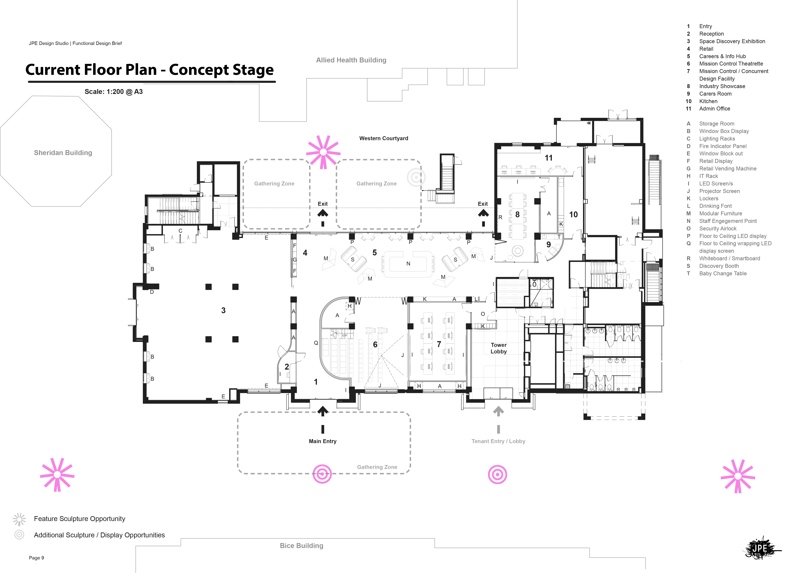
Figure 1 - Concept stage floor plan of McEwin Building, ground floor

Who will be responsible for the fit out and base build?
It is proposed that the successful applicant will be responsible for the cost of the fit out and base build of the facility. The South Australian Government, with support of the Australian Space Agency and the successful applicant, will project manage the base build and the fit out of the ground floor of the McEwin Building. The fit out is currently at concept stage with limited services identified. The design and documentation stage is pending. The fit out for the Mission Control Centre will include:
- External walls, external doors, internal walls, wall finishes, floor finishes
- Fitments, including storage joinery and secure lockers
- ICT including
  - Server room capacity located within the footprint of the Mission Control Centre for a minimum of two servers to support multiple computers and screens
  - LED screens, cabling and ICT rack
- Air-conditioning system separate to the Australian Space Discovery Centre
- Security – base building which has a building security system and security resources within the precinct (and conducting patrols)
- Security and fire protection
- Light and power, including feature lighting
- Workstations and chairs.
The successful applicant will be responsible for the cost and installation of equipment that is specific to the Mission Control Centre.

What are the technical requirements of the Mission Control Centre?
The Australian Space Agency is seeking proposals from applicants to establish a viable, ongoing, common access Mission Control Centre. To this end, applicants will need to consider what business case, hardware, software and other aspects are most appropriate to deliver a commercially viable facility to the intended users. We would expect applicants to consider a range of models and propose the most appropriate to access antennas and other infrastructure, including by lease, purchase or other arrangements. The technical specifications for antennas, and the ability to scale up to future needs, would be part of this consideration. Further, it is expected that the applicants will consider interaction with other infrastructure projects supported by the Space Infrastructure Fund, for example the Tracking Facilities Upgrade by the University of Tasmania. Applicants would also need to consider the objectives and outcomes of the grant opportunity, which sets out the intended users of the Mission Control Centre and therefore what technical capabilities are most suitable to deliver the intended outcomes. The applicant’s proposal will be considered against the assessment criteria during the assessment of applications, leading to a decision about which application to fund.
Server room provisions:
- Two service racks will be available in the server room.
- The acoustics of the Mission Control Centre and the Australian Space Discovery Centre will align with Australian standard AS 2107. Soundproofing options of the server room will be considered in the design stage.
Data connectivity:
- The Lot Fourteen precinct has been built as an innovation hub, with other tenants in the precinct able to access high speed internet. Further information is available on the website of RenewalSA and Lot Fourteen.
- Redundant power supply is not included in the fit out and should be allowed for if required.

Is it be possible to inspect the room in person in January 2020?
The McEwin Building has opened to tenants, with the lift lobby open during normal business hours. The area around the ground floor has got temporary fencing in place as it is not available to the general public, although it is possible to view the ground floor through windows. There is no opportunity for an inspection as it is a construction site. At present, it is just one large room without delineation between the Mission Control Centre and Australian Space Discovery Centre spaces.

Will the grantee be expected to cover rent for the Mission Control Centre space at the McEwin Building, and how much will this cost?
Discussions are currently underway between the Australian Government and South Australian Government around the rent for the Mission Control Centre space in the McEwin Building. A grantee would need to consider that a contribution from them may be required to cover rent cost. The extent of contribution required is currently unknown, and it is uncertain when it will be known. Rent is an eligible expenditure in the Mission Control Centre grant guidelines for the duration of the grant.

What is the Australian Space Discovery Centre?
The Australian Space Discovery Centre will be a public facility opening in the first quarter of 2021. Questacon, with the support of the Australian Space Agency will build and initially operate the Australian Space Discovery Centre. It is intended that the Australian Space Discovery Centre will be a centre:
- that ispublicly accessible space discovery centre that captures the hearts and minds of the Australian community to engage with an expanding national space sector.
- where the Australian community, students and visitors will have a unique opportunity to engage with the latest innovations in space technologies and expand their understanding of Australia’s role in national and global space activities and missions.
- o tell the local, national and international stories of Space, Place and the Australian Space Agency.
- that operates locally but communicates nationally and international.
- that aligns with and amplifies the work of the Australian Space Agency.
- that provides information and indicative career pathways in the space industry
- that leverages the Lot Fourteen expertise and that is fully integrated into Lot Fourteen and its surrounds
- that connects the public and industry community.

Australian Space Discovery Centre content will align with the Australian Space Agency’s seven National Civil Space Priority Areas which are outlined in the Australian Civil Space Strategy.
- Position, navigation and timing
- Earth observation
- Communications technologies and services
- Space situational awareness and debris monitoring
- Leapfrog R&D
- Robotics and automation on Earth and in space
- Access to space.
The Australian Space Discovery Centre’s key functions will include:
- Reception
- Space exhibition gallery
- Careers and information hub
- Mission Control Theatrette with viewing window to Mission Control Centre
- Industry showroom
- Carer’s facility
- Administration of the Australian Space Discovery Centre.

What is the expected relationship between the Mission Control Centre and the Australian Space Discovery Centre?
The Mission Control Centre and Australian Space Discovery Centre will be co-located on the ground floor of the McEwin Building. The centres will be managed separately, however from the public perspective it will have a joined experience by the use of a switchable glass partition between the Mission Control Centre and the Mission Control Theatrette in the Australian Space Discovery Centre.
The Mission Control Theatrette is managed within the Australian Space Discovery Centre operations and will be used to provide a wide variety of digital experiences for its visitors. This includes, when appropriate, viewing capability into the Mission Control Centre.
It is expected that a partnership model of delivery will exist and be developed between the two operators. In general, it is not expected that Australian Space Discovery Centre visitors will have access to the Mission Control Centre.

How do I contact Questacon to discuss the Australian Space Discovery Centre?
Questacon is within the same portfolio as the Australian Space Agency – part of the Department of Industry, Innovation and Science.
The appropriate way to seek additional information is to visit business.gov.au or call 13 28 46.

Can I apply for funding under the Mission Control Centre grant opportunity and the Robotics, Automation and Artificial Intelligence Command and Control Centre grant opportunity?
Yes, you will need to submit a separate application under each grant opportunity. Each application will be considered under the relevant grant opportunity.

Need more information?
For more information, visit business.gov.au or call 13 28 46.
We may update this document from time to time to add further information, where required.

