The Queen’s Platinum Jubilee Australia 2022
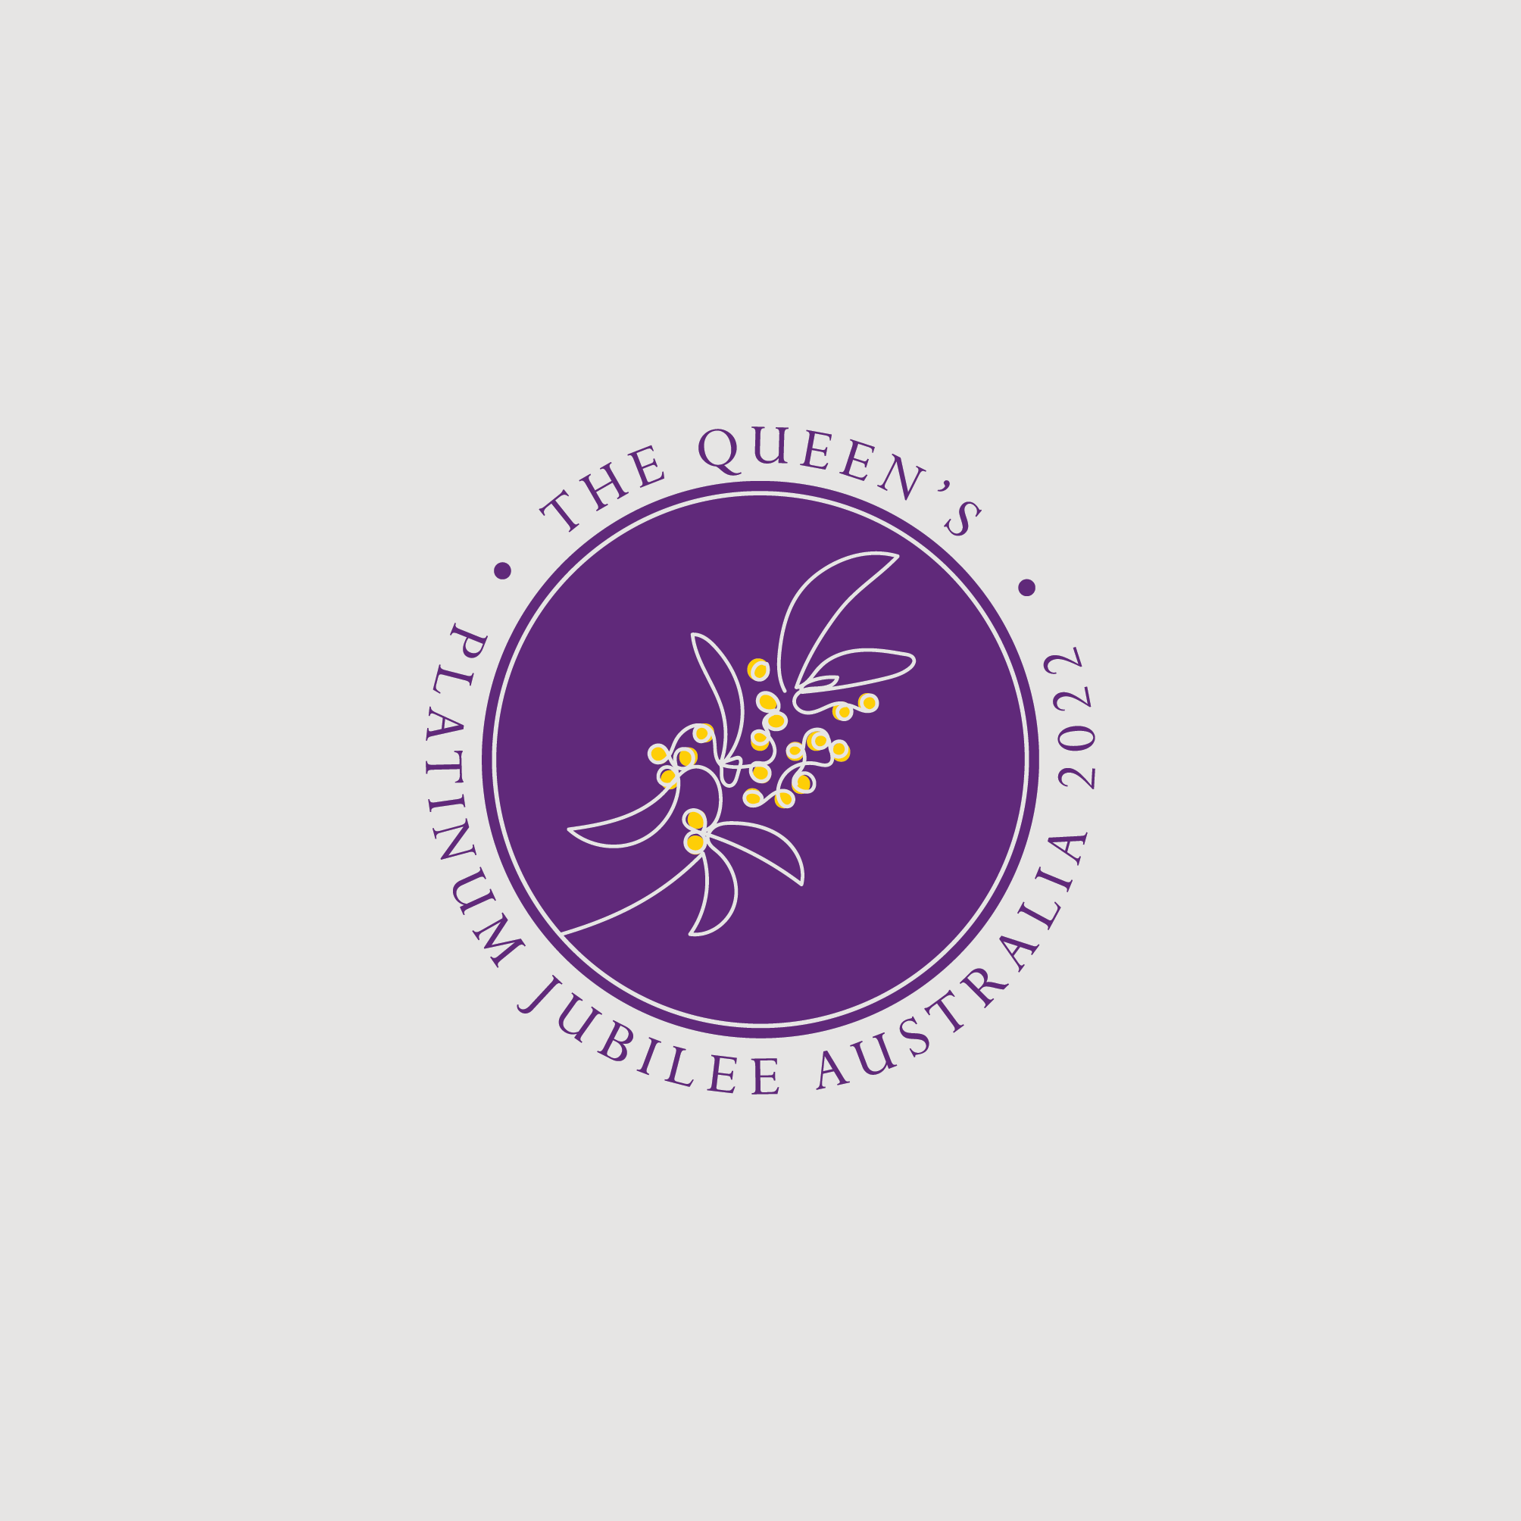
  - Australian Emblem Guidelines

Contents
1. Introduction 3
1.1. General Information 3
1.2. Further information 3
2. The Australian Platinum Jubilee Emblem 3
3. Official uses 5
3.1. Emblem Options 5
3.2. Exclusion zone 5
3.3. Colour contrast 6
3.4. Typography 7
3.5. Colours 7
3.6. Incorrect usage 8
4. Applications 9
4.1. Authorised uses 9
4.2. Unauthorised use 10

Introduction

General Information
The Australian Government has created an Australian Platinum Jubilee Emblem for use in Australia. The emblem may be used with permission by individuals, organisations, and charities for celebrations to mark Her Majesty The Queen’s Platinum Jubilee in 2022. The emblem will be available for use for official government and recognised events until the end of 2022.
Requests for permission to use the emblem outside of the authorised uses detailed in these guidelines should be directed to the Jubilee Events Taskforce.

Further information
Any questions about the use of the emblem as advised in these guidelines, including its use by third parties, should be directed to the Jubilee Events Taskforce at www.platinumjubilee.gov.au/contact.
The Official Queen’s Platinum Jubilee Emblem is also available for use for Platinum Jubilee events. Further guidance on its use is available on the Royal Family website at www.royal.uk/queens-platinum-jubilee-emblem.

The Australian Platinum Jubilee Emblem
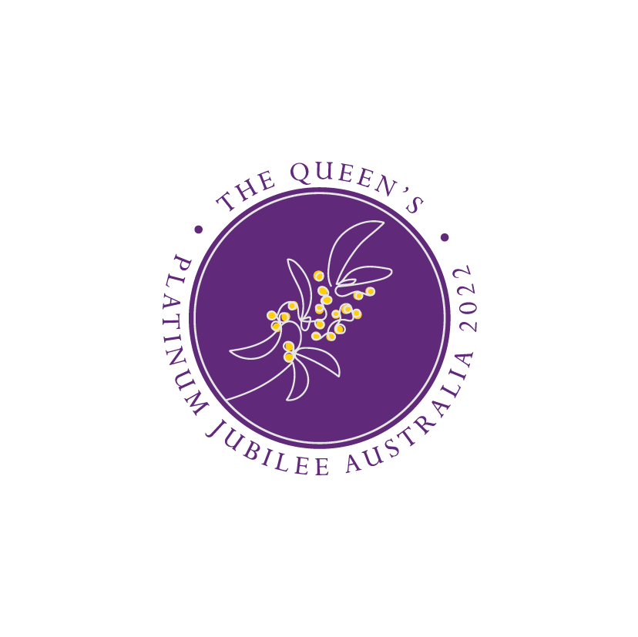
The Australian Platinum Jubilee Emblem design is a stylised representation of the Queen’s Wattle Spray Brooch worn by Her Majesty The Queen on numerous occasions. Australia gifted the brooch to The Queen during her first visit in 1954.
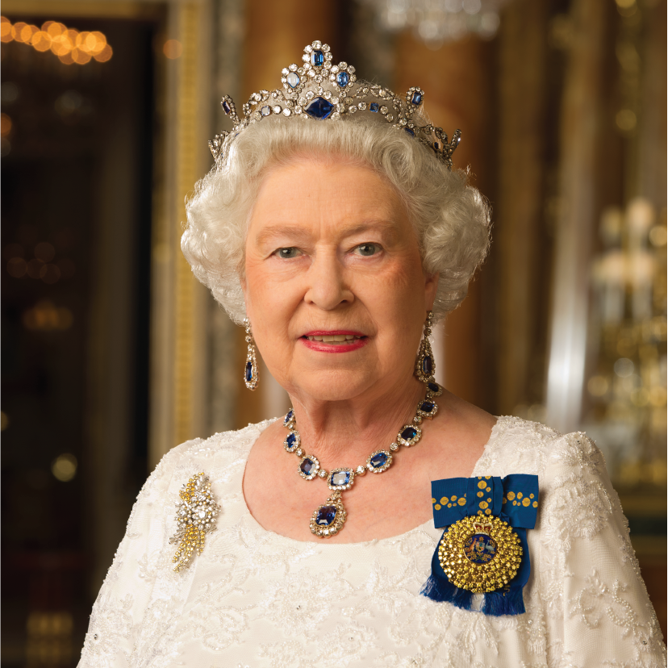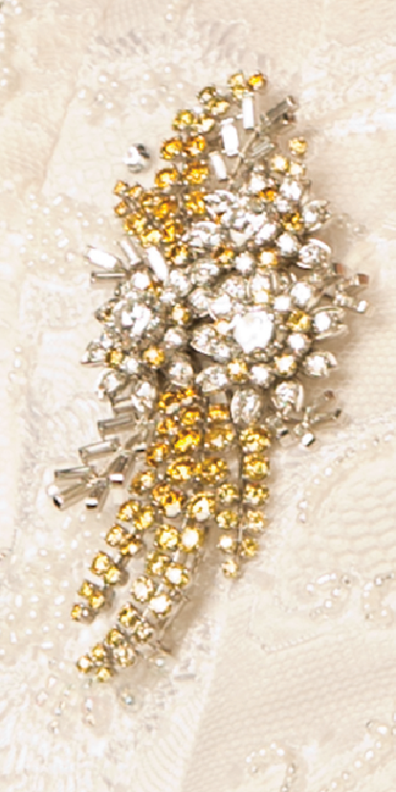
Her Majesty The Queen’s Wattle Spray Brooch

It inherits the illustrative traits of the current logo featured in the Official Queen’s Platinum Jubilee Emblem. The Golden Wattle is Australia’s national flower and the dominant icon on the logo, and therefore has a strong influence on the colour palette. The golden yellow colour swatch complements the royal purple of the United Kingdom led branding colour scheme.
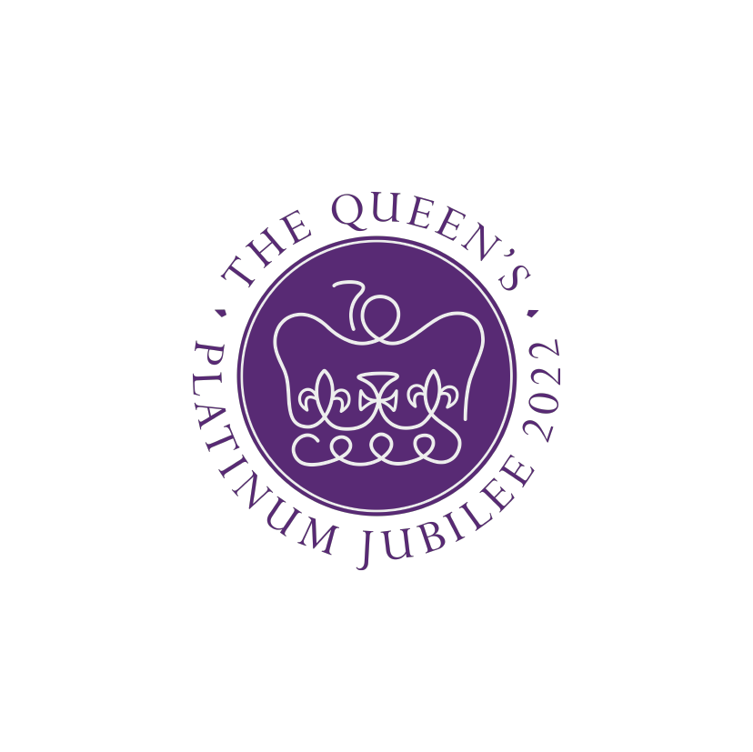

Official uses

Emblem Options
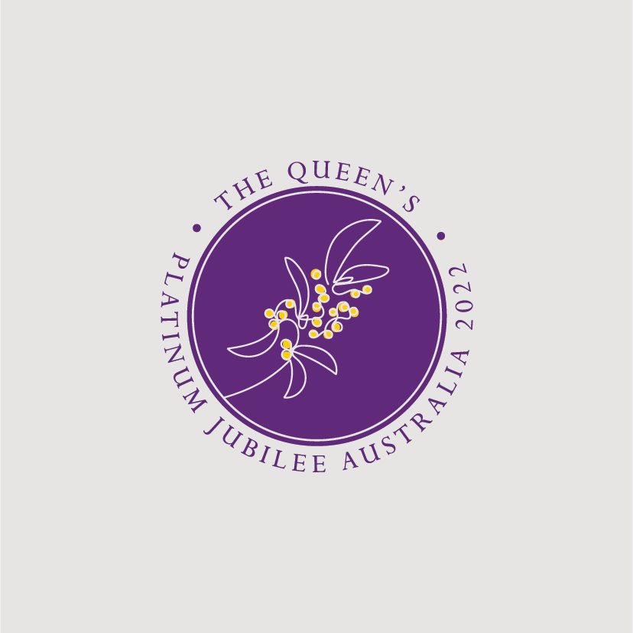 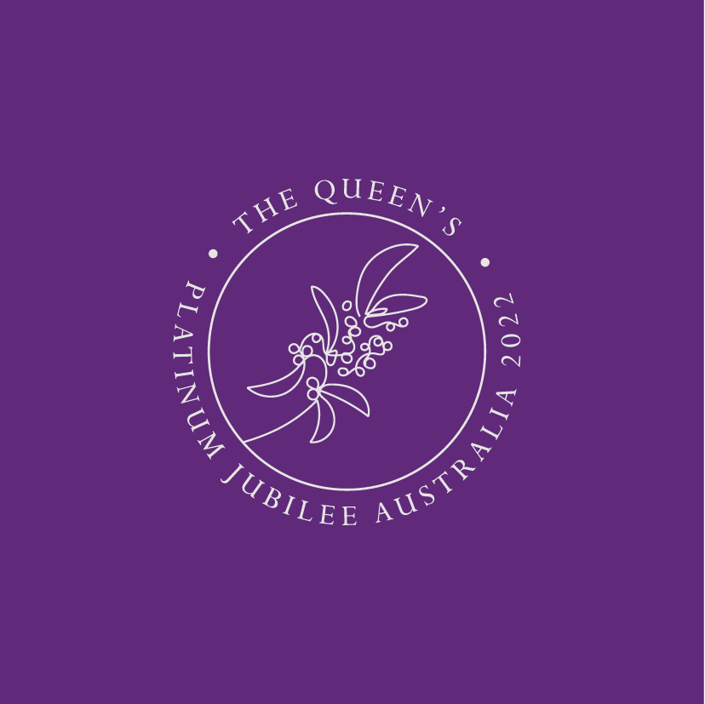There are two versions of the Australian Platinum Jubilee Emblem: Colour and Monotone.
The primary version of the emblem is a purple, platinum and gold seal and is recommended for use across print and communications.
For secondary uses, a platinum version of the font is acceptable on darker backgrounds.

Exclusion zone
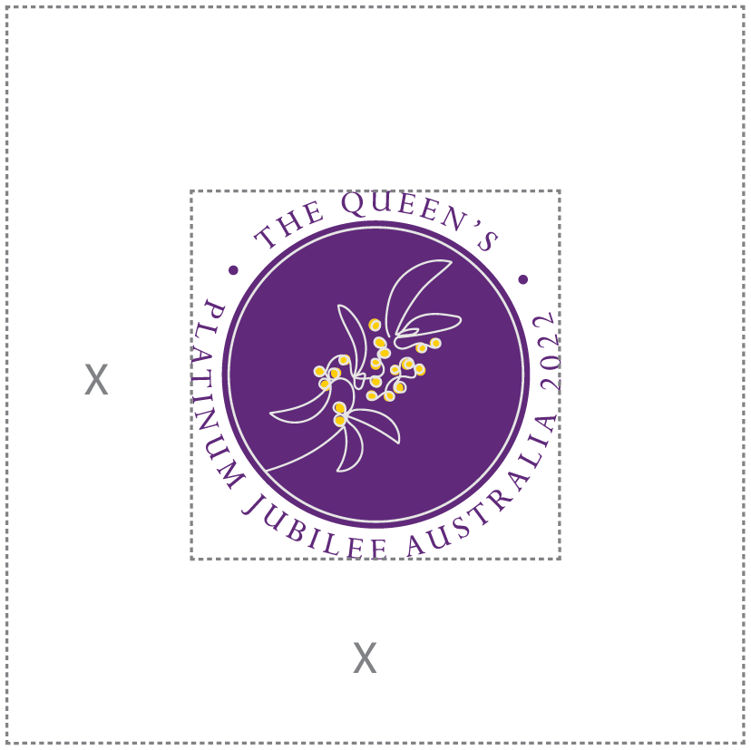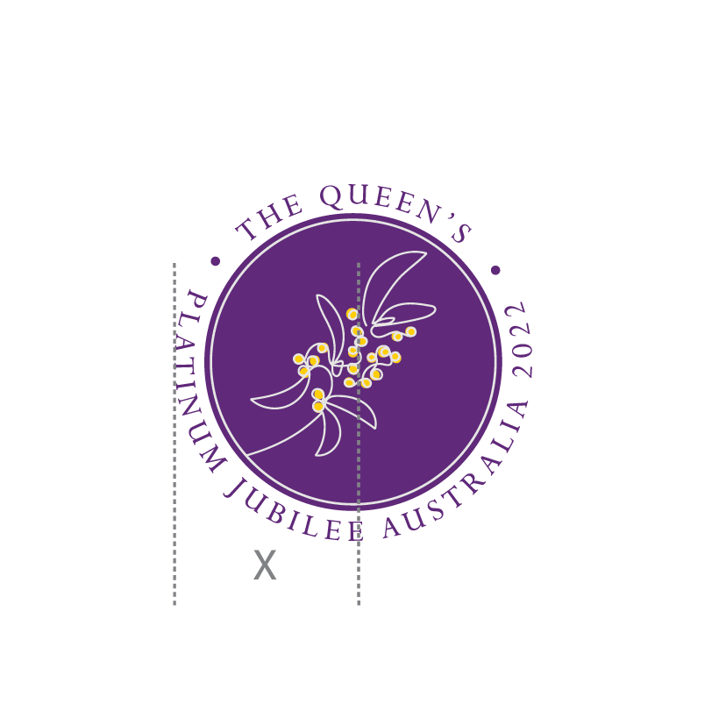
To ensure prominence and legibility, wherever possible the emblem should always sit in an area of clear space which remains free from other elements. The minimum amount of space is 1/2 the vertical height of the emblem, measured from side to side.

Colour contrast
For uses on complex backgrounds and foiling, a platinum monochrome version is acceptable.
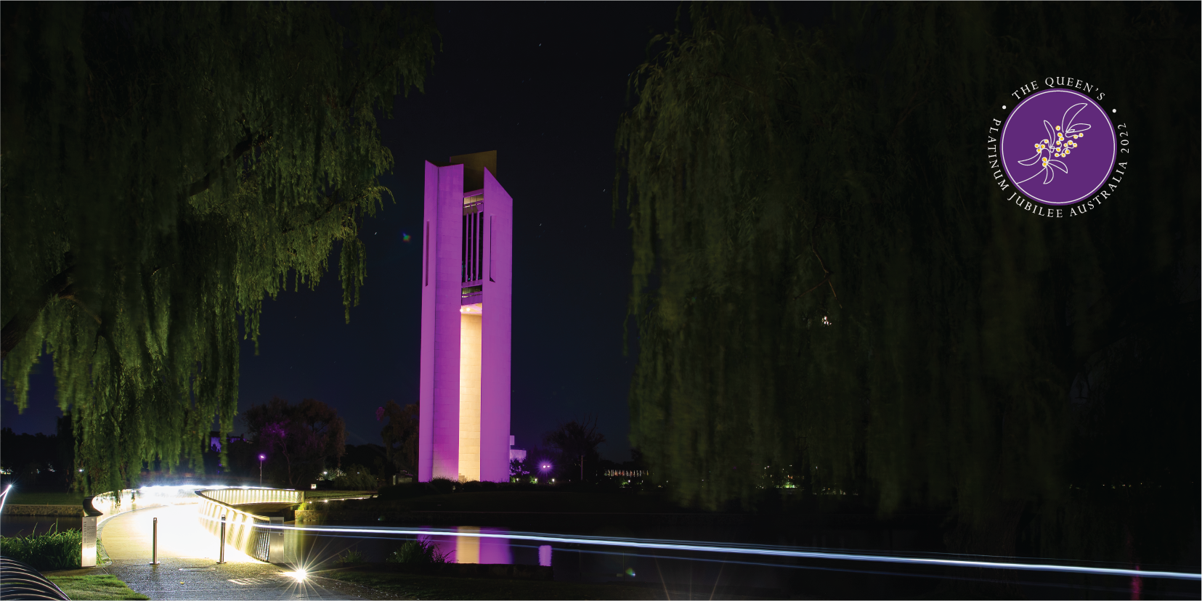
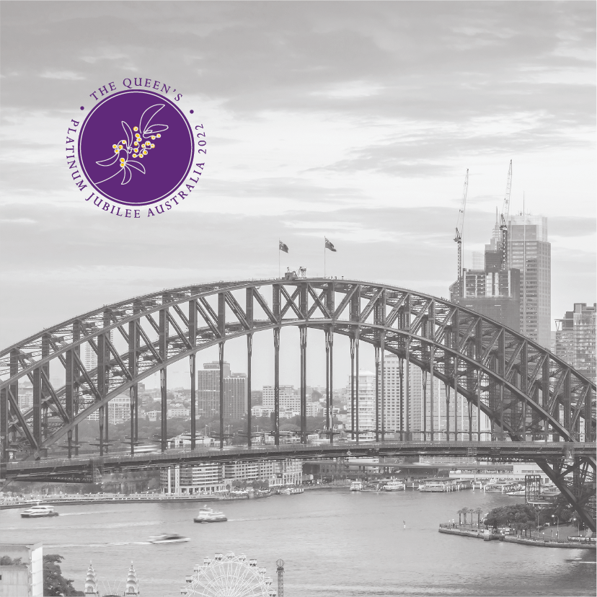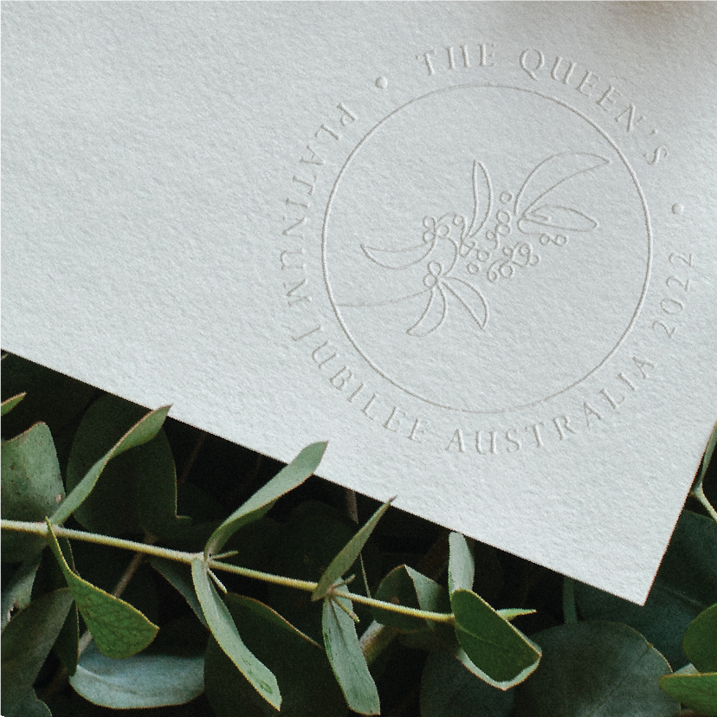

Typography
Perpetua was selected as the font to compliment the style of the emblem. Perpetua means forever, acknowledging the first Australian Monarch ever to mark 70 years of dedication and service to Australia and the Commonwealth. Titling requires tight character tracking and considerate kerning.
Perpetua Pro Roman
abcdefghijklmnopqrstuvwxyz
ABCDEFGHIJKLMNOPQRSTUVWXYZ
1234567890[(“#+-@©=%/>!?,…”)

Colours
Three colours make up the emblem – purple, gold and platinum. The platinum colour represents Her Majesty’s 70 years on the throne, whilst the purple colour is synonymous with royalty. The gold is drawn from Australia’s floral emblem, the golden wattle; and our national colours, the green and gold.
Pantone reference to assist are as follows:

Pantone 3515C
C 74, M 100, Y 0, K 12
R 97, 0, B 125
#61007D
Pantone 116 C
C 0, M 20, Y 100, K 0
R 255, G 205, B 0
#FFCD00
Pantone 663 C
C 0, M 0, Y 1, K 10
R 229, G 228, B 226
#E5E4E2

Incorrect usage
Please use the emblem as provided. It should not be redrawn, modified or re-constituted.

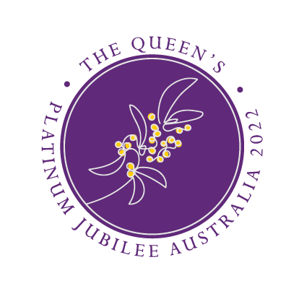
Correct emblem
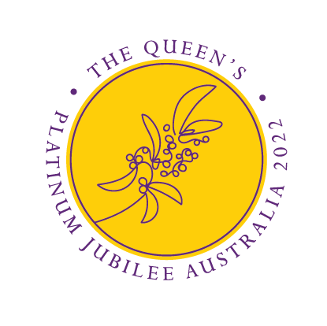
Do not recolour
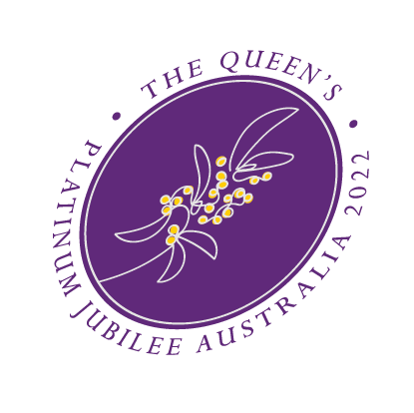
Do not shear
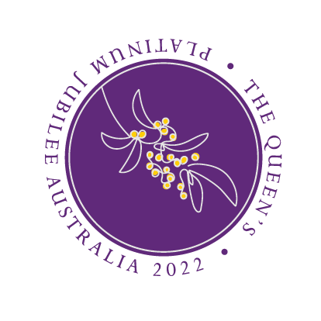
Do not rotate
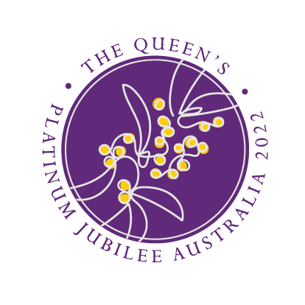
Do not scale
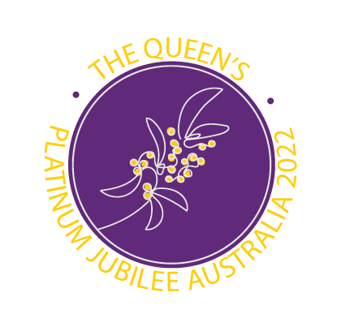
Do not change font 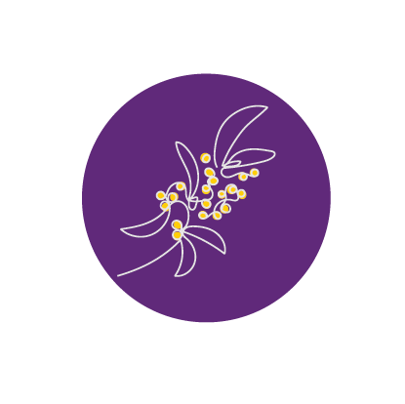
Do not remove any elements
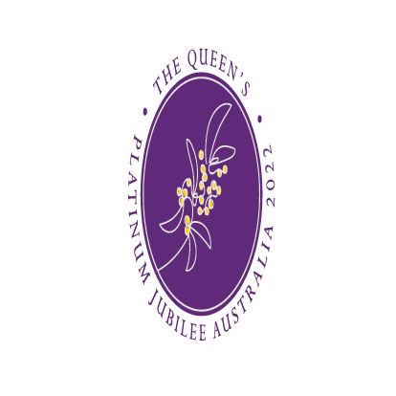
Do not distort
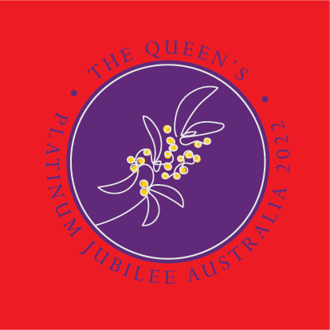
Do not use a block of colour 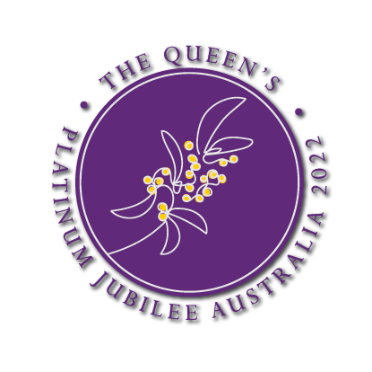
Do not add a drop shadow

Applications

Authorised uses

Official events that are coordinated by government, including Commonwealth; State; Territory and local government.
The Australian Platinum Jubilee Emblem may be used for government events and activities in Australia in accordance with these guidelines.

Events that have been recognised by the Australian Government and listed on the Platinum Jubilee website.
Community events that are recognised by the Government and listed on the Platinum Jubilee website are also permitted to use the emblem.

Appropriate event related and community souvenir items for official government and recognised events.
In addition to printed items, publications and social media the emblem may be applied to event items relevant to the celebrations (for example, flags, banners, teacups and souvenirs, badges, items of clothing and all textiles).
Appropriate event related and community souvenir items must be:
  - Dignified and in good taste
  - Free from any form of advertisement.
  - Carry no implication of Royal Custom or Approval.
Use this as a guide for placement, colour and scale when using the emblem on products.
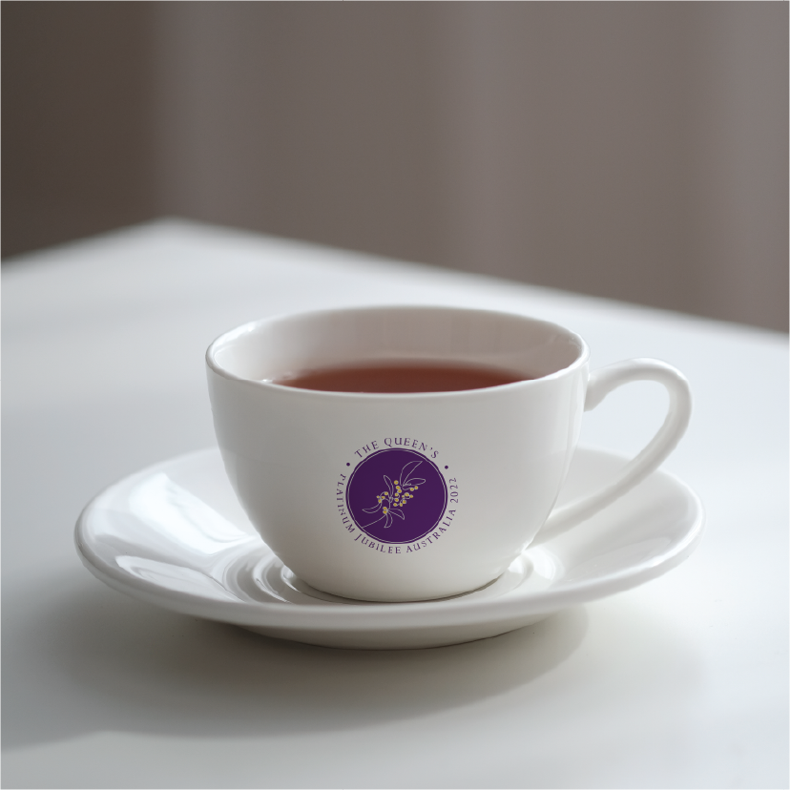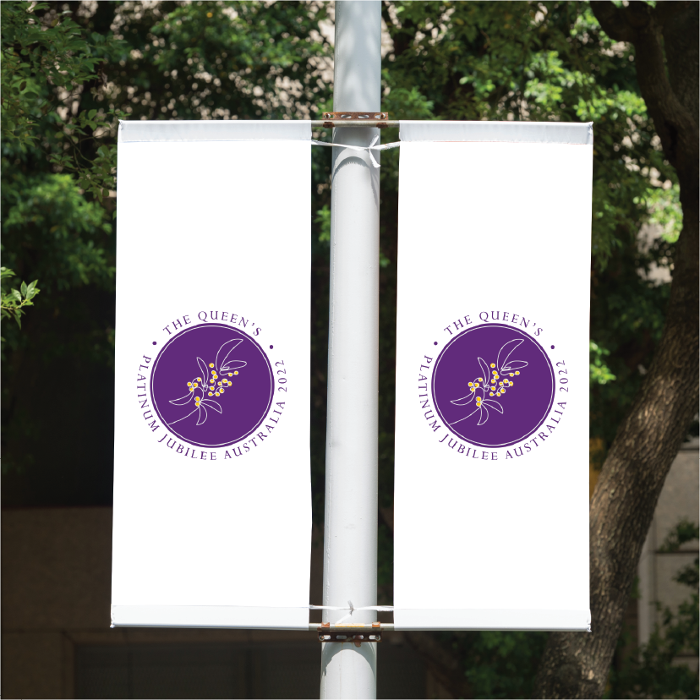
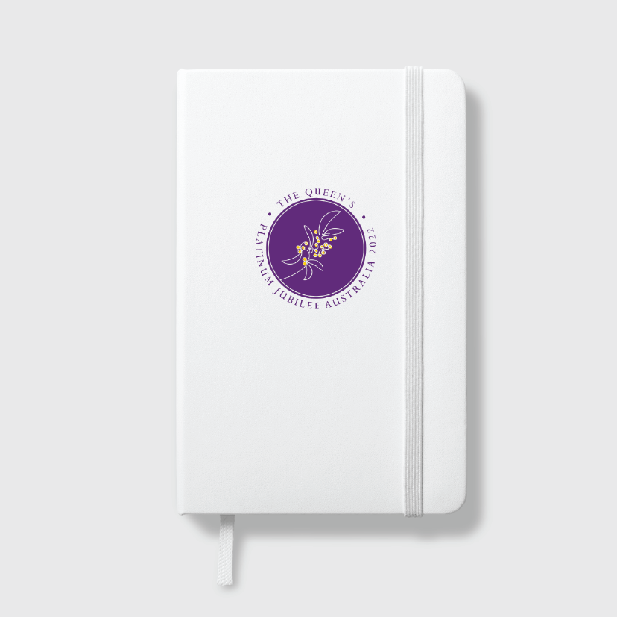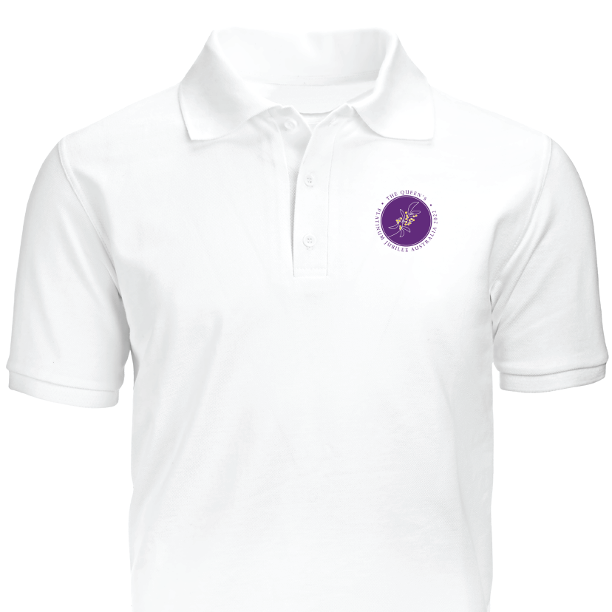

Unauthorised use
The emblem is only to be used for the purposes authorised in section 4.1 or by permission. If you have not received permission to use the emblem, it may be misleading to people participating in your event or purchasing your products.

